THE CHENANGO AND THE GENESEE
A Family History
Gross · Fenderson · Butts · Lounsbury · Ey · Goldsmith · Rankin
Compiled for Adrienne Leigh (Gross) Babcock
Third edition · 6 September 2026

Contents

A Note on This Document
This is a family history. It is arranged so that the story comes first and the evidence behind it follows.
Part | What it is
One — The Story | The narrative, from the first settlers of the Chenango valley to your own children. Read this, and give this to relatives.
Two — The People | Household by household: who married whom, who their children were, and what became of them. The reference half of the story.
Three — The Places | Four localities, and why each one shaped the people who lived there.
Four — The Evidence | The pedigree, the six sources everything rests on, and what the surnames mean.
Five — What Remains | What is still unknown, who to ask, and where to look.
Where the narrative rests on family memory rather than on a document it says so plainly — "the family says", "as remembered". Part Four sets out the sources behind everything else.
Your parents and your father’s two surviving sisters are living, and this document records only what they or you have supplied about them.

PART ONE
The Story

1. Two Valleys
Almost everyone in this family came from one of two river valleys in New York State, about a hundred and thirty miles apart, and for a hundred and fifty years the two sides had nothing to do with one another.
The first is the Chenango, in the southern tier: a narrow farming valley of hills rising five to seven hundred feet above the water, settled from New England and the Hudson Valley in the 1790s. Stephen Ketchum built the first permanent cabin within the bounds of what became the village of Greene in 1792, and the families who came in along the Chenango Road between 1792 and 1795 — Bennetts, Roots, Skinners, Elliotts, Clemmonses and a Roswell Fitch — are the stock your father’s line comes from. Fifteen miles downriver, where the Chenango meets the Tioughnioga, sits the hamlet of Chenango Forks. That is where your father’s mother’s people came from.
The second is the Genesee, and the city built on its falls. Rochester was a milling town that the Erie Canal turned into a boom city — the Flour City first, then the Flower City when the mills went west and the nurseries took over, and by the later nineteenth century a manufacturing centre making clothing, furniture, optics at Bausch & Lomb and photographic supplies at Eastman Kodak. It drew immigrants in waves, Germans among the first and largest: about three hundred German-born residents out of twelve thousand in 1834, and more than one in seven of the whole population by 1855. Your mother’s family belongs to that city.
For a while it looked as though there was a third place. Your father’s mother was born in Oakland, California, in 1919, two and a half thousand miles from anyone else in this book. It turned out to be the opposite of a mystery: her parents were both born at Chenango Forks, fifteen miles from where her husband would be born. They had gone west, and she came back. What looked like a transcontinental coincidence was a return.

2. Before the Valleys
Go back far enough and the two valleys empty out. The people who settled them came from somewhere else, and although almost none of it is yet proved for your own line, the shapes of those older journeys are visible.

The Gross line: Suffolk, Boston, and a Puritan quarrel
The paternal line is the one that reaches furthest, and it settles a question this history had been holding open. The surname was long assumed German, from groß. It is not. The Grosses came out of Suffolk, and the man who brought them across was a Puritan.
Isaac Gross — the early records spell him Groce, Grose, Grosse and Growse — was a husbandman, and a brewer by trade. He came to Massachusetts Bay about 1635 and was admitted to the First Church in Boston on 17 April 1636. That year he was granted a great allotment of fifty acres at Muddy River, and he put money towards the maintenance of a free schoolmaster for the town’s children.
Then he picked the losing side of the fiercest religious quarrel in early New England. The Antinomian Controversy of 1637 set Anne Hutchinson and the Reverend John Wheelwright, who held that they were receiving revelations directly from God, against the colony’s ministers and magistrates. Isaac was a friend of John Cotton and of Wheelwright. He was disarmed, and on 6 January 1638 he was dismissed from the Boston church and followed Wheelwright north to Exeter, where he took land in the first division. He came back to Boston by 1645 and died there in the first days of June 1649, between the writing of his will on the twenty-ninth of May and its probate on the fifth of June.
His son Clement Gross, born 1616, kept an inn at Boston and lived past 1691. Clement’s son Simon was born at Boston in 1652 and married Mary Bond of Haverhill. Their son Thomas was born at Hingham in 1678, and Thomas’s son — born 1708 — was christened Hincks Gross, after his mother Elizabeth Hincks. Hincks’s son Jabez, born 1743, married Abagail Crowell and died in 1819. Jabez’s son Micah, born 1780, came into Chenango County and died at South Plymouth, outside Norwich, in 1858 — which is exactly where the 1880 county history says the early settler of Preston went when he left. From Micah the line runs to John, born at Preston in 1806, who bought the farm at the foot of Gross Hill; then to the second Micah, then Fitch, then Edward, then Leland.
So from Isaac stepping ashore at Boston to Leland selling the farm in 1947 is eleven generations and three hundred and eleven years, and for the last hundred of them they did not move at all.

Cape Cod, and two hills called Gross
The middle of that journey went out to the end of Cape Cod. Jabez Gross was born in 1743 at Billingsgate — the old name for the Eastham and Wellfleet shore — and on 24 October 1763 he married Dorothy Ellis at Truro. His sisters married Cape Cod men: Huldah to a Rider at Wellfleet in 1765, Sarah to a Lombard there in 1768. The family had come down from Boston and Hingham to the outer Cape and stayed a generation or two.
The family remembers Jabez as a minuteman in the Revolution. Afterwards he did what a great many New England men did once the fighting stopped: he went west into New York. He died on 26 March 1819 at Garrattsville, a hamlet on Butternut Creek in the town of New Lisbon, Otsego County — a place first settled about 1773 and filled up mostly by veterans and their families after the war. Dorothy outlived him by two years and was buried in the Gross Hill cemetery there.
That is the detail worth stopping on. There are two Gross Hills. One at Garrattsville in Otsego County, where Jabez and Dorothy are buried; another at Greene in Chenango County, where their grandson John bought a hundred and sixty acres in the 1840s. The family named a hill, moved sixty miles, and named another.
Between them stands Jabez’s son Micah, born 1780, a cooper, who came into Chenango County, settled at Preston, and died at South Plymouth outside Norwich in 1858.

How much of this to trust
The colonial part of that chain is solid. Isaac Gross is a documented Great Migration immigrant and his life in Boston and Exeter is recorded in church, land and probate records. But two things about him are genuinely disputed, and the family chart takes one side of the argument without saying so.
- His English home. The chart says Kelsale in Suffolk. The Great Migration scholarship makes him a husbandman of King’s Lynn in Norfolk; another compilation says Cornwall. These are three different counties.
- His wife. The chart gives Mary Howard of Cornwall, married 4 August 1612. The King’s Lynn account gives Ann Lobley, married at St Margaret’s there on 5 August 1613 — a day and a year apart, which looks like the same wedding remembered differently, except that the names do not match. And Isaac’s widow, who remarried in 1658, is recorded as Ann.
Behind Isaac the chart runs on to 1282, and that part should not be relied on. It places four generations at "Agincourt, Suffolk", and there is no such place — Agincourt is in the Pas-de-Calais. Three of the wives are entered only as Mrs. Walter, Mrs. Oliver and Mrs. Oliver. And two married couples are each given the same death date as one another, three hundred years apart. Those are the marks of a line extended past its evidence rather than one traced through records.
Which leaves a good conclusion and a good project. The good conclusion is that the Gross name in this family is English, from the Old French gros, and came to Boston in 1636. The good project is the Suffolk parish registers — Kelsale’s survive — and the Great Migration volumes, either of which could settle Isaac properly.

The other lines
The oldest thread runs to Yorkshire. Almost every Lounsbury and Lounsberry in North America is held to descend from one man: Richard Lounsberry, born about 1634 at Broxa in the parish of Hackness on the North Yorkshire moors, who came over about 1651 and by the 1670s was a proprietor of Peningo Neck at Rye, on the border between Connecticut and New York. On 1 August 1670 he married Elizabeth Pennoyer, a Stamford girl of about eighteen. He died at Rye in December 1694. Their descendants spread through Stamford and Westchester and then west; one documented Gideon Lounsbury was born at Bedford in 1793 and died at Fenton in Broome County in 1866 — the shape of journey that would put a Lounsbury family at Chenango Forks in time to be Cora’s people.
A second thread may run to Essex. There were Fitches at Greene from the beginning — a Roswell Fitch on the Chenango Road between 1792 and 1795, a David Fitch at Greene village before 1800 — and the New England Fitches descend from the Reverend James Fitch, born at Bocking in Essex on Christmas Eve 1622. His father died when he was ten and left money for Cambridge; he used it instead to sail for New England at sixteen, trained under Thomas Hooker at Hartford, and became the first minister of Saybrook in 1646. In 1659 he led most of his congregation inland to found Norwich, Connecticut. He learned Mohegan and preached in it, and the sachem Uncas thought well enough of him to want him made guardian of his people. He died in 1702 under a Latin epitaph written by his son. Whether your Fitch name comes down from that family is unproved and should stay unproved until a record says so.
A third runs to the coast of Maine and possibly beyond it to the North Sea. The Fendersons of America cluster at Scarborough in Cumberland County from the middle of the eighteenth century, and the surname is grouped by researchers with Feddersen and Fedderson — North Frisian and Danish patronymics meaning son of Fedder, a northern form of Frederick. There are documented Fendersons at Owego in Tioga County by 1841, twenty miles from where Myrtie Fenderson was born in 1884.
The fourth is the Rhine, and it is the one thread documented rather than inferred. Herman Ey’s father and mother were both born in Germany. They did not come to New York; they came to Pennsylvania, and their son moved north.

The French colony at Greene
And then there is the strangest episode in any of these places, which belongs to the ground rather than to the bloodline. About 1792 a Frenchman named Charles Felix de Bolyne — the name is spelled Buloign and Bulogne as well, and he is described as a man of considerable talent, learning and wealth — bought from the patentees Malachi Treat and William Morris a tract on the east bank of the Chenango. It became the French Tract: some three hundred acres laid out as a village plot in ten-acre lots.
Eight or ten families came, fleeing the Revolution — de Bolyne, and men recorded only as M. Shamont, M. Le Fevre, M. Bravo, M. Du Vernet, M. Obre and M. Dutremont. Until they could shelter themselves they lived on Stephen Ketchum’s hospitality, and they paid him to cut a road from their settlement to the Chenango Road. It was called the French Road, and its traces were still visible sixty years later, though it seems never to have been used again.
They farmed the way their countrymen farmed at home — the family living in the village and working land some distance off — which was reasonable in Picardy and unworkable on the New York frontier. In 1795 the colony entertained Talleyrand, riding from Philadelphia to Albany. He met a son of M. Dutremont, liked him, and took him back to France as his private secretary. Within a few years the rest had gone. The land was bought in 1798 by Simon Barnett, himself the son of French refugees and born in the West Indies, who raised a large family on it and died in 1821. His son Charles, six months old when the family arrived in 1793, was still living outside Greene in 1880, the last survivor of the French colony.
Nothing yet connects your family to any of them. But your father’s people farmed ground that had been laid out in ten-acre lots by refugees from the Terror, and walked a road cut for them.

3. The Gross Farm
Your father’s side stayed put, and for a hundred years they stayed put in one particular place.
The Grosses were in Chenango County by the turn of the nineteenth century. Micah Gross was among the early settlers of the town of Preston, on the road that runs from Preston to Norwich, and afterwards moved on to the neighbourhood of North Norwich. His son John was born at Preston in 1806, the year the town was formed. John married Elizabeth Aldrich, daughter of Nathan Aldrich, and in the 1840s the two of them bought a hundred and sixty acres at the foot of what is now called Gross Hill, in the town of Greene. The farm directly to the south was bought at the same time by John’s brother William and Elizabeth’s brother Nathan. John and Elizabeth had fourteen children, and by 1880 the farm had grown to four hundred and fifty acres on lot 30.
A hundred and forty years later there was a twist. John’s great-great-granddaughter Madolyn — Leland’s sister — married a Joseph Gross who descended directly from John’s brother William. The two farms bought side by side in the 1840s came back together in a wedding.
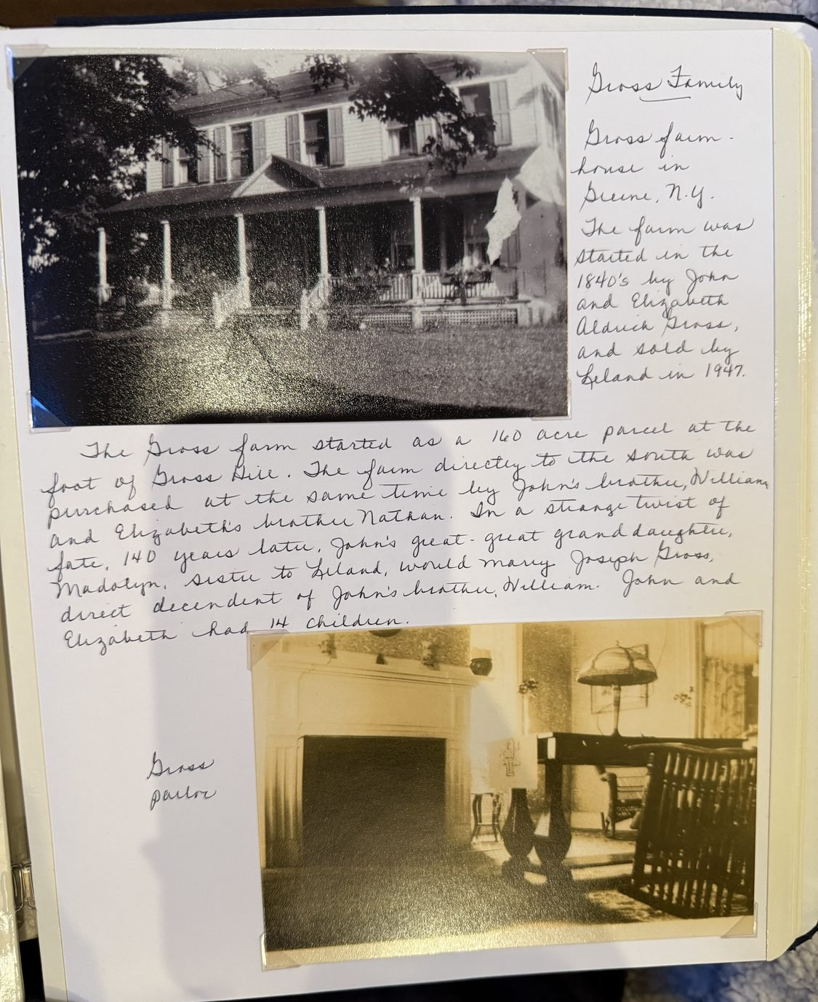
The Gross farmhouse at Greene. The farm was begun in the 1840s by John and Elizabeth Aldrich Gross as a hundred and sixty acres at the foot of Gross Hill, and sold by their great-great-grandson Leland in 1947.

The second Micah
John and Elizabeth’s son Micah took the farm on after them. The censuses of Greene find him plainly: in June 1865 Michael Gross, thirty-four, born in Chenango County, a farmer, with his wife Martha, twenty-nine, and a child Fitch, eleven; in August 1870 the same household as Micah Gross, thirty-nine, farmer, personal estate eighteen hundred and fifty dollars, Martha thirty-four, and Fitch sixteen.
So the line runs Micah the elder, early settler of Preston; his son John, born at Preston in 1806, who bought the farm at the foot of Gross Hill; John’s son Micah, born in Chenango County about 1831; and then Fitch. Five generations of Grosses on that hillside before Leland sold it.
Micah the younger was still there in 1893, when the Commissioner of Highways appointed him pathmaster for district 93 of the town of Greene — the man responsible for keeping a stretch of road in repair. Fitch B. Gross had district 73 that year and a Cortland Gross had district 101. Three Grosses looking after three pieces of the same town’s roads. And in 1910 Martha Gross, widowed and about eighty, was keeping her own house next door to her grandson Edward.
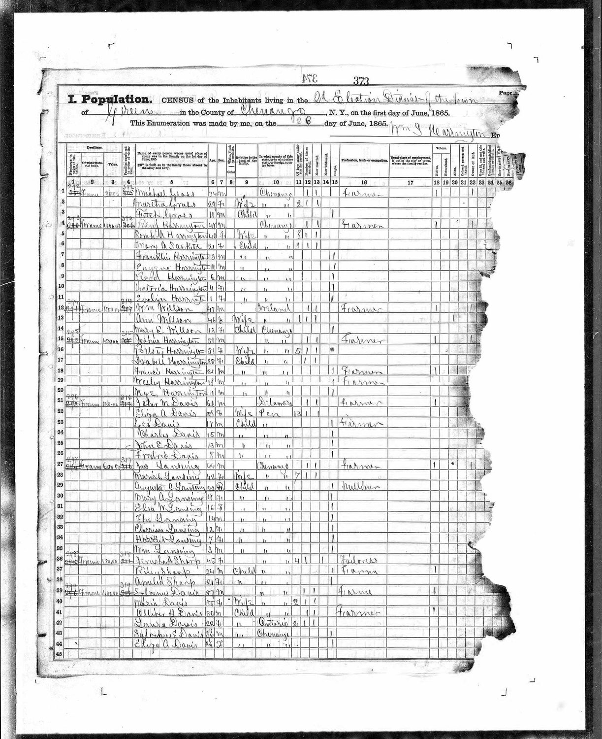
The New York State census of Greene, 26 June 1865: Michael Gross, thirty-four, farmer; Martha, twenty-nine; and Fitch, eleven.

The farm passes on
Fitch B. Gross, born May 1854, married Maria A. Willcox in about 1876 — the family said her name Ma-RYE-ah. She was born in November 1855, the daughter of Charles Willcox, a farmer of the town of Oxford in the same county, and his wife Levina; the census of 1870 finds her there at fourteen with a sister Sophia and a brother Inman. Fitch and Maria had three children and all three lived: Edward N., born March 1880, Mattie L., and Claud C.
By 1900 there were three Gross households in a row on that stretch of Greene — George D., Fitch B. and Cortland M., all farmers, at dwellings fifty-four, fifty-five and fifty-seven. The hill had earned its name.
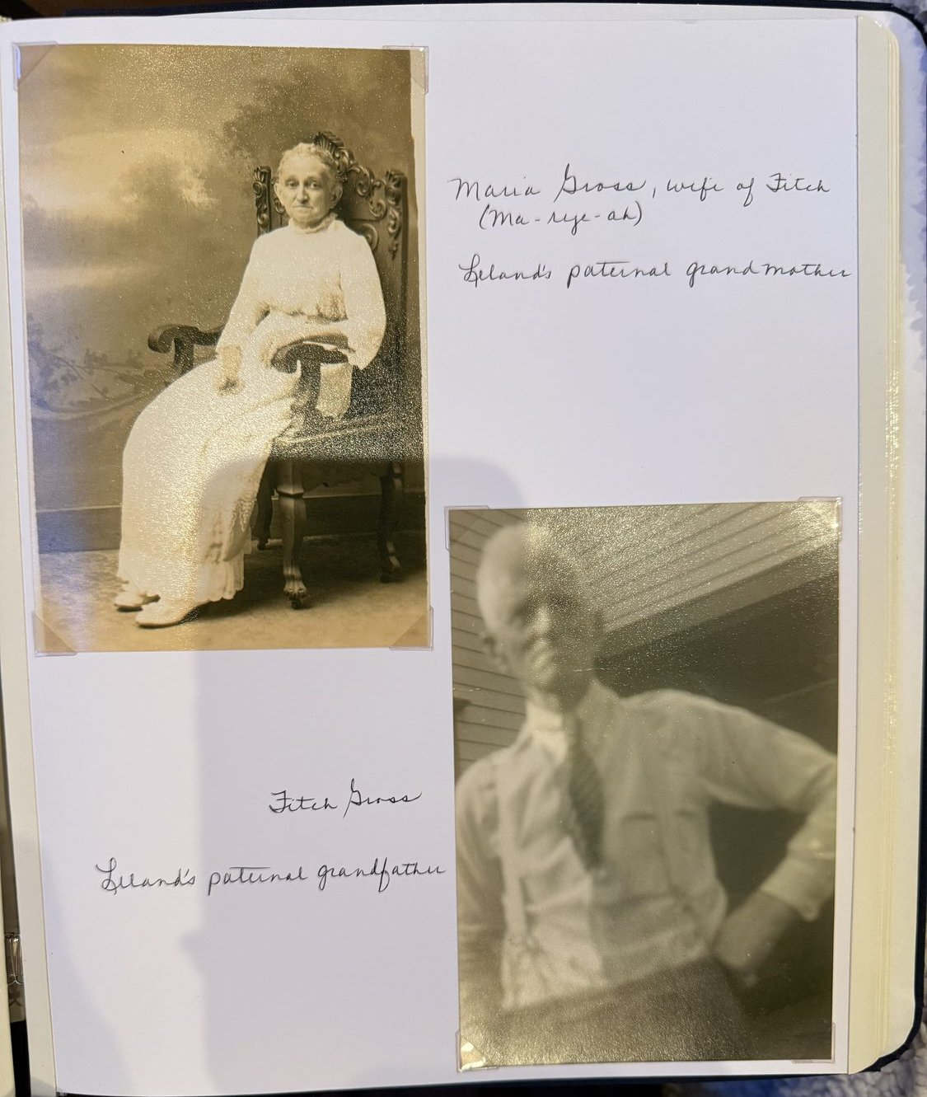
Fitch B. Gross, 1854–1911, and Maria A. Willcox, 1855–1926 — the family said her name Ma-RYE-ah. Leland’s paternal grandparents.
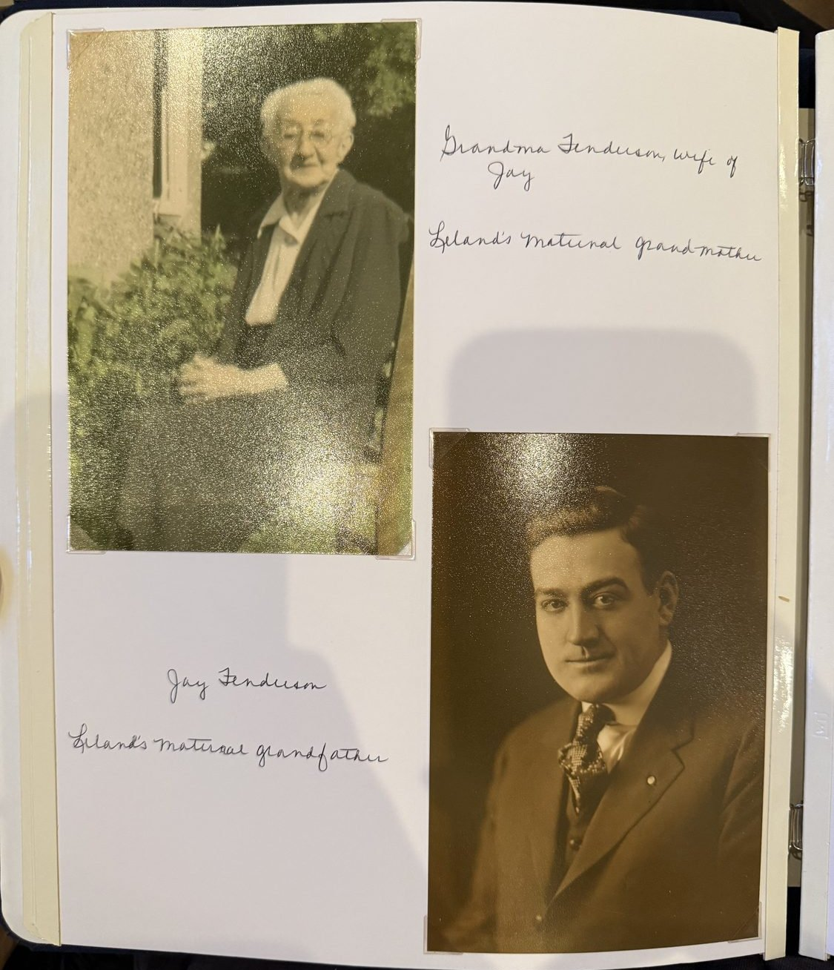
Jay Fenderson, 1863–1936, and his wife — Leland’s maternal grandparents. It is from him that the name Jay descends.
The farm passed to Edward N. Gross, born at Greene in 1880, who married Myrtie Fenderson about 1902. Myrtle, as the records spell her, was born about 1884 in what is now Endicott; the village did not exist under that name until 1906, so she was born in the town of Union, in Broome County, and gave the modern name later.
Edward and Myrtie had at least five children: Edna, Ralph, Leland, Madolyn, and Donald, who died at six. Leland Jay Gross was born on 22 February 1906 in a house on the edge of the farm, at Genegantslet — an Indian name that one nineteenth-century authority glossed as the Three Deer-Lick river and others rendered as Pleasant Stream. Other houses had gone up around it over the years as the family grew. He went to a one-room school, and a photograph survives of it from about 1915, with Leland in the bottom row, his brother Ralph beside him and his sister Edna above.
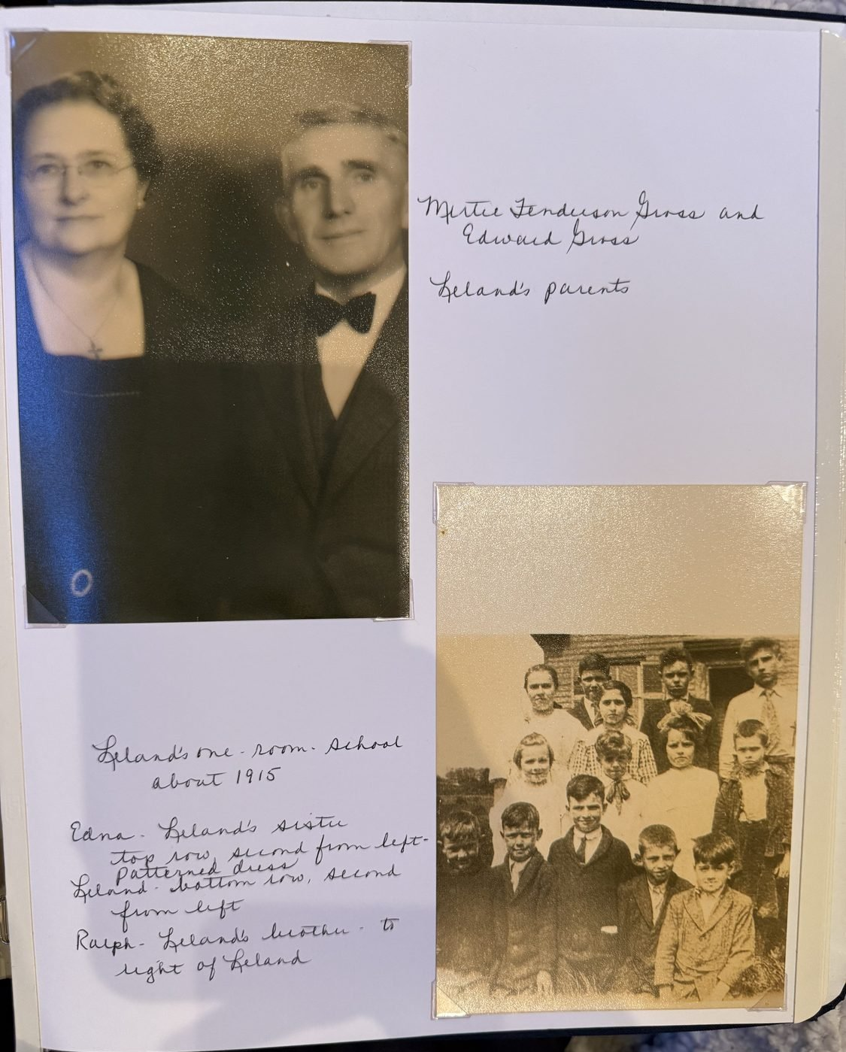
Myrtie Fenderson Gross and Edward Gross, Leland’s parents; and below, the one-room school at Genegantslet about 1915, with Leland in the bottom row, his brother Ralph beside him and his sister Edna above.
Two further photographs of them have since come to light, loose prints rather than album pages, and they are the opposite of that studio portrait. Edward sits on a plank bench with a rail fence and a garden bed behind him, in a cardigan worn open over a sweater and an open-collared shirt, his hair gone white and brushed up, his hands folded on one knee. Myrtie stands out of doors in a floral bib apron over a striped house dress with the sleeves pushed up, laughing at whoever held the camera, a car at her shoulder and the vertical boards of a barn or shed behind her. Neither print is dated and neither is captioned. Both are small snapshots with the deckled white borders the drugstore finishers used from the early nineteen-thirties into the forties; hers has warmed to sepia and his has gone grey.
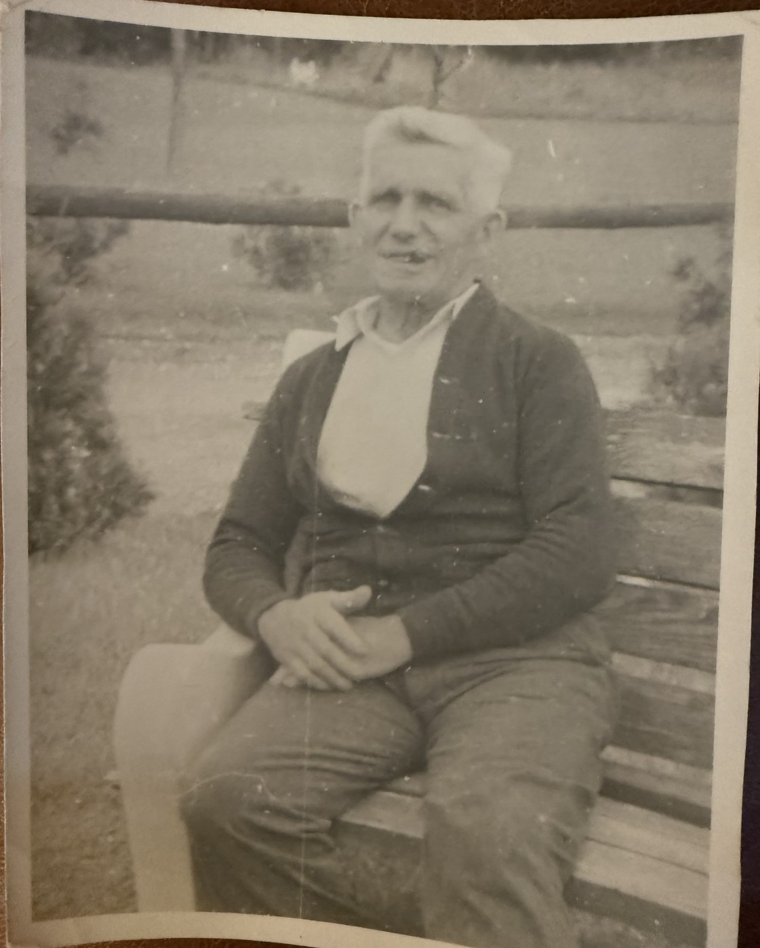
Edward N. Gross, 1880–1941, Leland’s father, on a bench beside a rail fence. A loose snapshot print, undated and uncaptioned.
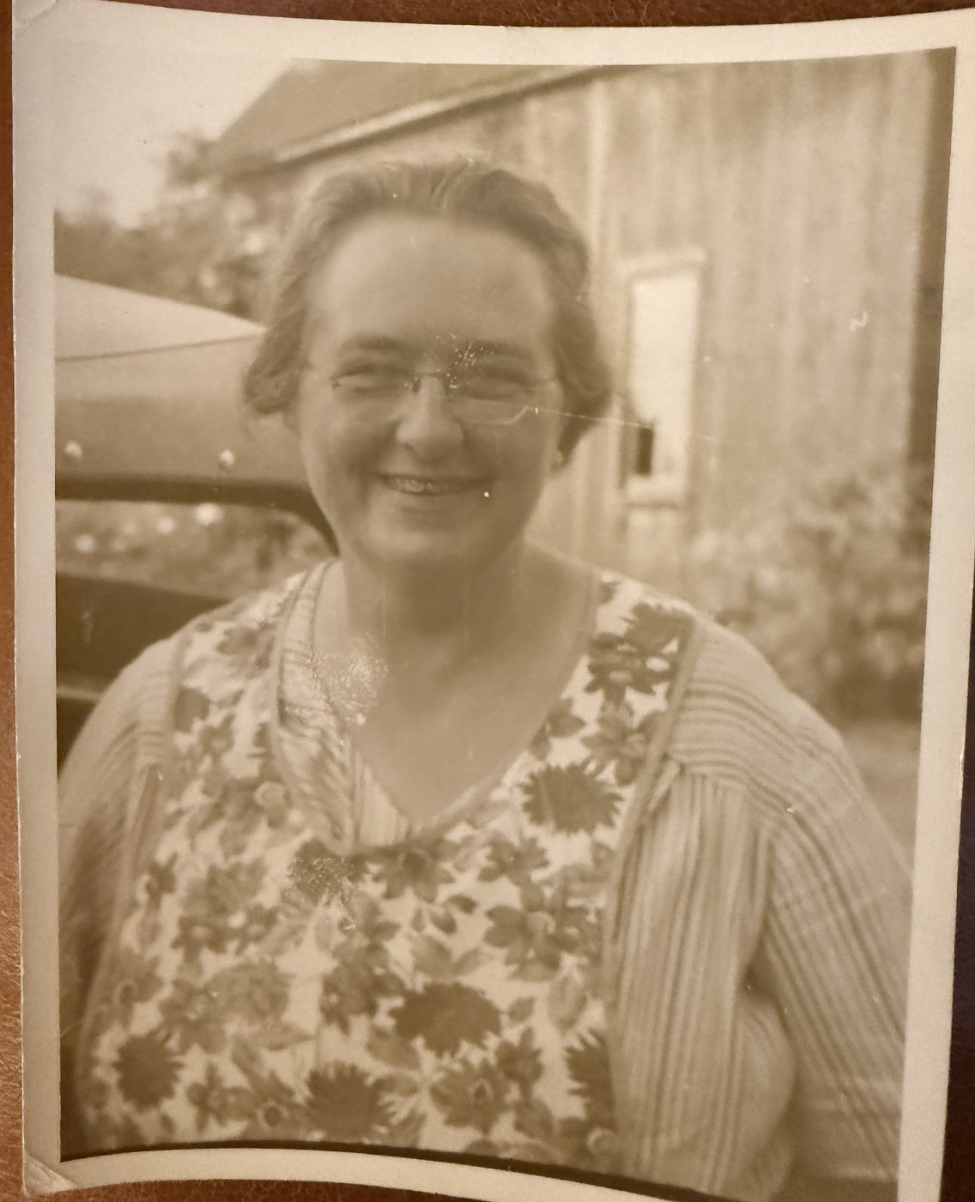
Myrtie Fenderson Gross, 1884–1961, in a bib apron out of doors, a car at her shoulder and the boards of a barn behind her. The spectacles and the swept-back hair are the same as in the studio portrait.
They are the only photographs in this history in which either of them appears alone, and if the setting is the farm at Genegantslet — the fence, the garden and the outbuilding all suggest it is — the only ones taken at home rather than in front of a photographer’s backdrop. Edward was born in March 1880 and died in 1941, so the print of him falls somewhere in his fifties or his sixty-first year.
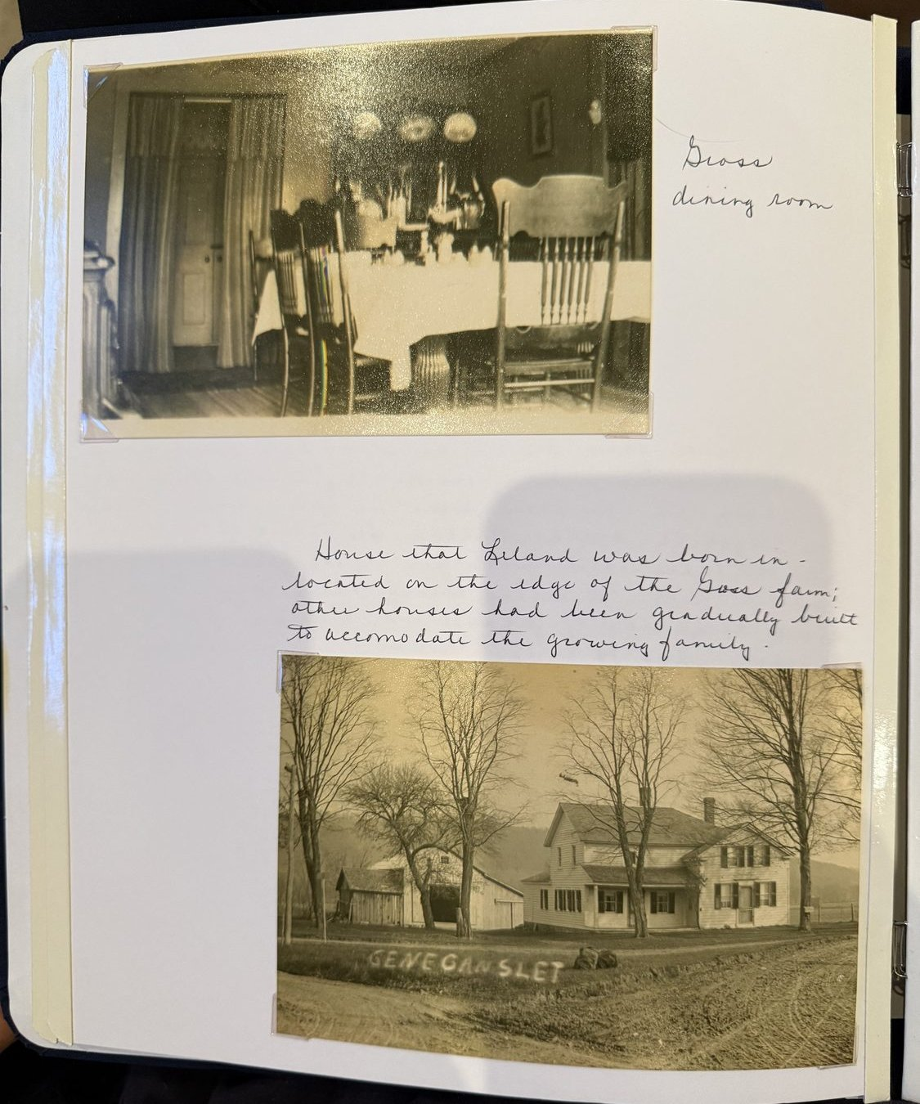
The Gross dining room; and the house at Genegantslet, on the edge of the farm, where Leland was born in 1906.
His middle name was not decoration. Myrtie’s father was John Jay Fenderson, 1863 to 1936, and everyone called him Jay. The name came down from him to his grandson Leland Jay Gross and then to his great-grandson Michael Jay Gross — three generations of a name travelling down the female line and then along the male one.
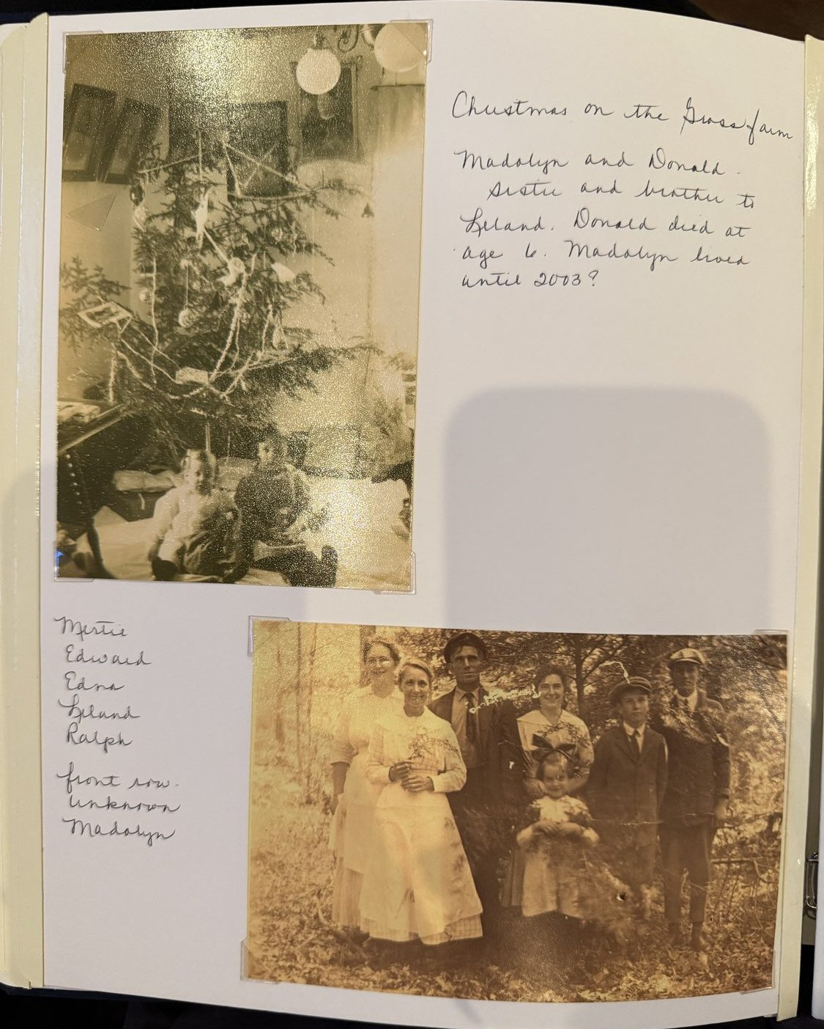
Christmas on the Gross farm: Madolyn and Donald, Leland’s sister and brother. Donald died at six. Below, the family out of doors — Myrtie, Edward, Edna, Leland and Ralph, with Madolyn in front.
In 1941 Leland bought the farm from his mother. He had been driving for Greyhound. Six years later, in 1947, he sold it — a hundred years of Grosses on that hillside ended in the year your father was born — and with the proceeds he and Margaret bought a house at 16 Willard Street in the village of Greene.

4. The Butts Family, and What Raymond Did
The other half of that generation came from fifteen miles away and had a harder story.
Raymond M. Butts and Cora M. Lounsbury were both born at Chenango Forks, in Broome County, in 1887 and 1884. Raymond was one of a large family; his brothers and sisters included Mary, Serena, Esther, Leslie, May and Florence. He and Cora married and had two daughters: Marlea, and then Margaret, born at Oakland, California, on 1 June 1919.
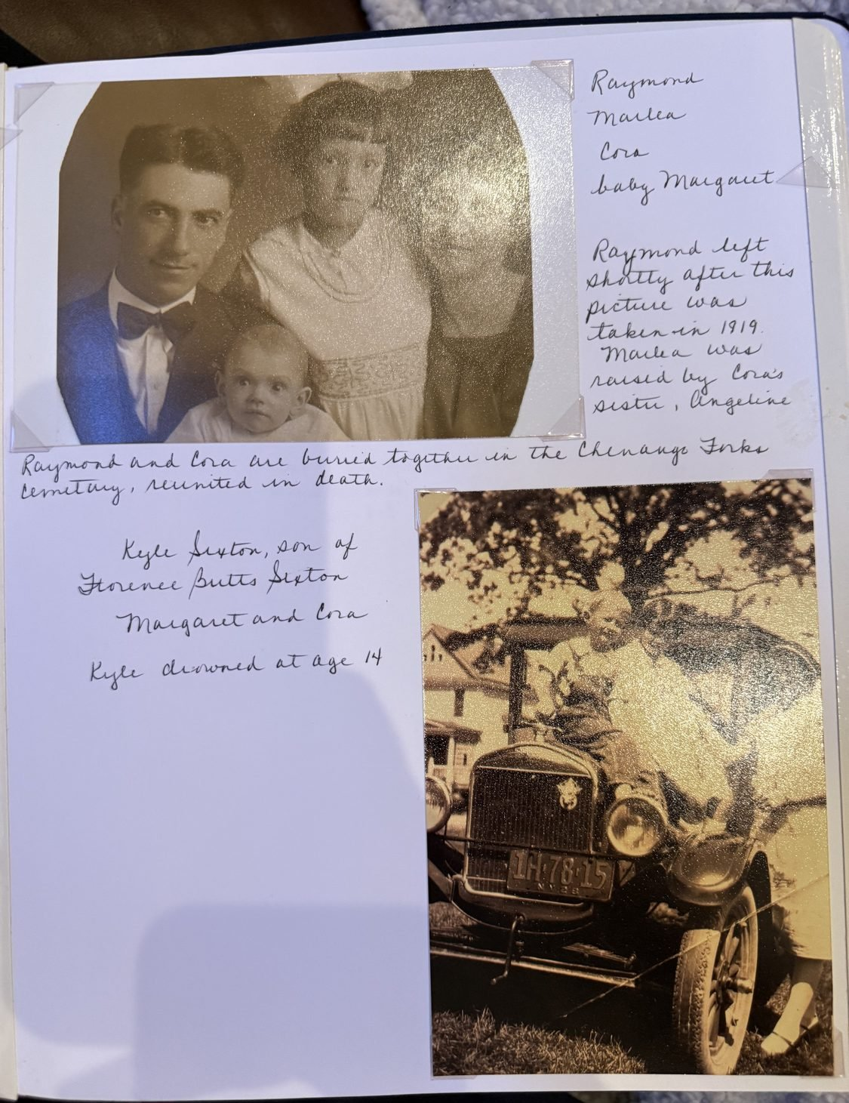
Raymond, Marlea, Cora and the baby Margaret, 1919. Raymond left shortly after it was taken.
There is a photograph taken that year: Raymond in a bow tie, Cora beside him, Marlea between them, the baby Margaret on her mother’s lap. Raymond left shortly after it was taken. His younger daughter was a few months old.
What happened to the three of them afterwards has to be pieced together. Marlea was raised by Cora’s sister Angeline. Cora died in 1929, when Margaret was ten. By November 1941, when Margaret swore her marriage application in Pennsylvania, she was living alone in Schenectady, working as a bookkeeper, and she recorded both her parents as dead.
Whether that was true of her father is another matter. There was, at some point, a reunion: Raymond came back and met Marlea and Margaret again. Of his own brothers and sisters, only Serena was willing to see him. Esther and Leslie had died by then; May and Florence refused. A photograph survives from that visit — six of them along the front of a clapboard house, Raymond in shirtsleeves and braces near the middle, Leland standing beside him.
And now the dates arrive, and they change the story. Raymond was born in 1888 and died in 1954. He was alive in November 1941. Margaret, swearing an application for a marriage licence in a Pennsylvania courthouse at twenty-two, wrote down that her father was dead — and he had another thirteen years to live.
It is impossible to know now whether she believed it, or had been told it, or simply said the thing that was true in every sense that mattered to her. A man who walks out on a baby and comes back decades later is not owed a place on a form. It was a daughter’s answer to a question about a man who had left.
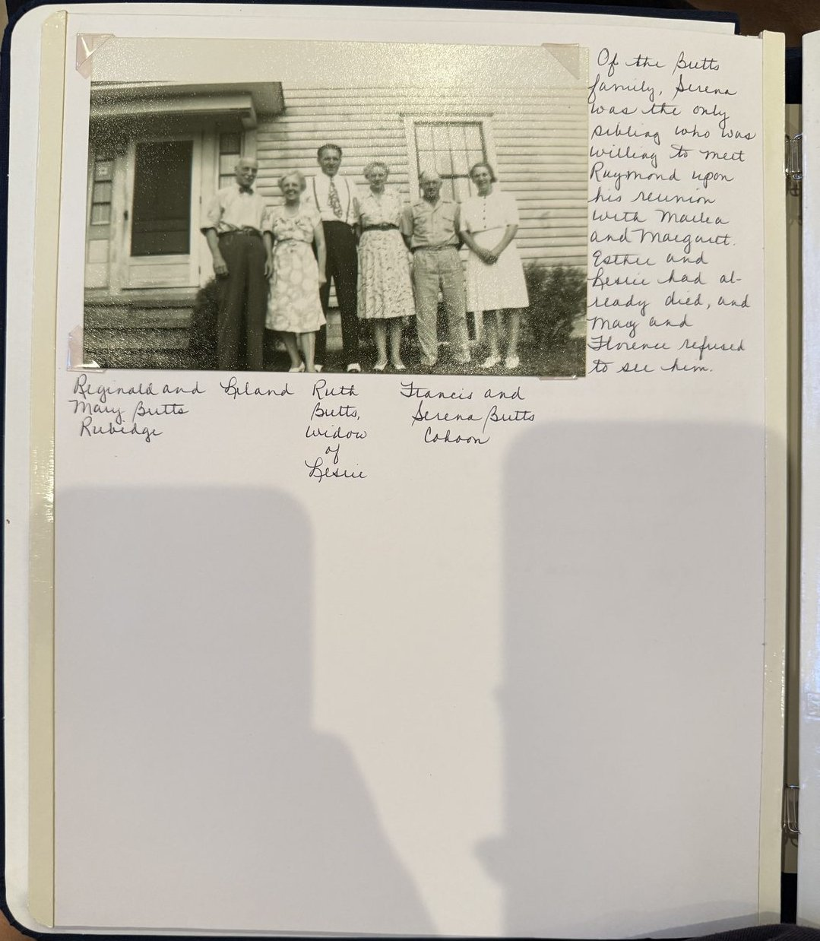
The reunion. Reginald and Mary Butts Rubidge; Leland; Ruth Butts, widow of Leslie; Francis and Serena Butts Cahoon. Of Raymond’s six brothers and sisters, only Serena would meet him.
And the last line of the family’s account of him is still the one worth keeping. Raymond died in 1954, twenty-five years after Cora, and they are buried together in the Chenango Forks cemetery. Reunited in death.

The Philippines
The family says Raymond was a soldier, and that he served in the Philippines. It cannot have been the Spanish-American War: he was born in 1888 and was ten years old in 1898. But an army posting explains something this history has otherwise had to leave as coincidence — why a family from Chenango Forks was in California at all.
San Francisco was the army’s gateway to the Pacific from 1898 onward. Every soldier going out to the Philippines or coming home again passed through the bay: the general depot on the San Francisco waterfront, later Fort Mason, with the discharge and quarantine station at Fort McDowell on Angel Island. A man from the Chenango valley who served a Philippine tour would have shipped out from San Francisco and been discharged there, and the far side of that bay is Oakland.
The timing fits too. Marlea was born about 1912 and Margaret in June 1919, and a gap of that length between two children is the shape an overseas posting leaves. There are two periods it could have been. The United States kept permanent garrisons in the Philippines from 1898, and the Philippine Department, formed in 1911, ran to some thirty thousand men; a three-year enlistment taken up about 1907 or 1912 would fit a man born in 1888. During the war itself the American presence was thinner — the only all-American garrison unit, the 31st Infantry, was sent to Siberia in 1918, and most of the remaining force under United States command was Filipino.
One document would settle it. Raymond, born in 1888, falls squarely inside the first draft registration of 5 June 1917, which took men aged twenty-one to thirty-one. That card asks twelve questions, and one of them is what previous military service the registrant has had — rank, branch, years, nation or state. It also records where he was living that June, which would say whether the family was already in California two years before Margaret was born.

Margaret
There is a high school yearbook photograph of her. Margaret E. Butts, hair set, dark collar, looking straight out of the page, and beside it the line the class chose for her: A merry heart maketh a cheerful countenance. Under it, her activities — Choir, Glee Club, T.O.P., Class Leader, Le Cercle Français, Mary Lyon, song leader, Class Play Committee.
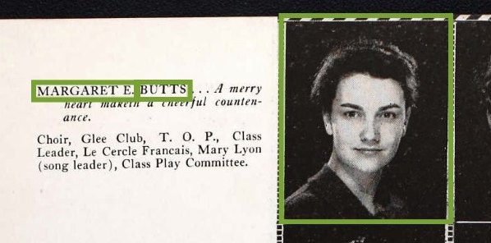
Margaret E. Butts in her high school yearbook: A merry heart maketh a cheerful countenance. Choir, Glee Club, T.O.P., Class Leader, Le Cercle Français, Mary Lyon song leader, Class Play Committee.
She would have been seventeen or eighteen. Her father had walked out when she was a few months old and her mother had been dead for seven years, and the sentence the yearbook picked for her was about a merry heart. Whether that was accurate or kind or both, it is the only description of her character that survives from her own lifetime.
It also tells us something the records had missed. She was singing in a school glee club and leading her class somewhere in the east, not in Oakland — and if the school was at Schenectady, where she was living when she married, then she came east as a child rather than as a young woman, and the family’s return from California happened long before 1941. Which school it was, and who she was living with, are now the sharpest open questions about her.
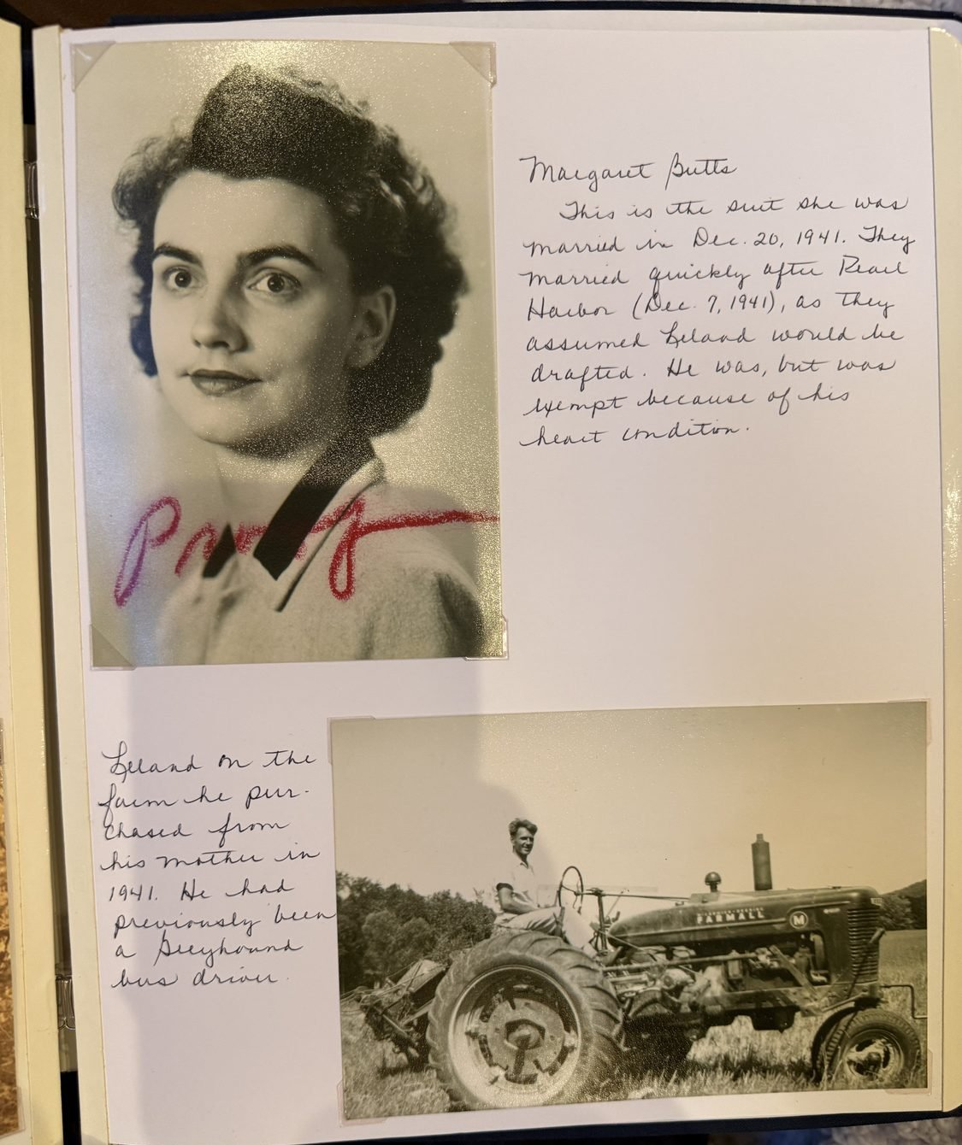
Margaret Butts in the suit she was married in; and Leland on the farm he bought from his mother in 1941, having driven for Greyhound before it.

And afterwards
The bookkeeper of 1941 became a mortgage officer at the Marine Midland Bank in Binghamton, and retired from it. She and Leland lived at Greene until 1974 — the house at 16 Willard Street, bought with the money from the farm — and were, the obituary says, involved in many community activities. She was a member of the United Church of Christ of Greene. After Leland died in 1976 she moved down to Binghamton, to 559 Chenango Street.
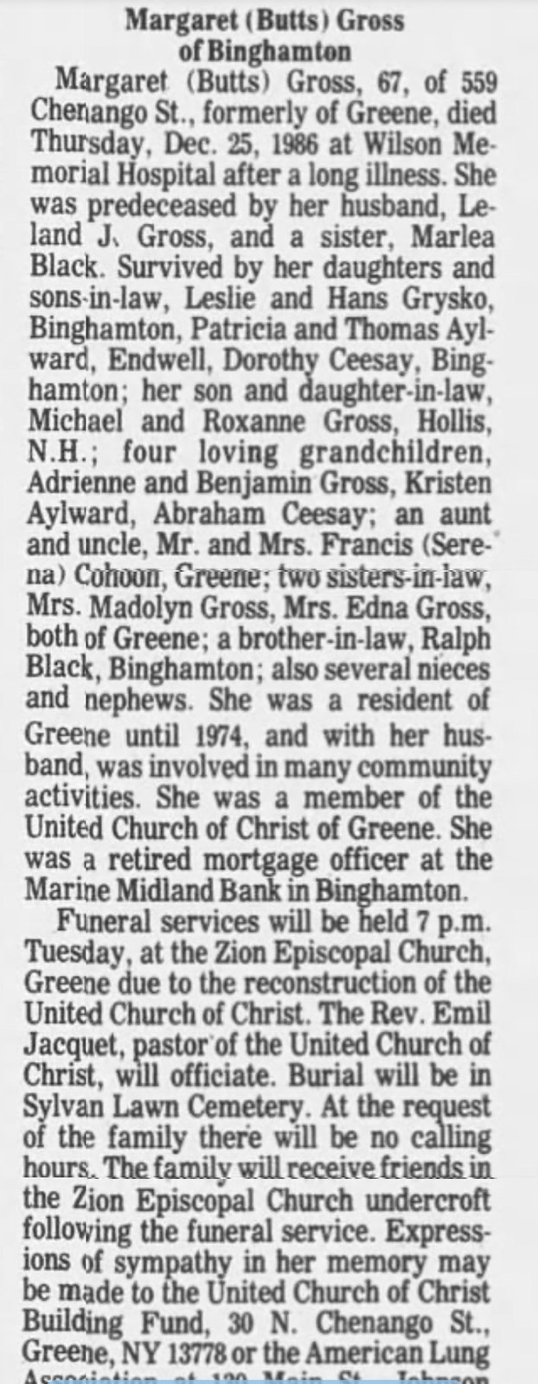
Margaret (Butts) Gross of Binghamton, formerly of Greene, died Christmas Day 1986. Her sister Marlea Black had gone before her; among the mourners were her aunt and uncle, Francis and Serena Cohoon of Greene.
She died on Christmas Day 1986, a Thursday, at Wilson Memorial Hospital in Johnson City, after a long illness. She was sixty-seven and had outlived her husband by ten years. Because the United Church of Christ was being rebuilt, the funeral was held at Zion Episcopal Church in Greene, with her own pastor officiating; at the family’s request there were no calling hours, and they received friends in the church undercroft afterwards. She is buried at Sylvan Lawn Cemetery, on the corner of Juliand Street and Route 206, east of the village.
Her obituary closes two threads at once. Her sister was by then Marlea Black, and had died before her; Marlea’s husband Ralph survived them both, in Binghamton. So the little girl who was handed to her aunt Angeline in 1919 grew up, married, and lived out her life twenty miles from where she was born.
And among the mourners: an aunt and uncle, Mr. and Mrs. Francis Cohoon of Greene. Serena. The one of Raymond’s six brothers and sisters who had been willing to see him when he came back — still there, decades later, still counted as family by the daughter he left.
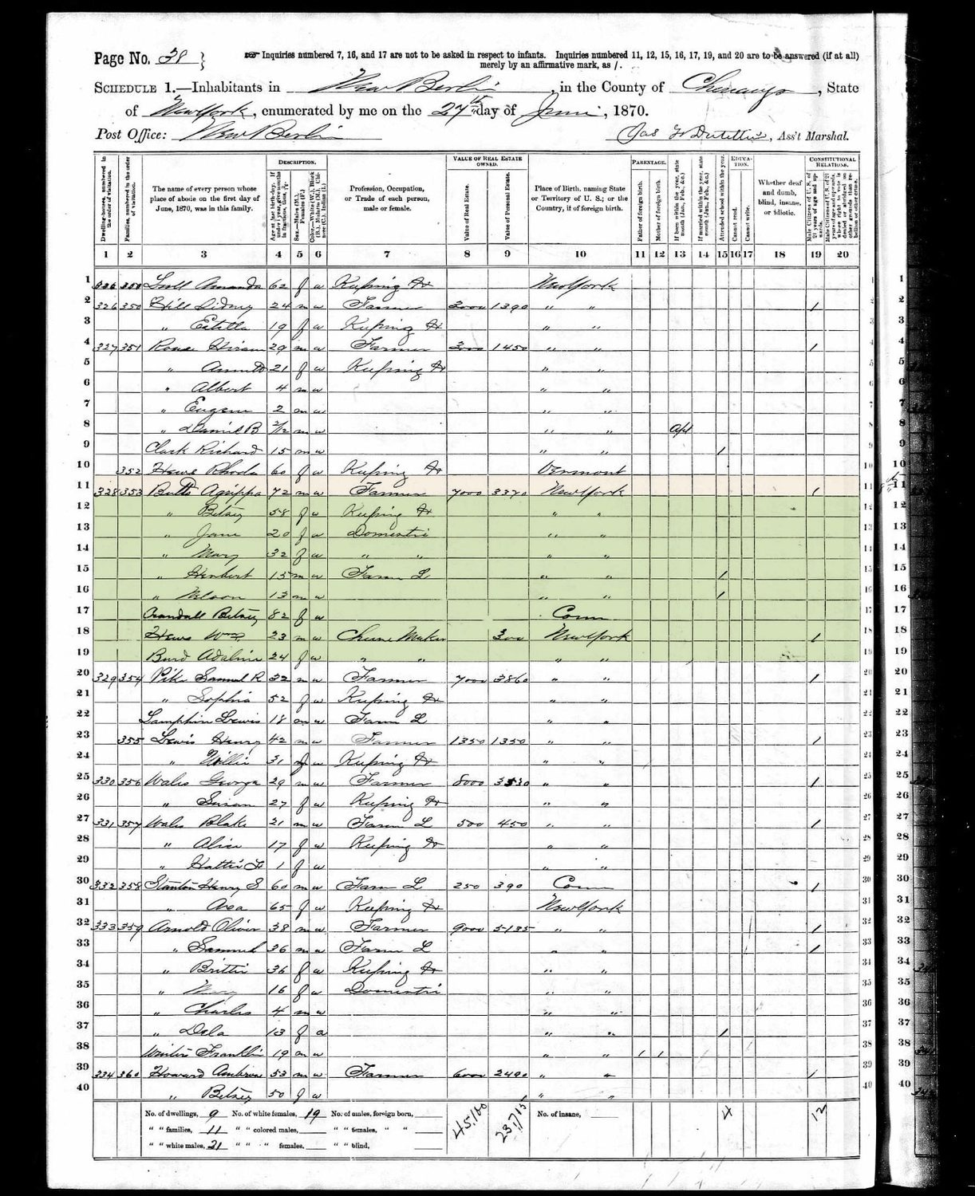
The 1870 census of New Berlin: Agrippa Butts, seventy-two, and his wife Betsey; their son Nelson, thirteen; and Betsey Crandall, eighty-two, born in Connecticut — Nelson’s grandmother, living in the house.

The Crandalls behind the Butts
One initial in that family turns out to be a doorway. Raymond’s father was Nelson C. Butts, 1857 to 1929 — and the C stands for Crandall. His mother was Betsey M. Crandall, 1812 to 1887, and he carried her maiden name as his middle name, which is exactly the pattern this family kept doing and which Chapter 11 sets out.
The 1870 census of New Berlin, in Chenango County, shows the whole arrangement in one household. Agrippa Butts, seventy-two, farmer, with seven thousand dollars in real estate and rather more than three thousand in personal. His wife Betsey, fifty-eight. Their children Mary, Jane, Herbert, and Nelson, thirteen. And, living with them, Betsey Crandall, aged eighty-two, born in Connecticut — Betsey’s own mother, and the widow of Lodowick Crandall, who had died in 1847.
So Nelson grew up in a house with his Crandall grandmother in it, born in Connecticut before the Revolution was twenty years past, and when he came to name a son of his own he used her family’s name. Agrippa Butts, born about 1798, is Generation VI on that line, and a name worth keeping.
Behind Betsey the Crandalls run back through Lodowick Crandall, 1775 to 1847, Ezekiel Crandall, 1746 to 1838, James W. Crandall, 1719 to 1778, John Crandall, 1682 to 1767, and Samuel Crandall, 1661 to 1737, to Elder John Crandall of Westerly, Rhode Island, who died in 1676. The join at Betsey still wants proving from a record, but Crandall descents are unusually well studied, and at the top of that line stands a genuinely remarkable man.

Elder John Crandall
He was baptised at Westerleigh in Gloucestershire on 15 February 1616 or 1617, the son of James Crandall, a yeoman of Kendleshire, and his first wife Eleanor. He came to New England by 1643 and appears as a juror at Newport that September.
On 21 July 1651 he was arrested at Lynn, in Massachusetts, for holding a Baptist service in a private house. He was taken to Boston, imprisoned, fined, and publicly whipped for it. He went to Rhode Island, where such things were permitted, and became one of the founding settlers of Westerly and its first elder and preacher.
The rest of his life reads like the frontier it was. Freeman in 1655. In 1669 the governor of Connecticut wrote complaining that he and others had appropriated land belonging to Stonington; he and Tobias Saunders answered for the Westerly people. Conservator of the peace at Westerly in 1670, deputy to the general assembly in 1670 and 1671. On 2 May 1671 the Connecticut authorities seized him and carried him off to New London for trial in the boundary dispute; Rhode Island advised him to refuse bond and promised to defend him and pay his costs. He moved back to Newport during King Philip’s War and died there on 29 November 1676. Some accounts say the cause was an infection from wounds taken at the Great Swamp Fight the previous December.
His first wife’s name is not known; she died in 1670 and was buried at Westerly. His second was Hannah Gaylord. Between them they gave him nine children, and one of them, Samuel, is the link in this chain.

One line to leave out
Some trees give Elder John Crandall’s mother as an Elizabeth Drake, daughter of Sir Captain John Drake, and derive from her a distant cousinhood with Oliver Wolcott, a signer of the Declaration of Independence. That parentage comes from John Cortland Crandall’s Crandall genealogy and is undocumented. It has been superseded: Paul Gifford’s article in RI Roots, the journal of the Rhode Island Genealogical Society, for December 2006 documents Elder John’s baptism at Westerleigh to James and Eleanor Crandall, with several earlier Crandall generations behind them. Elizabeth Drake does not belong in this family, and the Wolcott connection goes with her.
The family had its other griefs. Florence’s son Kyle Sexton drowned at fourteen. Donald Gross died at six. These are the ordinary catastrophes of a farming county in the first half of the twentieth century, and they are the reason a family history that lists only births and marriages tells you almost nothing.

5. The Eys of Rochester
Your mother’s father’s line begins with two people born in Germany whose names this document does not yet have. They emigrated, settled in Pennsylvania, and there in 1878 their son Herman was born.
A census page has now narrowed both halves of that. The 1880 census of the first ward of Erie, Pennsylvania, records a machinist and his wife, both born in Prussia, with children born in Pennsylvania — daughters at school, and a son Herman, an infant. So the immigrants were Prussian, and they settled at Erie, on the lake. Their names are on that sheet, and they are the two names this history has been missing longest.
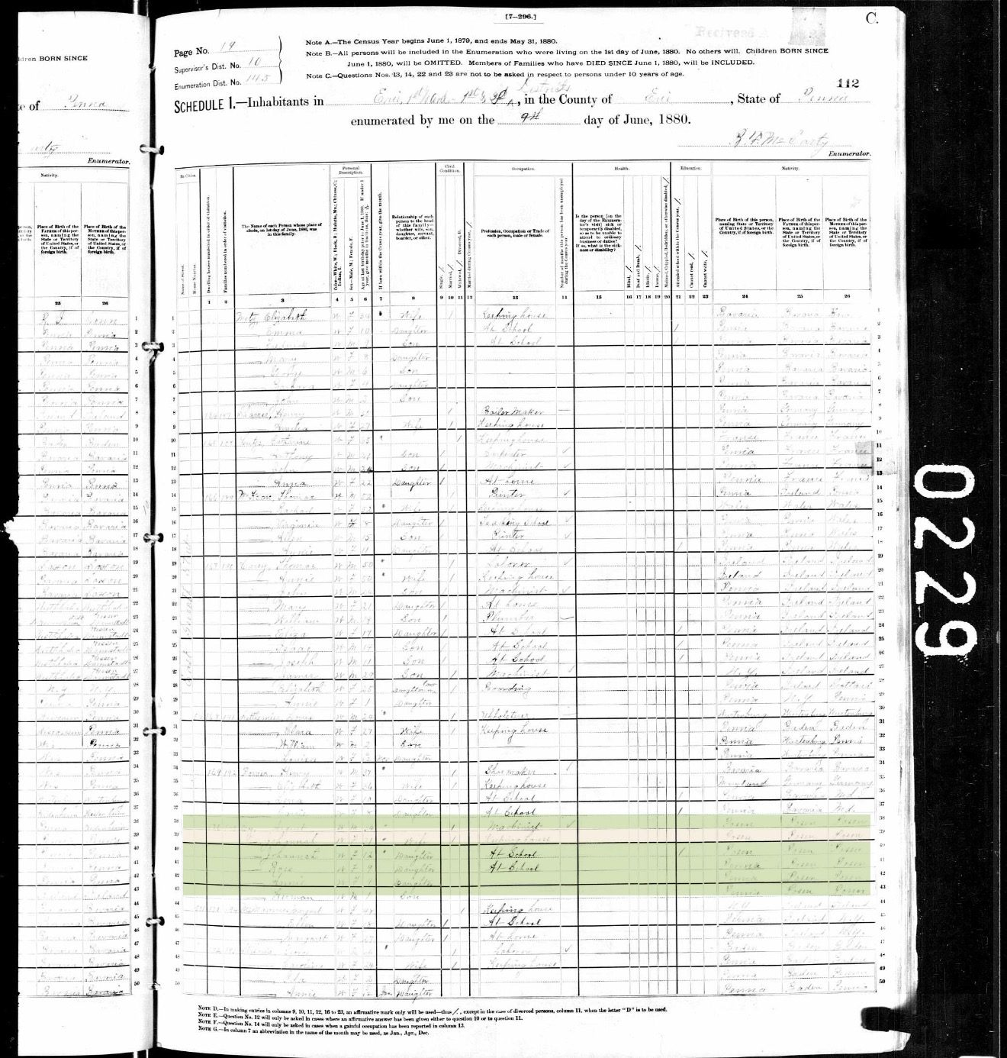
The 1880 census of the first ward of Erie, Pennsylvania: a machinist and his wife, both born in Prussia, with children born in Pennsylvania — among them an infant son, Herman.
The surname is worth pausing on. Ey is one of the rarest in the United States — roughly four hundred bearers in the whole country in the 2020 census, ranking about fifty-five thousandth. It is German, most probably a topographic name from the Middle High German for a river meadow, and it occurs in the Rhineland. The rarity has been the single most useful fact in this whole project: with a name this uncommon, effectively every Ey in a New York record is a relative.
Herman came north to Rochester and married Clara Nettie Goldsmith, whose father was a New Yorker and whose mother had been born in England. They had nine children.
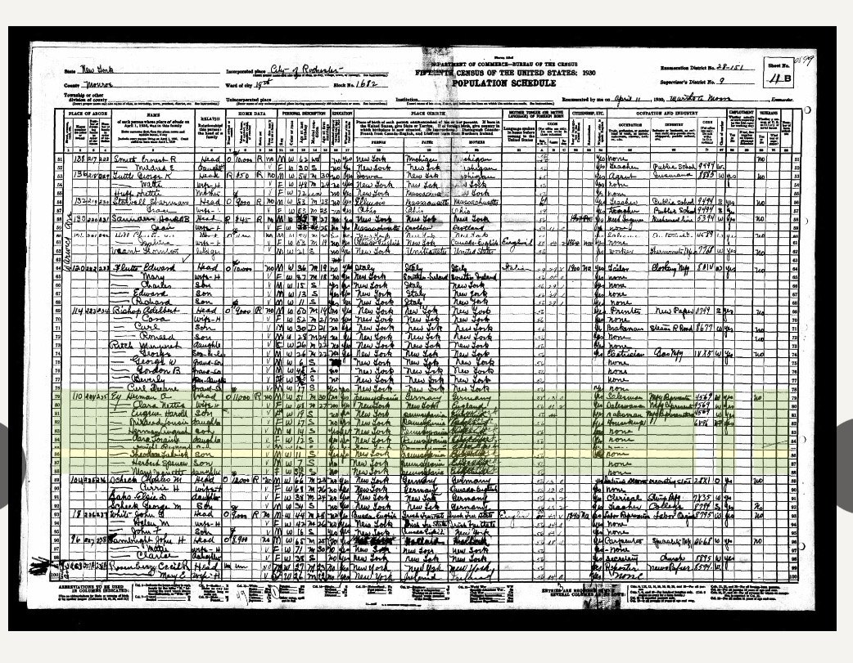

The page in the family hand
A sheet of ruled loose-leaf headed Ey Genealogy gives what no census page could. Herman August Ey, of Erie, Pennsylvania, 21 September 1877 to 5 October 1937. Clara Nettie Goldsmith Ey, 24 July 1880 to July 1948. And in the left margin, turned sideways and easy to miss: married Oct 21, 1908.
That date corrects this history. It puts Herman at thirty-one at his wedding and Clara at twenty-eight, and it fits the birth of the eldest child in May 1910, which the about 1899 previously worked back from the 1930 census does not. Either the enumerator wrote the ages down wrong, or one of them was answering about an earlier marriage.
Then the children, nine of them, with dates:
- Eugene Harold, 24 May 1910. Louise is written beside his name.
- Mildred Louise, 3 June 1912. Brown, by marriage.
- Winifred Eleanor, 4 October 1913 — 7 January 1929.
- Herman August, 8 July 1915.
- Dwight Raymond, 26 July 1917 — 16 March 1974.
- Clara Lorraine, 26 July 1917 — 27 April 1977. Smith, by marriage.
- Theodore Frederick, 5 January 1919 — 9 June 1976.
- Spencer Herbert, 26 March 1923.
- Mary Jeanette, 17 May 1926. Short, by marriage.
Dwight Raymond and Clara Lorraine share a birthday to the day, 26 July 1917: they were twins, which no record in this history had shown. And Winifred Eleanor died on 7 January 1929, at fifteen.
Winifred’ death is what proves the page. The 1930 enumerator counted eight children in that house. Nine children born, less one who had died fourteen months earlier, is eight. The family page and the census sheet lock together.
The page also repairs the names. The census gave Harmon Eugene, Clara Frances, Donald Bernard, Herbert Spencer and Mildred Anna; the family gives Herman August, Clara Lorraine, Dwight Raymond, Spencer Herbert and Mildred Louise. Five of the eight had been written down wrong, which is what happens when a stranger at the door takes nine names by ear. Where the two disagree, prefer the family page.
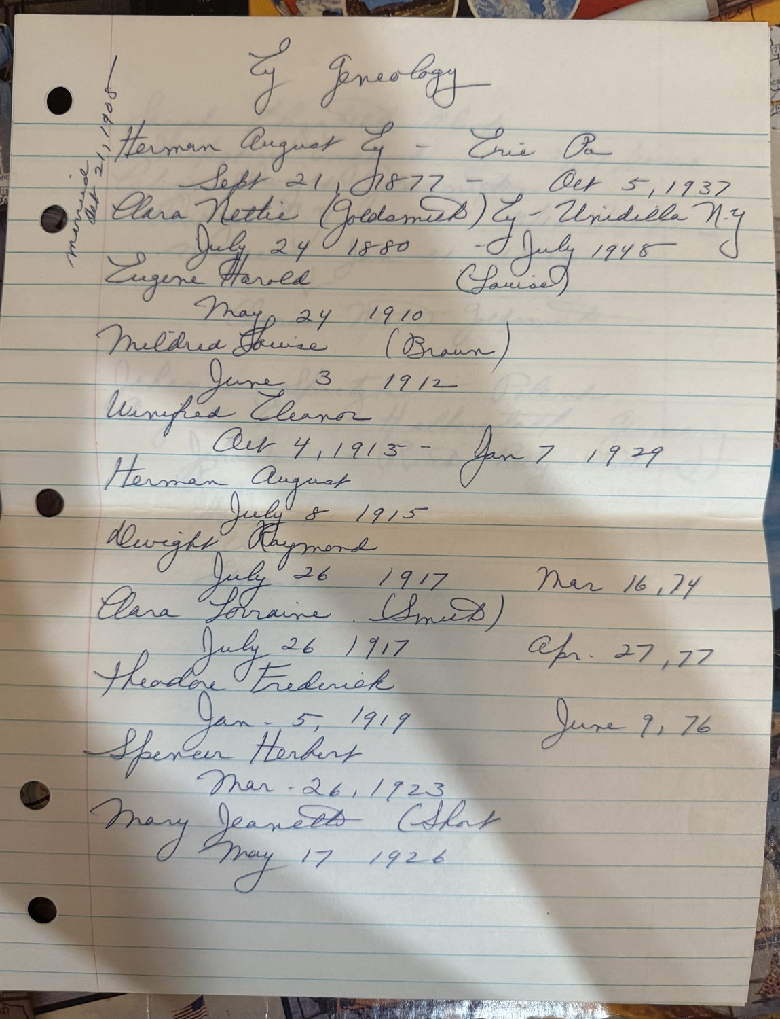
Ey Genealogy, in a family hand. Herman August Ey of Erie, Pennsylvania, 1877–1937; Clara Nettie Goldsmith of Unadilla, 1880–1948; married, in the left margin, 21 October 1908; and their nine children with dates.

The immigrants, named
A second sheet names them. August Ey, of Halberstadt, Germany, and Johanna Spritzke. Their children are listed as Johanna, Rose, Herman, Anna and Edward.
This history has been carrying the missing names of the two Germans who began the Ey line as an open question since the first edition, and that question is now closed. Halberstadt is in the Harz foothills in Saxony-Anhalt — well east of the Rhineland where the surname is said to cluster, which is worth knowing when the emigration record is looked for. The sheet writes Poland beside Johanna Spritzke’s name, while the ancestral-tree chart gives her Halberstadt like her husband. Spritzke is a name of the German-Polish borderlands, so both can be true of a life; they cannot both be true of a birthplace.
The same sheet opens the Goldsmith side, which had been nothing but a line in a census. Calvin Dwight Goldsmith, born at Owego, New York, 18 March 1842. Sarah Elizabeth Alsop, born in Shropshire, England, 24 May 1843. Married 31 January 1866. An arrow runs from the pair down to their daughter Clara Nettie Goldsmith. So the English mother the 1930 enumerator recorded has a name, a county and a wedding date, and Owego puts the Goldsmiths in Tioga County — twenty miles from where Myrtie Fenderson was born, on the other side of the family entirely.
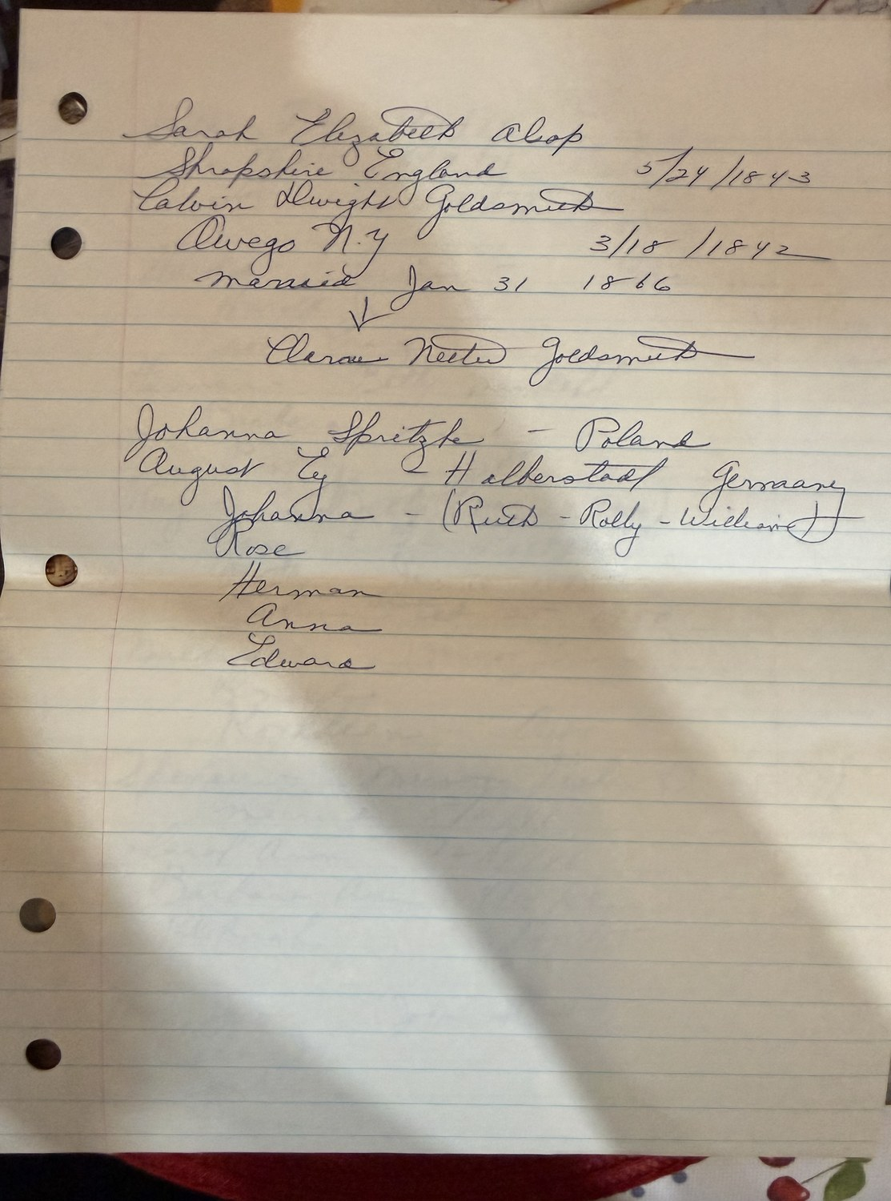
The immigrants named: August Ey of Halberstadt and Johanna Spritzke, with their five children; and above, Calvin Dwight Goldsmith of Owego and Sarah Elizabeth Alsop of Shropshire, married 31 January 1866, with an arrow to their daughter Clara Nettie.

The deaths page
A third sheet is a working list of the next generation, headed by three deaths — Ray, 16 March 1974; Ted, 9 June 1976; Lorraine, 27 April 1977. Ted is Theodore, and 9 June 1976 is the date the Phoenix obituary and the government marker both give. Three independent records now agree on it.
Below that the sheet runs through the brothers and sisters and their families, and it records Spencer’s marriage to Marion Fisher on 2 May 1946. Those are living cousins and their children, and this history records them only as the family recorded them.
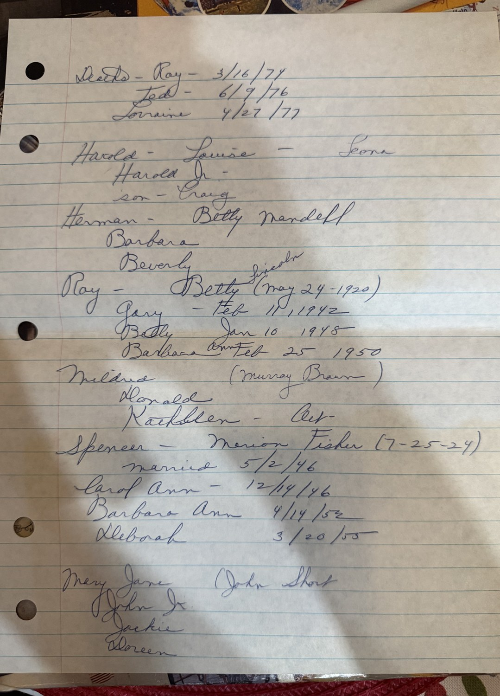
The deaths page: Ray, Ted and Lorraine at the top, and below them the households of Theodore’s brothers and sisters.
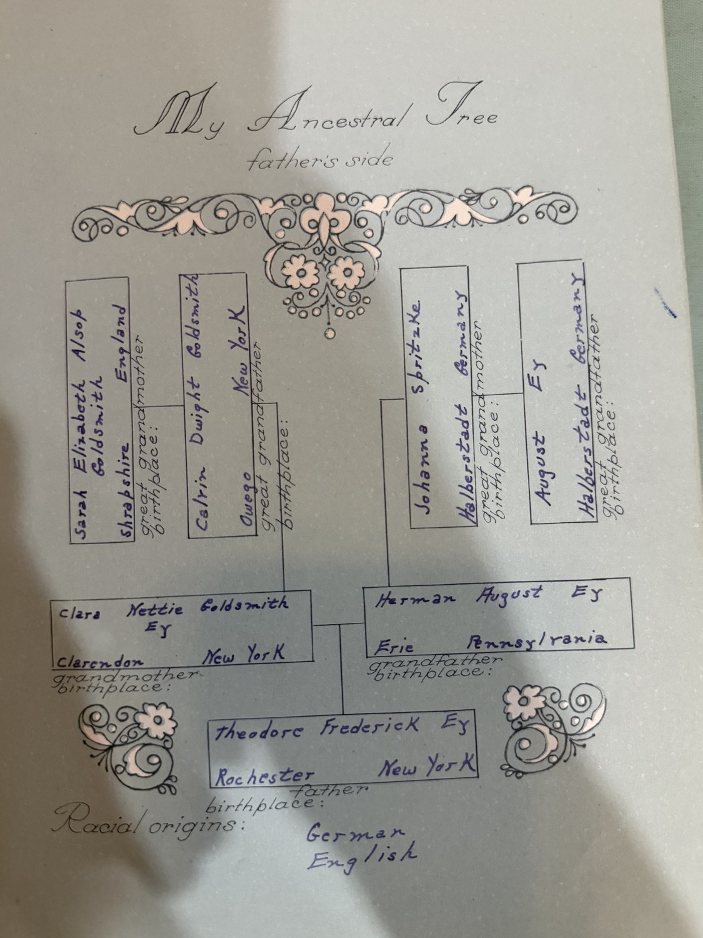
My Ancestral Tree, father’s side — a school chart of Theodore’s ancestry, giving Clarendon for Clara Nettie’s birthplace where the family page gives Unadilla.
Rochester, Ward 16, 11 April 1930: Herman Ey, salesman, born Pennsylvania of German parents; Clara Nettie, born New York of an English mother; and eight children, Theodore among them.
The census enumerator found them on 11 April 1930 in the sixteenth ward, and the picture is a comfortable one. They owned their house, valued at eleven thousand dollars — a substantial sum six months into the Depression — and they had a radio. Herman was working as a salesman; Clara was working too; the eldest son at home, Eugene Harold, eighteen, was a bookkeeper. Eight children were under that roof: Eugene, Mildred Anna, Harmon Eugene, Clara Frances, Donald Bernard, Theodore Fredrick, Herbert Spencer and Mary Jeanette. Theodore, about ten, was somewhere in the middle of them.
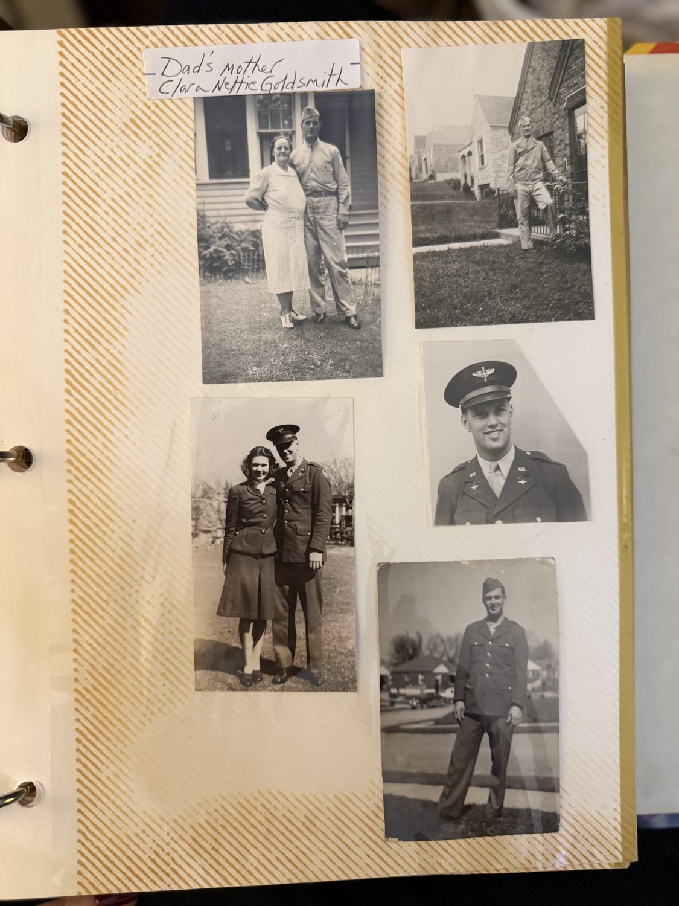
Clara Nettie Goldsmith with a son in uniform, and other young Eys of the war years. From Marty Ey’s album.
Herman died in 1937, when Theodore was seventeen or eighteen. Clara outlived him by eleven years and died in 1948, the year after her granddaughter Roxanne was born.
Two connections fall out of setting the new papers against what was already here.
The first is at Owego. Calvin Dwight Goldsmith was born there in March 1842, and this history already records documented Fendersons at Owego by 1841. So in the same small Tioga County village, in the same two years, stood a family that would become your mother’s line and a family that would become your father’s. They were a hundred and twenty-six years and four generations from meeting. The 1850 census of Owego would show whether both households were still there together, and it is one of the cheapest checks in this whole book.
The second is in Rochester. The 1938 newspaper story lists Clarence Rankin’s lodge as Germania — a German lodge in a heavily German city — and his wife’s father, we now know, was Bernard Neth, born in Germany. A man of Scots-Canadian descent in a German lodge makes better sense once you know whose family he had married into. It is a connection, not a proof, and the lodge’s membership records would settle it.

And the Rankins, at last
The Rankins have been the emptiest branch in this tree — a grandmother with no maiden name, a grandfather who disappears after a newspaper story in 1938, and nothing at all behind either of them. Two sheets have now filled four generations of it.
Her name was Neth. Gertrude Emma Neth, born at Rochester, married to Clarence Rufus Rankin, also born at Rochester. A medical-history chart drawn up in 1976 gives her death as August 1947 at forty-eight, of uterine cancer, and his as 1963 at sixty-four, of a second heart attack. The New York State death index confirms her independently: Gertrude Rankin died on 28 August 1947 at Rochester, aged forty-eight, certificate number 48114.
Her age settles his story too. Dead at sixty-four in 1963 puts Clarence’s birth about 1899, which makes him thirty-nine or forty in 1938 — exactly the age the newspapers gave the funeral director who sold his business to sail round the world. And Virginia was twenty-six when her mother died, and had lost her by the time her own daughters were born.
Behind Gertrude stand Bernard Neth, born in Germany, and Anna Frederica Hartman, born at Rochester. The 1976 chart gives Bernard cancer of the prostate about 1940, at seventy-nine as the writer thought, and Anna old age in 1964 at ninety-eight. If both figures hold, Anna Hartman Neth was born about 1866 and outlived her daughter by seventeen years.
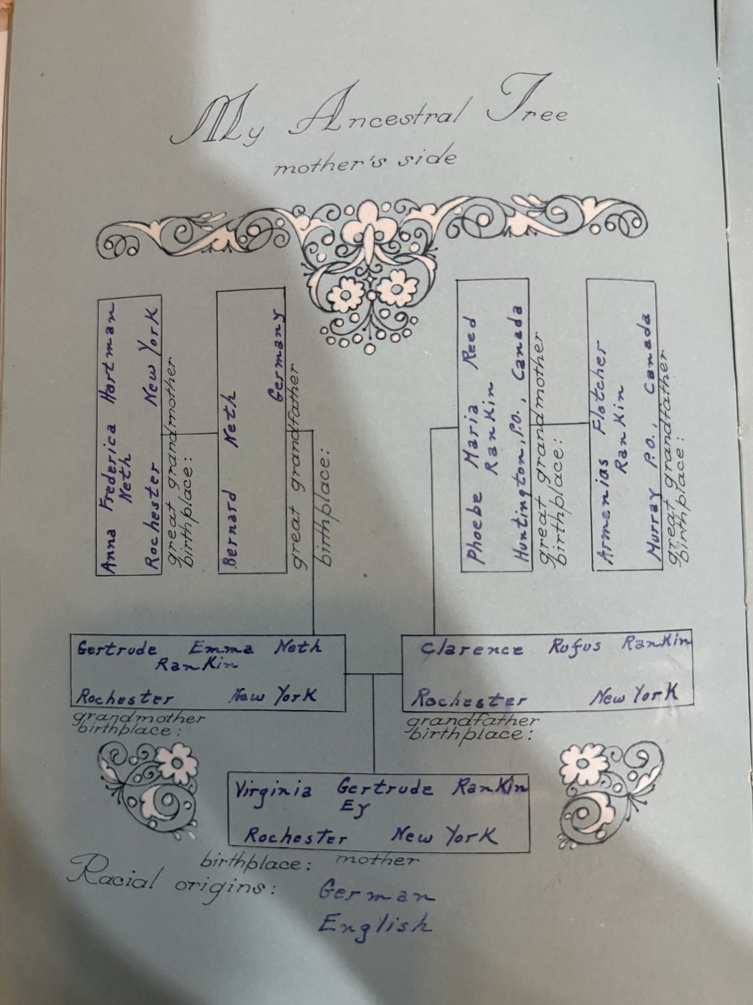
My Ancestral Tree, mother’s side. Gertrude Emma Neth and Clarence Rufus Rankin, both of Rochester; behind them Bernard Neth of Germany and Anna Frederica Hartman of Rochester, and Armenias Fletcher Rankin and Phoebe Maria Reed, both of Canada.
And behind Clarence, the surprise of the whole document. His parents were Canadians. Armenias Fletcher Rankin, of Murray P.O., and Phoebe Maria Reed, of Huntington P.O. The chart gives him a heart attack at seventy and her old age at eighty-three.
Those two place names looked at first like a problem. There is a well-known Huntingdon in Quebec, in the Chateauguay valley south-west of Montreal, and a Murray Township in Northumberland County, Ontario, on the north shore of Lake Ontario — four hundred miles and two provinces apart, which would want explaining in a couple who married. But there is also a Huntingdon Township in Hastings County, Ontario, with a village of the same name in it, amalgamated with Madoc in 1998 to form Centre Hastings. Read that way the two places are neighbours. Murray Township sits on the north shore of Lake Ontario at the western end of the Bay of Quinte, and Huntingdon Township lies inland about thirty miles north-east of it. Since 1998 both have fallen under Hastings County. In the nineteenth century they were adjacent counties, both Loyalist and both settled by English and Scots — which is what Reed and Rankin are.
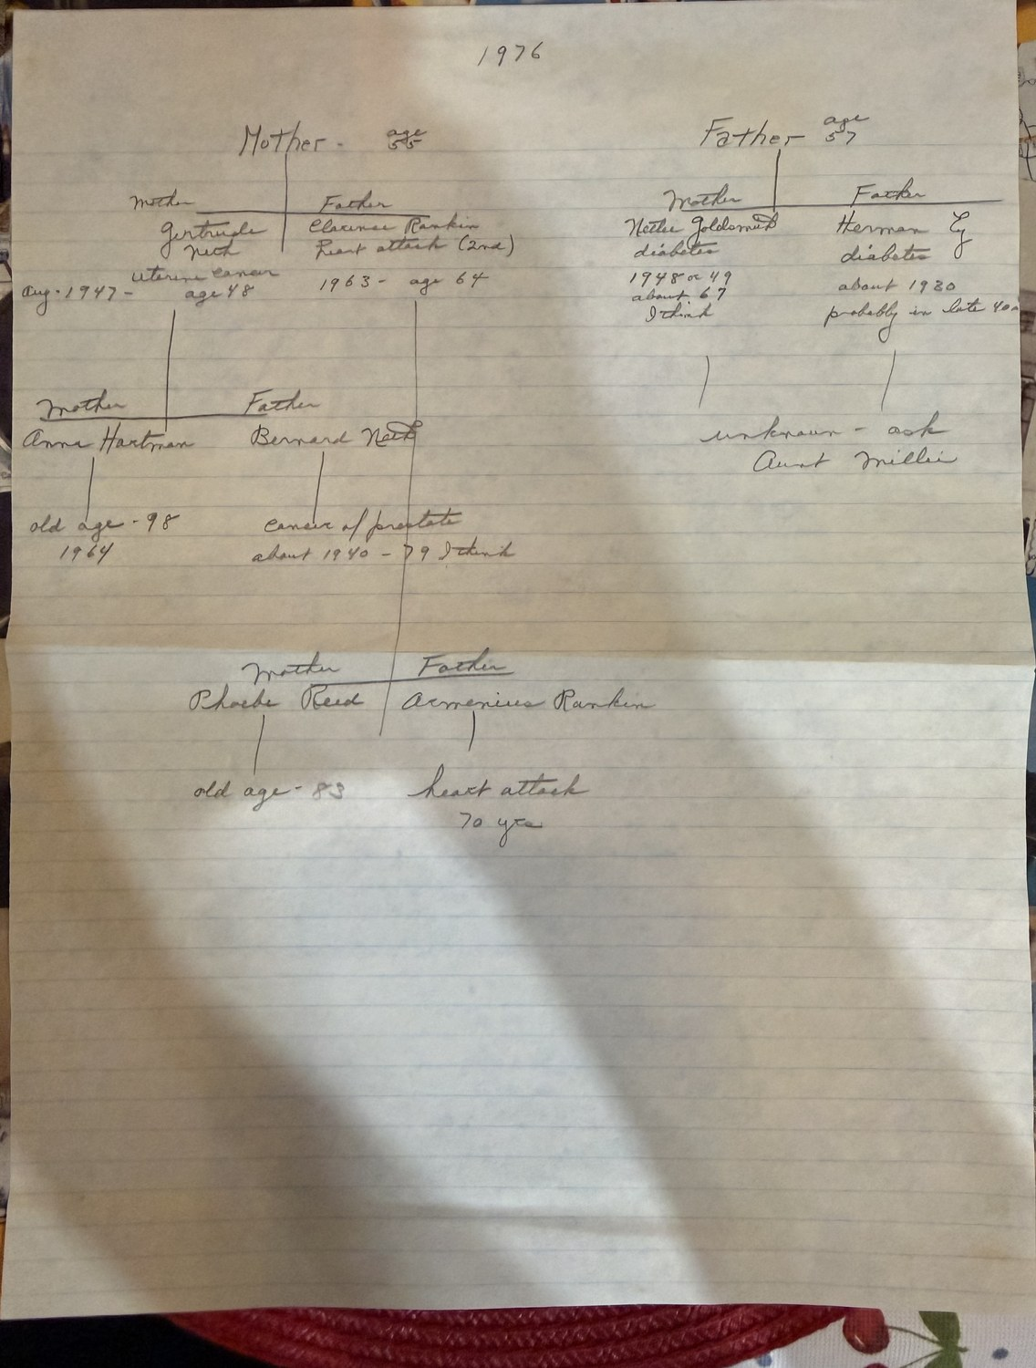
And the Bay of Quinte reading does something the Quebec one cannot: it explains Rochester. Trenton and Cobourg sit almost directly across Lake Ontario from the mouth of the Genesee, and the lake was a highway rather than a barrier — steamers ran between the Canadian north shore and Rochester’s port at Charlotte all through the later nineteenth century. A young couple from Murray and Huntingdon leaving for the American side would not have gone round by land. They would have crossed. Clarence was born at Rochester about 1899, so the crossing falls before that, and it was ninety miles of open water rather than an emigration.
This is the first new country in the family since the Germans. Every other line in the book comes out of New England, New York, Germany or England. The Rankins came down across the lake.
The 1976 medical-history chart. Mother, 55; Father, 57 — Virginia and Theodore in the year he died. Gertrude Neth, uterine cancer, August 1947, aged 48; Clarence Rankin, heart attack, 1963, aged 64; and behind them the Neths, the Rankins, and the note against the Ey side: unknown — ask Aunt Millie.
Against the generation behind Herman and Nettie the chart simply says unknown — ask Aunt Millie. Aunt Millie was almost certainly Mildred Louise Ey Brown, born 1912, Theodore’s elder sister, and in 1976 the answers this document has been hunting were one telephone call away.
The ages at the head of the chart — Mother 55, Father 57 — fit births in September 1920 and January 1919.

6. The War
Theodore Fredrick Ey served in the United States Army, in India.
That is a more unusual thing to be told than it sounds. Of the twelve and a quarter million Americans under arms at the height of the war, only about two hundred and fifty thousand — two per cent — were assigned to the China-Burma-India theatre. It is routinely called the forgotten theatre. Very few Americans in India saw combat; the mission was logistics, keeping China supplied after the Japanese occupation of Burma cut the last land route. Men and materiel came in through Karachi and Calcutta and went north by rail, on a supply line twelve thousand miles long — so strained that in 1943 the Allies brought in 4,600 American railway workers to run sections of it. From the airfields of Assam, transport aircraft flew the Hump over the Himalayas from April 1942 to November 1945, at a cost of 594 aircraft and more than sixteen hundred men. From December 1942 the Corps of Engineers drove the Ledo Road out of Assam through jungle towards the old Burma Road, and the first convoy crossed in February 1945.
If Theodore was in India rather than Burma he was almost certainly in one of the supporting arms — supply, engineers, transportation, signals, medical. Disease, malaria above all, was that theatre’s defining hazard. His headstone records him as a private first class.
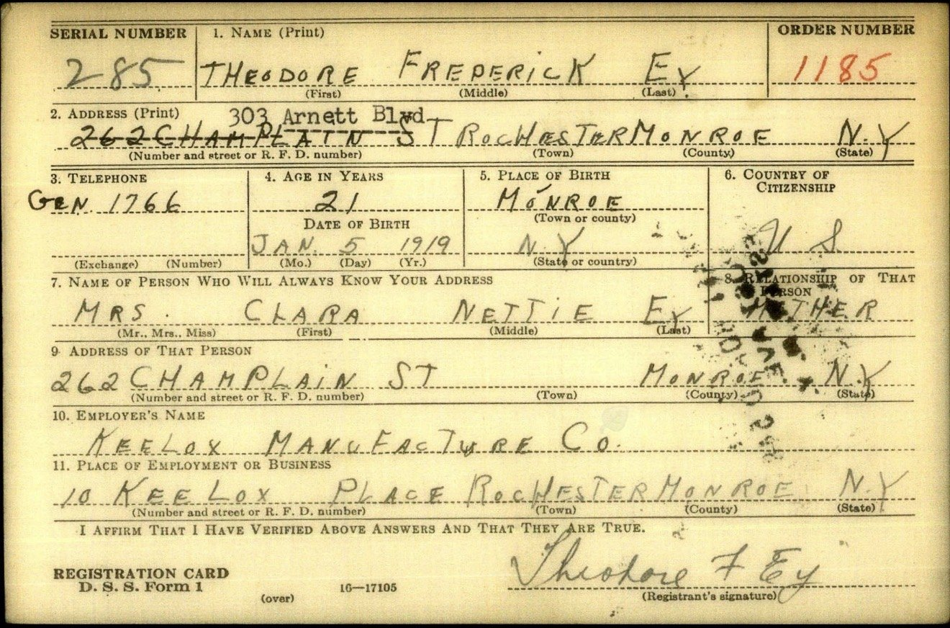
Theodore Frederick Ey’s draft registration card, 16 October 1940. Twenty-one, of 262 Champlain Street, Rochester; employed by the Kee Lox Manufacturing Company; next of kin, Mrs Clara Nettie Ey, mother.
We know exactly what he left behind to go. He registered for the draft on 16 October 1940, in the first registration, and filled in the card himself: Theodore Frederick Ey, twenty-one, of 262 Champlain Street, Rochester, later 303 Arnett Boulevard. Telephone Genesee 1766. Employed by the Kee Lox Manufacturing Company at 10 Keelox Place — a Rochester firm that made typewriter ribbons and carbon paper under the Ivory, Silver and Wonder brands. For the person who would always know his address he gave Mrs Clara Nettie Ey, mother, at the same Champlain Street house. His father had died three years earlier; his mother was the one who would know.
Leland Gross had no war at all, and the reason is worth recording. He registered on 16 October 1940, in the very first draft registration, which took men born between 17 October 1905 and 16 October 1919 — his February 1906 birth falls inside that window by about four months. He was drafted. And he was exempted, because of a heart condition. He was thirty-five, newly married, and had just bought his mother’s farm; instead of going to war he spent the next four years working it. He died in 1976, at seventy.

7. Two Weddings

Susquehanna, Pennsylvania, and the twentieth of December
The family remembers it simply: they married quickly after Pearl Harbor, because they assumed Leland would be drafted. Margaret was married in a suit, and there is a photograph of her wearing it, twenty-two years old, looking straight at the camera.
The records complicate that, and the complication is more interesting than the story. Leland and Margaret swore their application for a marriage licence before Ruth Lamb, deputy clerk of the Orphans’ Court of Susquehanna County, Pennsylvania, on 29 November 1941 — eight days before Pearl Harbor. They were married on 20 December, thirteen days after it. So the decision was made in peacetime; what the war did was hurry the ceremony, not prompt the engagement. Family memory keeps the emotional truth and moves the dates to fit it, which is what family memory generally does.
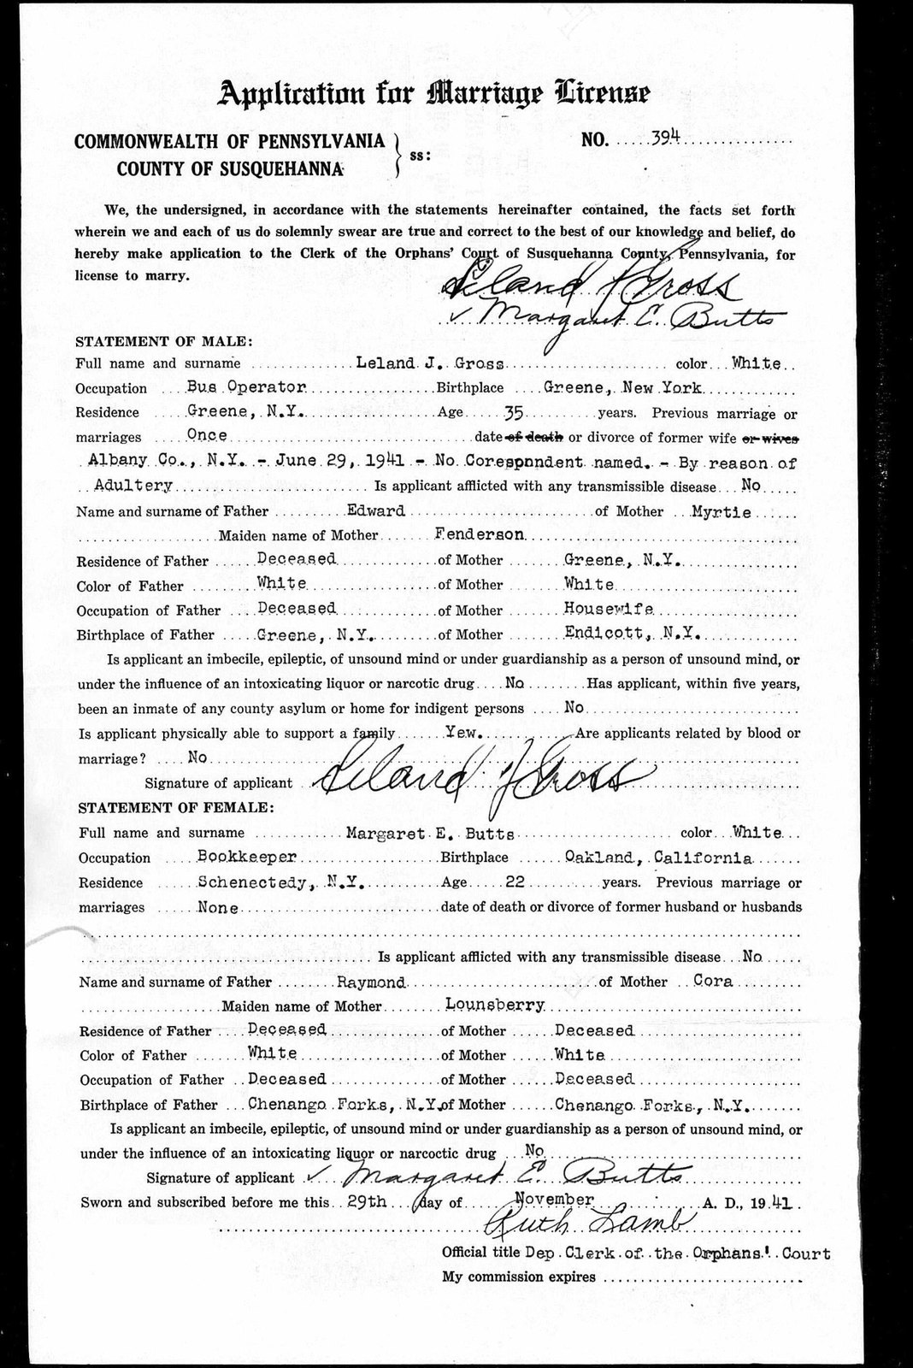
Application for Marriage Licence No. 394, Susquehanna County, Pennsylvania, sworn 29 November 1941 before Ruth Lamb, Deputy Clerk of the Orphans’ Court, and signed by them both.
Her name was Laura. Leland married twice, and the marriage that ended in that Albany courtroom in June 1941 was to a Laura; nothing else about her is yet recorded here.
The application is the richest document in this history. He was thirty-five, a bus operator, living at Greene. She was twenty-two, a bookkeeper, living at Schenectady. It names both sets of parents and both birthplaces, records that both of Margaret’s parents were dead, and records, in Leland’s own sworn statement, that he had been married once before, and that the marriage had ended in a divorce granted in Albany County, New York, on 29 June 1941 — five months earlier — by reason of adultery, with no co-respondent named.
Two things about that deserve care. Adultery was not a choice: from 1787 until 1966 it was with very few exceptions the only ground on which a New York court would grant a divorce, so the phrase tells you the marriage ended in New York rather than in Nevada, and nothing more. And "no co-respondent named" is the signature of the arranged, uncontested divorce — the device by which couples who wanted out produced the minimum evidence the statute required without naming anybody real.
It also explains the venue. A New York decree of that era ordinarily declared the innocent party free to remarry and forbade the guilty party from remarrying while the former spouse lived. If Leland was the party found at fault, he could not lawfully have married Margaret in New York. Twenty-five miles across the Pennsylvania line, he could.
And it puts two people in the same corner of the state who ought not to have met. Albany is fifteen miles from Schenectady; Greene is a hundred and forty miles from both. Leland drove for Greyhound. A man whose working life consisted of running a fixed route between towns, filing his divorce in the county where that route ended, meeting a young bookkeeper at that end of the line — that is a hypothesis rather than a finding, but it is supported from two directions and it is testable.
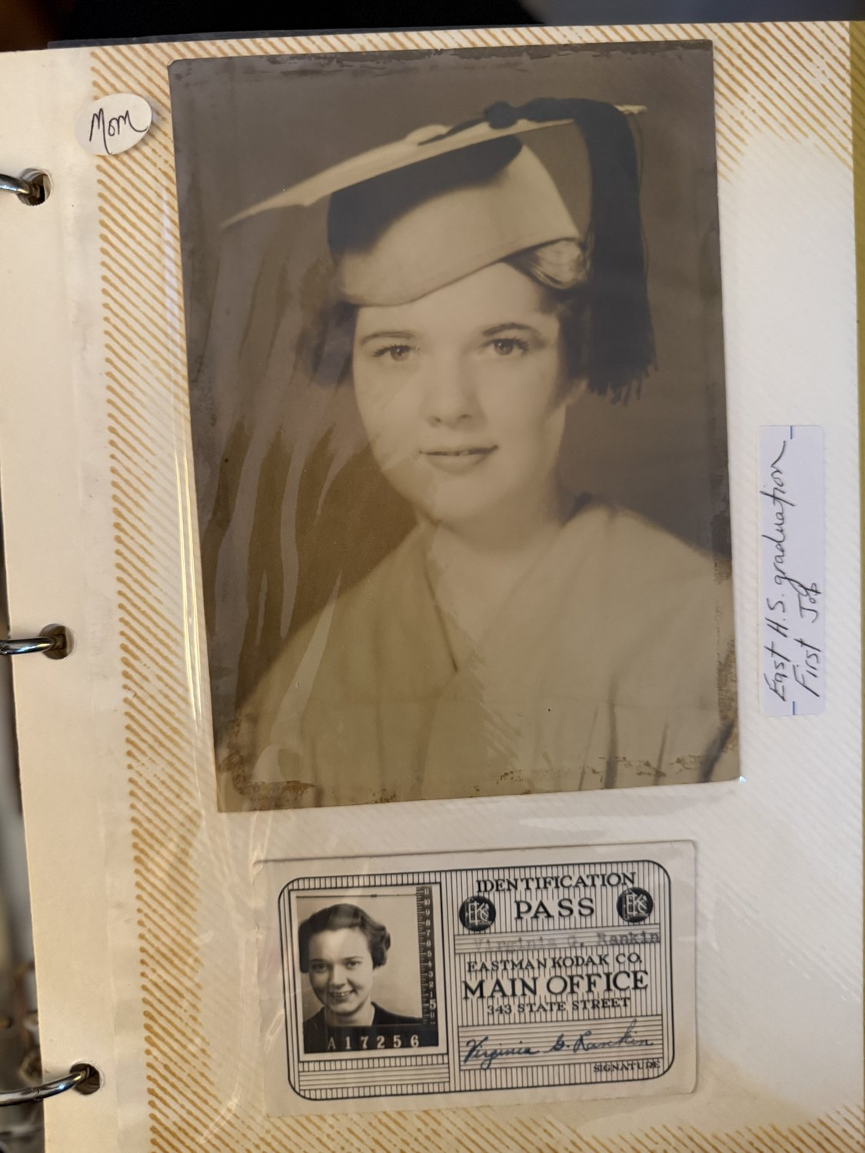
Virginia’s East High School graduation portrait, and her Eastman Kodak identification pass for the main office at 343 State Street — her first job, signed Virginia G. Rankin.

Clarence Rankin and the Sachem
Virginia’s father was a funeral director, and the best story in this book belongs to him. Clarence R. Rankin kept an undertaking establishment at 756 Main Street East in Rochester and had run it for twenty years. He belonged to the Chamber of Commerce, the Monarch Club and Germania Lodge of the Masons. A newspaper described him as a tall, well set-up man with reddish hair. And at forty he decided to give the whole thing up.
Two ambitions had possessed him since boyhood: to own a pipe organ, and to vagabond around the world in his own boat. He had had the organ for several years. For the second he bought the Sachem — a hundred and thirty-two feet of Lunenburg fishing schooner, a hundred and sixty-eight tons, designed by the Chester Basin Corporation in 1920 and converted into a yacht by a New York broker. She had seven staterooms, two shower baths, a radio room, a dark room for developing pictures, fuel for five thousand miles and berths for nineteen. He engaged a navigator who had spent seventeen years in the Navy and the merchant marine, and a mate, a Swedish seafarer who had been round the world many times.
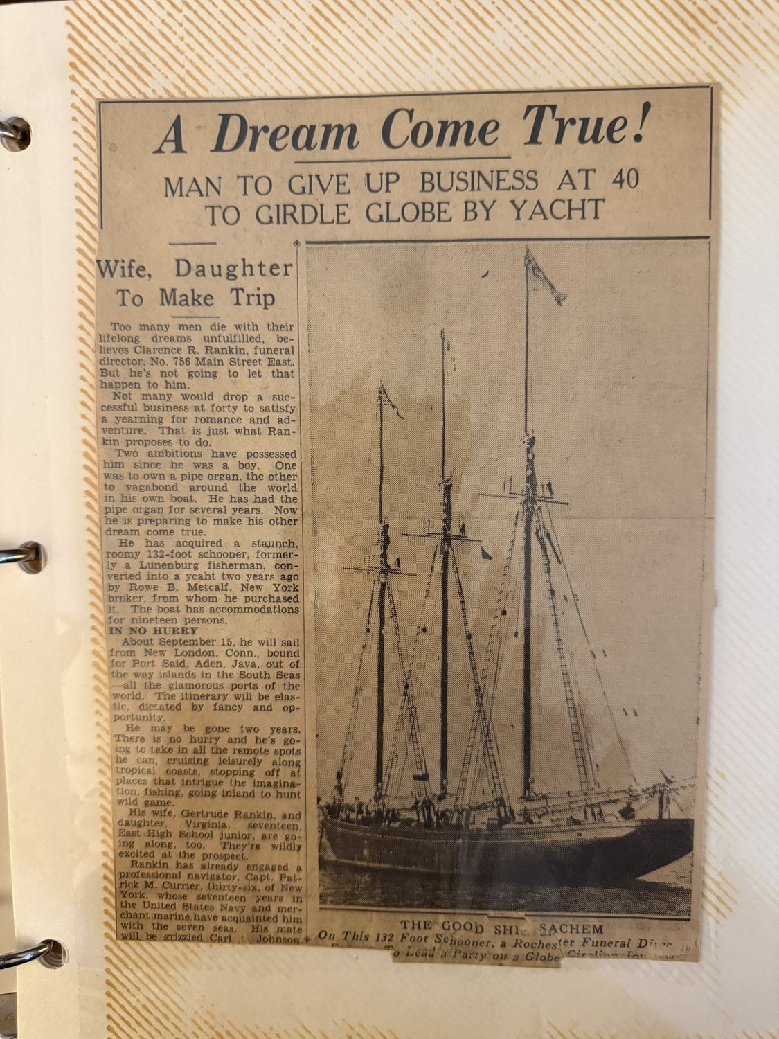
A Dream Come True! Man to Give Up Business at 40 to Girdle Globe by Yacht. The Sachem, a hundred and thirty-two feet of Lunenburg schooner, in a Rochester paper in 1938.
The itinerary ran to a full column of newsprint. Down the Atlantic coast to the Bahamas, Haiti, Jamaica and Panama; along South America to Trinidad, Georgetown and Rio; across to the Cape Verde Islands and Dakar; then the Canaries, the Mediterranean, Algiers, Egypt, Malta and Port Said; through the Suez Canal to the Red Sea, with stops in Ethiopia and Aden; on to Bombay, Ceylon, across the Bay of Bengal to Bangkok, the Dutch East Indies, Singapore, the Philippines, Japan, Kamchatka, Russia; over to the Aleutians and the Bering Strait to Unalaska; down to Vancouver, San Francisco and Mexico; through the Panama Canal and home. He thought it might take two years.
His wife Gertrude was going, and so was Virginia — seventeen years old, a junior at East High School, and, the paper said, wildly excited at the prospect. They were to sail from New London, Connecticut, about the fifteenth of September.
He gave the reporter his reasons, and they are worth quoting because they are the only words of any ancestor in this book that survive in his own voice. He supposed a lot of people would think him eccentric to give up a profitable business to satisfy a whim, but he did not feel that way and neither did his wife. He had seen a number of friends with whom he had planned to do things die before they carried the plans out. He was not a rich man, but he had enough to see the thing through, and when it was over he might have to start all over again, and it would be worth it. And he agreed, he said, with the writer who wrote: I have only one life; then I am likely to be a long time dead. But before I die there is this beautiful world to see.
They never went. On 21 September 1938 the Great New England Hurricane came ashore on Long Island and crossed the Sound into Connecticut at high tide, moving north at fifty miles an hour. New London was destroyed: ships were torn from their moorings and slammed round the harbour, wrecking the wharves before sinking or beaching themselves, and fires burned out of control downtown for seven hours. About twenty-six hundred vessels were destroyed outright and thirty-four hundred more damaged; in the days afterwards only three commercial fishing boats were left usable in the whole of southeastern Connecticut and Rhode Island.
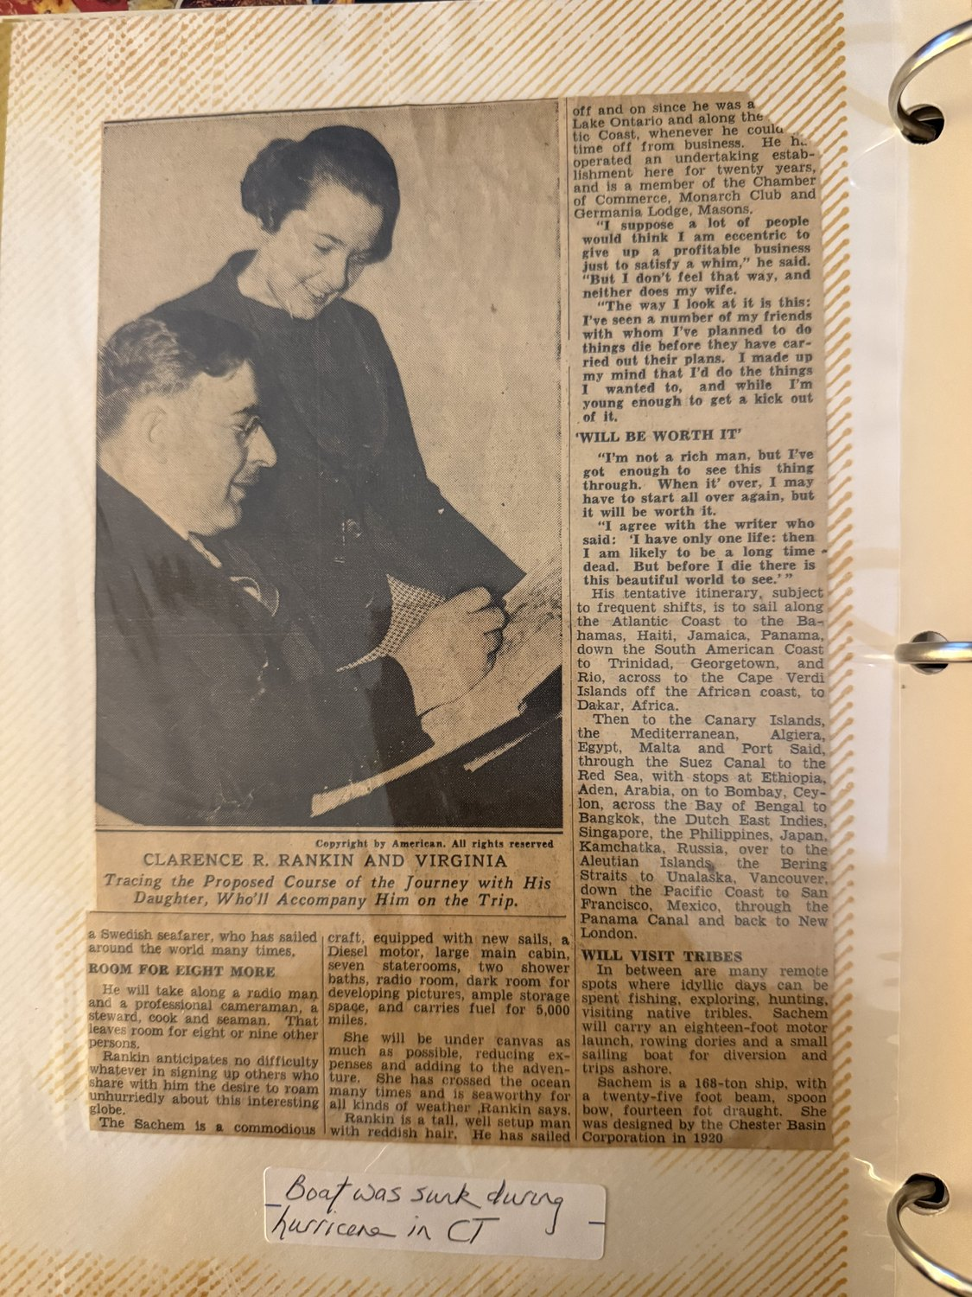
Clarence R. Rankin and Virginia, tracing the proposed course of the journey. She was seventeen, and a junior at East High.
The family’s note on the clipping is six words long: the boat was sunk during a hurricane in Connecticut. The Sachem was lying at New London and they had meant to sail from there six days before the storm.
So Clarence Rankin sold his business, bought a schooner, planned a voyage round the world, and lost it a week before he left. Nothing else about him has come down. Whether he went back into the undertaking trade, whether he ever got another boat, whether he talked about it afterwards — none of that is recorded here. But his daughter kept the clippings all her life, and her daughter kept them after her.

Rochester, 28 May 1941
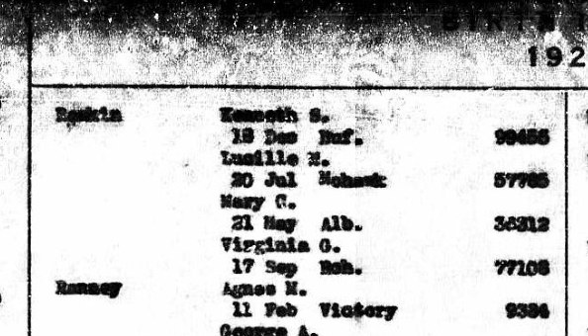
New York State birth index, 1920: Rankin, Virginia G., 17 September, Rochester — certificate number 77105.
Virginia’s birth is now on an official record, and it carries the number that opens the next door. The New York State birth index for 1920 lists her plainly under Rankin: Virginia G., 17 September, Rochester, certificate 77105. The index gives no parents — indexes never do — but the certificate behind that number names both of them, and gives her mother’s maiden name, which is the piece still missing.
It is also unusually easy to order. New York opens birth records at seventy-five years if the subject has died, and Virginia died in 2013; a 1920 birth is long past both tests, and direct-line descendants have the time limits waived in any case. A request to the Genealogy Unit at the State Department of Health quoting the certificate number, the place and the date is about as precise as a records order ever gets.
Her parents were Clarence Rankin and Gertrude. With those two names the great-grandparent generation is complete for the first time — all eight of them, on both sides. And Virginia was Virginia Gertrude: named for her mother, which is this family doing again what it has done in every generation of this book.
Gertrude’s maiden name is not yet known, and it is the next thing to find. It will be on Virginia’s birth certificate, and on the Rankin marriage record — which would also give both sets of her grandparents, and open a branch that until now has been a blank.
Theodore Ey and Virginia Gertrude Rankin were married on 28 May 1941 — three weeks before Leland’s divorce came through in Albany, and seven months before Leland and Margaret married in Pennsylvania. Both sets of your grandparents married in 1941. A wedding photograph survives: four of them in a studio, Virginia with a veil and a great sheaf of flowers, and beside her an Aunt Ethel and a Ralph Corrigan.
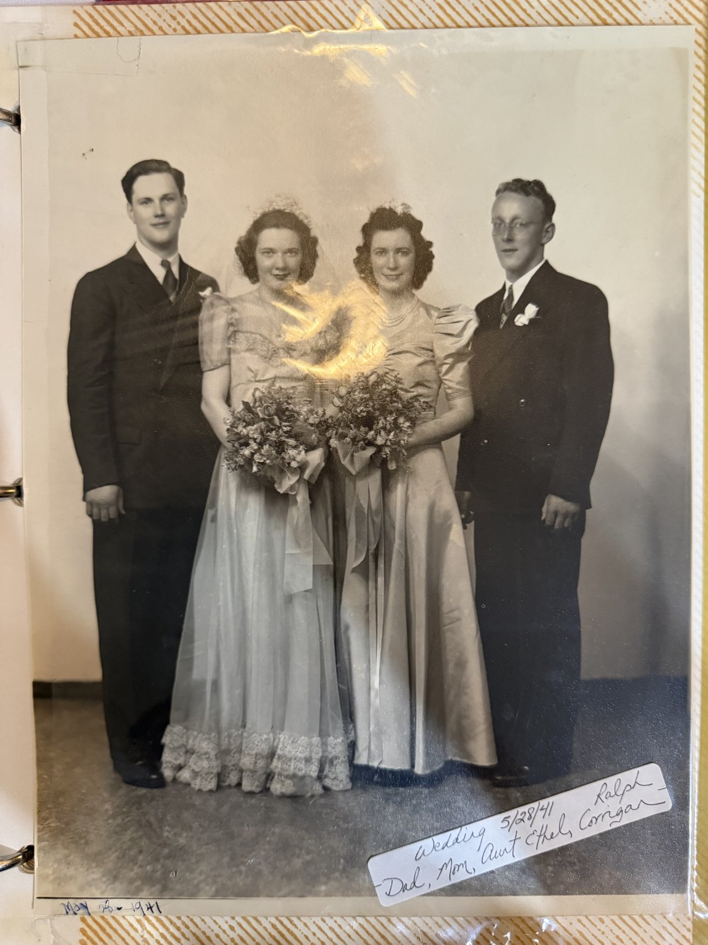
The wedding, 28 May 1941 — with Aunt Ethel and Ralph Corrigan.
He was Ted to the family. A snapshot from the following year is captioned Mr and Mrs Ted Ey, 1942 — he is already in uniform, standing with her outside a brick house — and a studio portrait taken on 19 July 1943 is labelled PFC Ey.
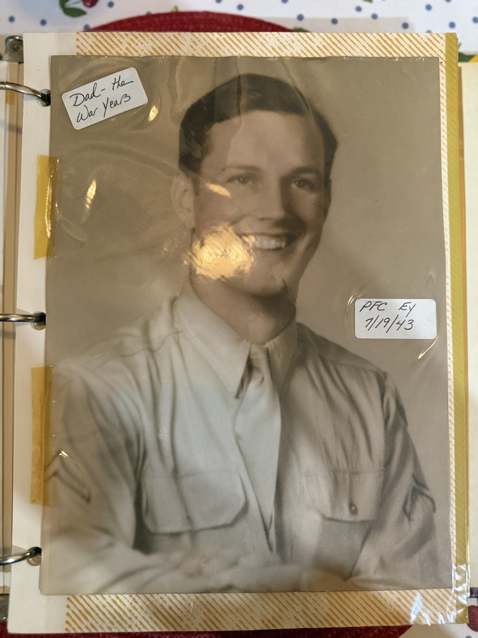
Dad — the war years. PFC Ey, 19 July 1943.
Virginia had gone to East High School in Rochester and her first job was at Eastman Kodak: her identification pass for the Main Office at 343 State Street survives, number A17256, signed Virginia G. Rankin in a careful hand. Theodore worked for Kodak too. A company magazine of the 1950s shows a Test Kitchen panel luncheon — the wives brought in to taste the recipes instead of the usual husbands — and among the names is Mrs. Theodore Ey.
Rankin is a Scottish name from a medieval diminutive of Rand or Ronald, first recorded in the charters of the burgh of Ayr in 1429 and carried into Ireland by the Plantation of Ulster — so a Scots or Ulster-Scots line, worshipping in different churches from the German Eys and leaving a different trail.
Their first daughter Patricia was born about 1942 or 1943, which dates the marriage to about 1940 or 1941. Roxanne followed in November 1947, and Martha — always Marty — after April 1950.

8. Two Households, 1950
The census of 1950 catches both families within days of each other, and it is worth setting the two sheets side by side.
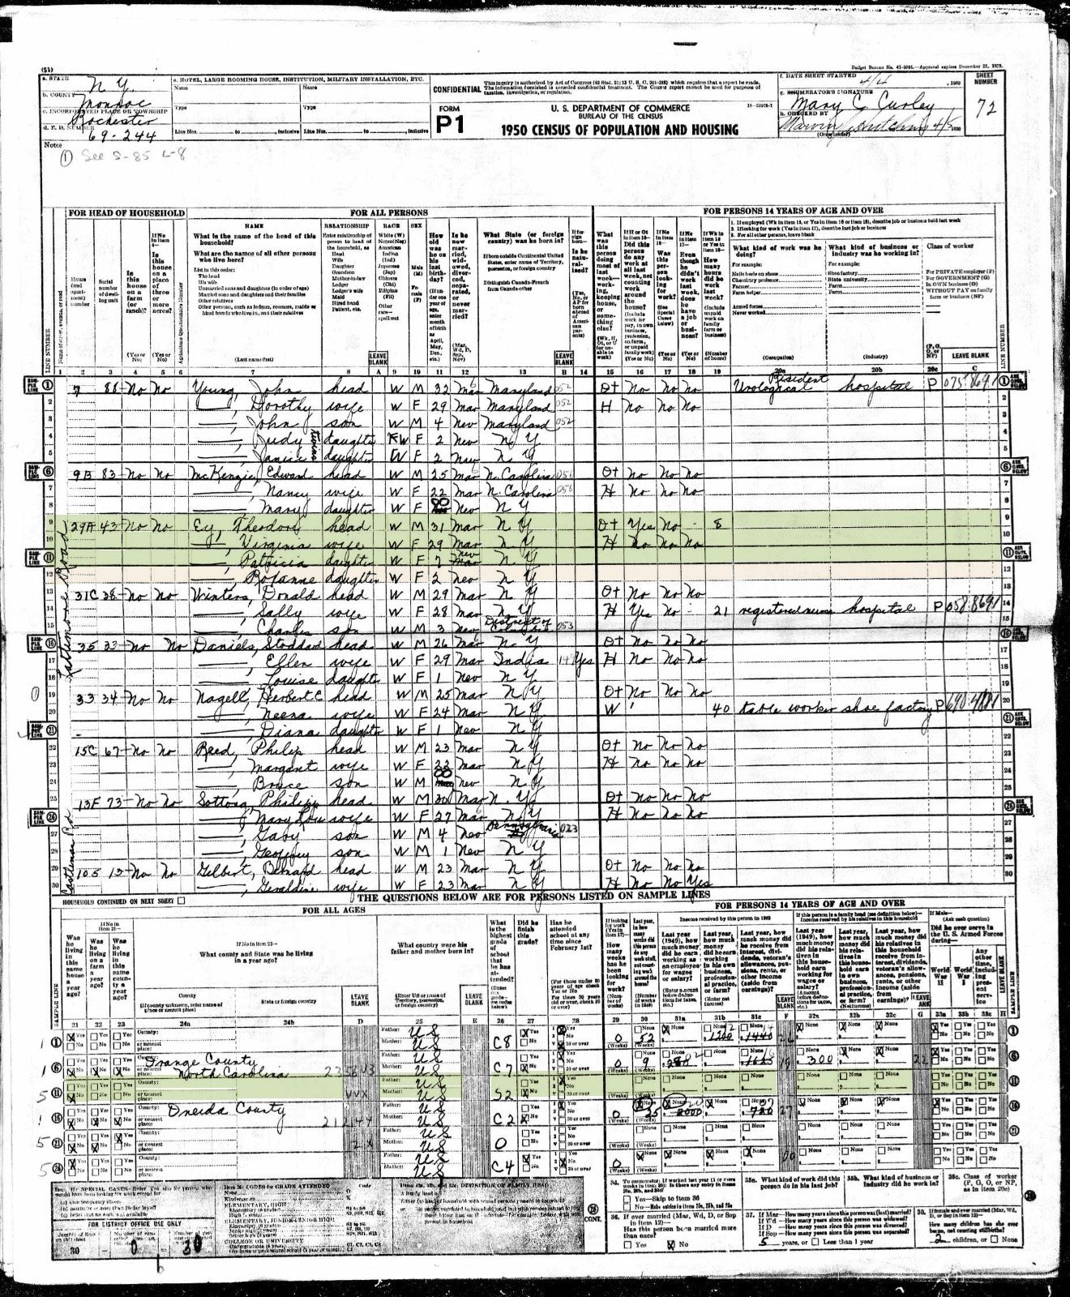
Rochester, Enumeration District 69-244, sheet 72: Theodore Ey, thirty-one; Virginia, twenty-nine; Patricia, seven; Roxanne, two.
In Rochester, at house 29A in Enumeration District 69-244, the enumerator Mary C. Curley recorded Theodore Ey, thirty-one, his wife Virginia, twenty-nine, and their daughters Patricia, seven, and Roxanne, two. Marty had not yet been born. Virginia was keeping house. Against Theodore’s name the occupation and industry columns appear blank, with what may be a figure of eight in the hours-worked column — against forty for a shoe-factory worker two households down. That reading is provisional; and even if it holds, one reference week in April 1950 is not a working life.
A hundred and thirty miles away, Leland and Margaret Gross had four children: Leslie, born 1942; Patricia, 1944; Michael, 1947; and Dorothy, 1950. Four children in nine years, the first arriving within about twelve months of that Pennsylvania wedding. By 1950 they were off the farm — sold three years earlier — and living at 16 Willard Street.
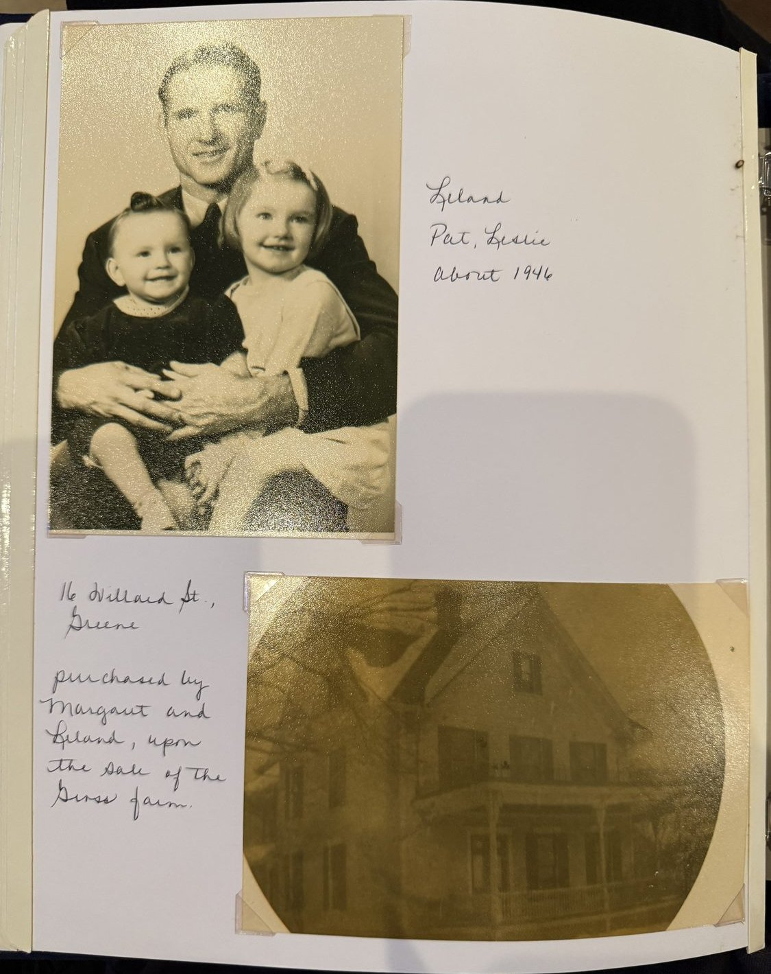
Leland with Pat and Leslie, about 1946; and 16 Willard Street, Greene, bought by Margaret and Leland on the sale of the farm.
Michael Gross and Roxanne Ey were born within nine months of each other in 1947, in two families that had never heard of one another.

Two babies, 1947
Both births are now documented, and both families kept a baby book.
Michael Jay Gross was born on 7 February 1947 at Greene, New York, son of Leland Jay Gross and Margaret Elizabeth Butts. The certificate of birth registration was filed five days later, on 12 February, and signed by the local registrar, Willard F. Knickerbocker. It is the first document in this history to give Margaret’s maiden name in an official hand rather than on the marriage application she swore herself.
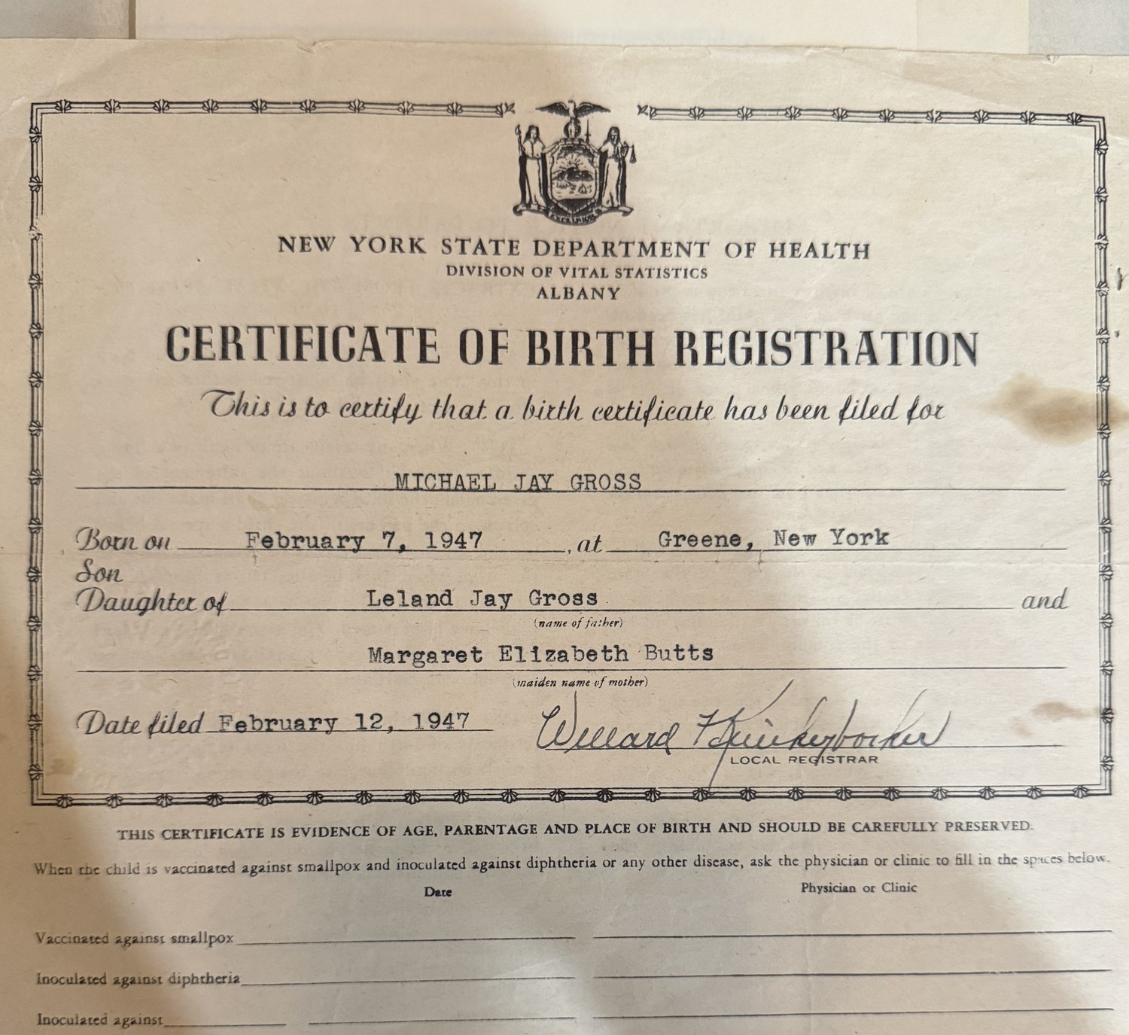
Certificate of birth registration, Albany: Michael Jay Gross, born 7 February 1947 at Greene, son of Leland Jay Gross and Margaret Elizabeth Butts, filed 12 February 1947.
His baby book carries a printed family tree, filled in as far as the family could go. The Leland Jay Gross Family. Baby’s name, Michael Jay. Father, Leland Jay, birthplace Greene, date 22 February 1906. Mother, Margaret, birthplace Oakland, Calif., date 1 June 1919. Grandfather Edward, grandmother Myrtie, grandfather Raymond, grandmother Cora. Then eight empty boxes for the great-grandparents.
Those eight boxes are, in a sense, what this book is. Whoever filled the page in 1947 could name four grandparents and stopped. Behind Edward stood Fitch and Maria; behind Raymond, Nelson and Mary; and behind them John and Elizabeth Aldrich on the hill, and Micah, and Jabez at Garrattsville, and Isaac stepping ashore at Boston in 1636.
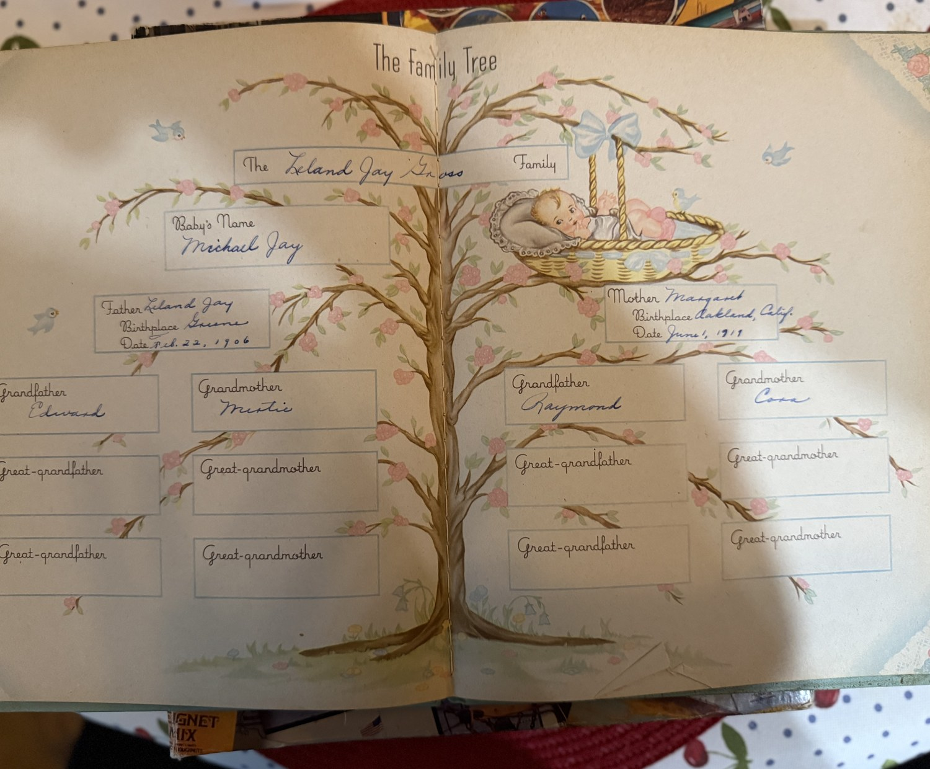
The Family Tree page from Michael’s baby book: Leland Jay, born Greene, 22 February 1906; Margaret, born Oakland, California, 1 June 1919; Edward, Myrtie, Raymond and Cora — and eight empty boxes behind them.
Roxanne Marcia Ey was born nine months later, on Sunday 2 November 1947, at St Mary’s Hospital in Rochester, at seven minutes past three in the afternoon. The doctor was Joseph Cooney. Her birth was filed with the registrar two days later, and the certification that survives was issued from that record in September 1965.
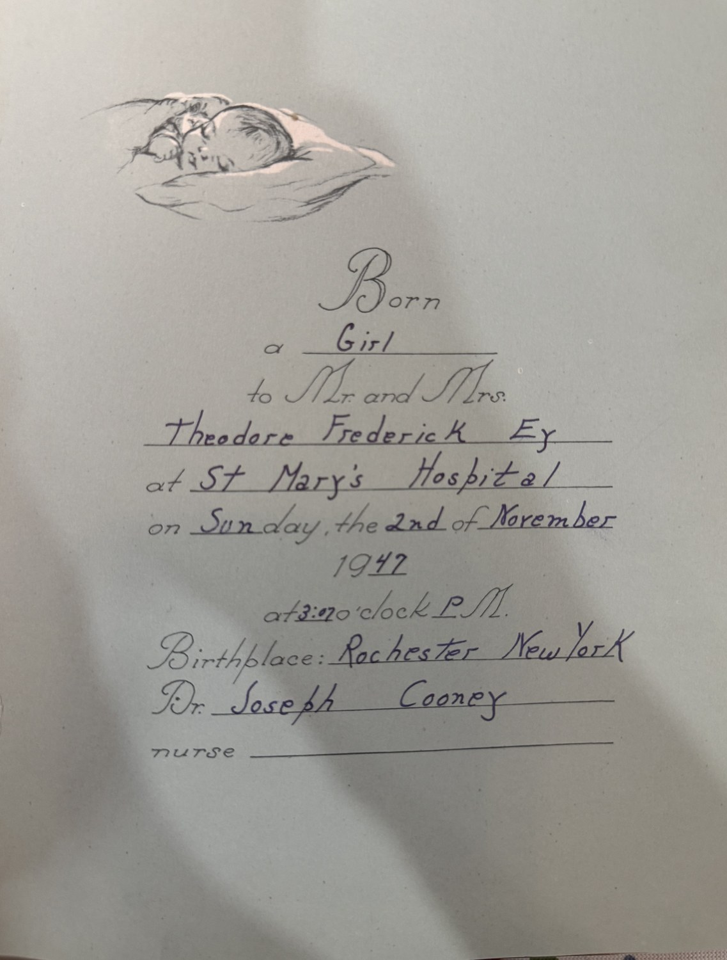
The baby book: born a girl to Mr. and Mrs. Theodore Frederick Ey at St Mary’s Hospital, Sunday the 2nd of November 1947, at 3:07 P.M. Dr. Joseph Cooney.
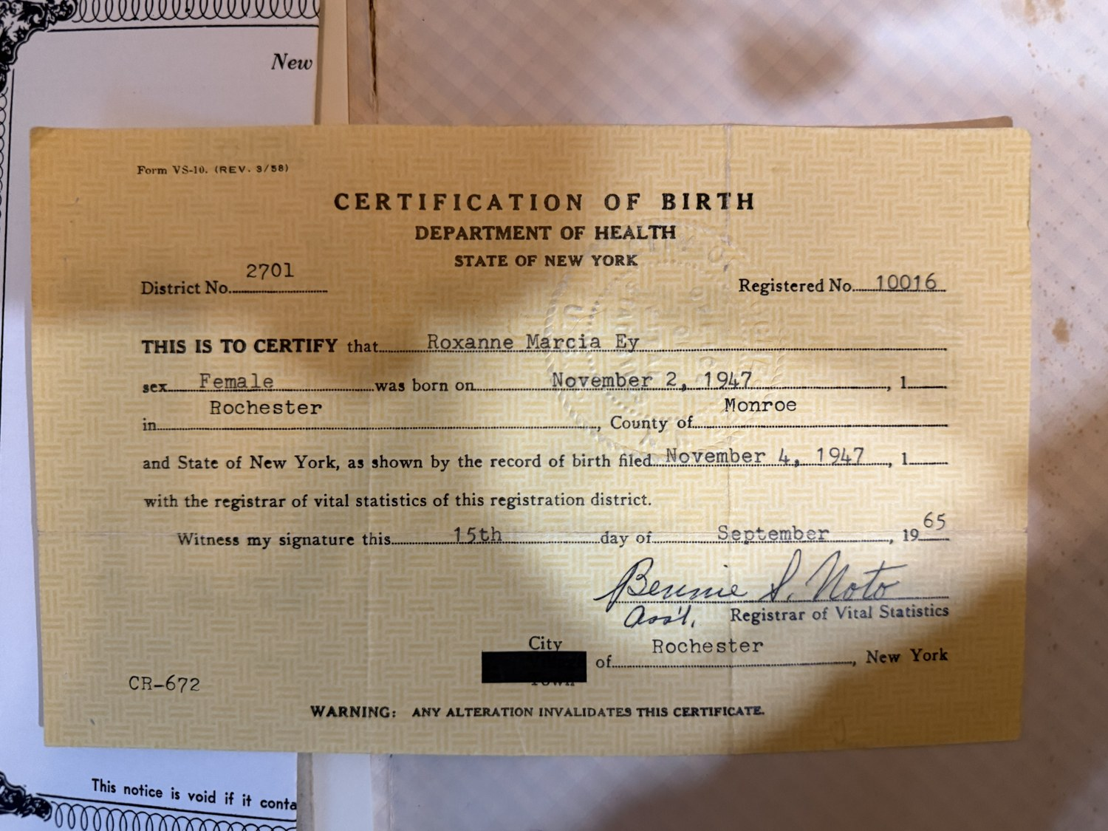
Certification of birth, State of New York: Roxanne Marcia Ey, born 2 November 1947 at Rochester, Monroe County; record filed 4 November 1947; certification issued 15 September 1965.
The baby book adds the one thing no certificate carries: the hour. Everything else in this history is a date; this is a Sunday afternoon.

9. What Came Apart
The Ey marriage did not last. Theodore and Virginia divorced — the date is not yet known, but it falls after Marty’s conception, so after 1950 — and at some point he left Rochester for Arizona.
He died at Phoenix on Wednesday 9 June 1976, aged fifty-seven, at 6837 North 25th Drive. Friends called at the Sunset Chapel on West Camelback over the weekend, and on the Monday there were graveside military rites at Glendale Memorial Park, where he lies under a government marker: THEODORE F EY, PFC, US ARMY, WORLD WAR II, 1919–1976.
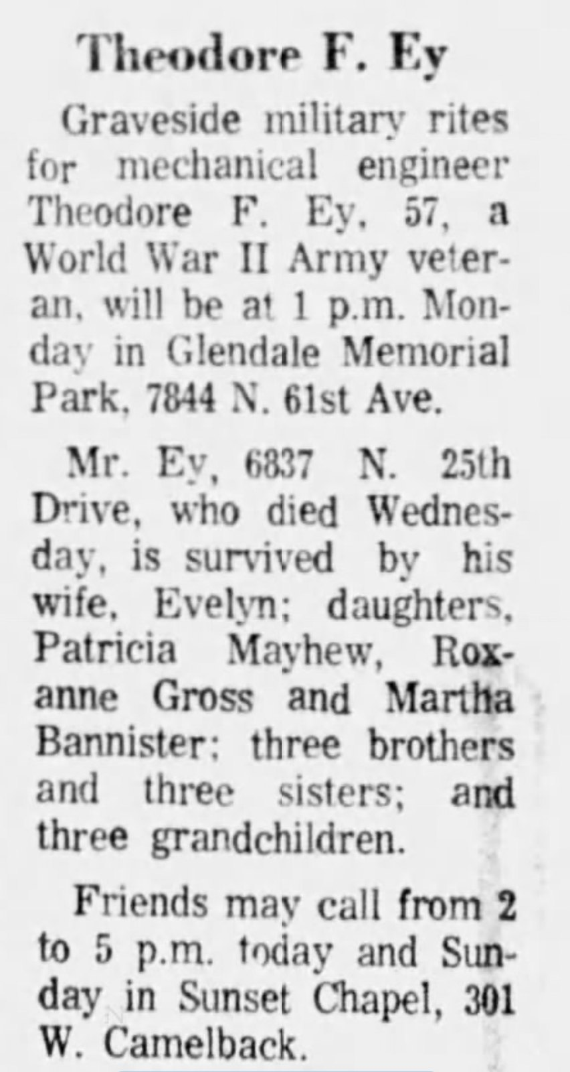
The notice in the Phoenix paper: graveside military rites for mechanical engineer Theodore F. Ey, 57, survived by his wife Evelyn, three daughters, three brothers and three sisters, and three grandchildren.
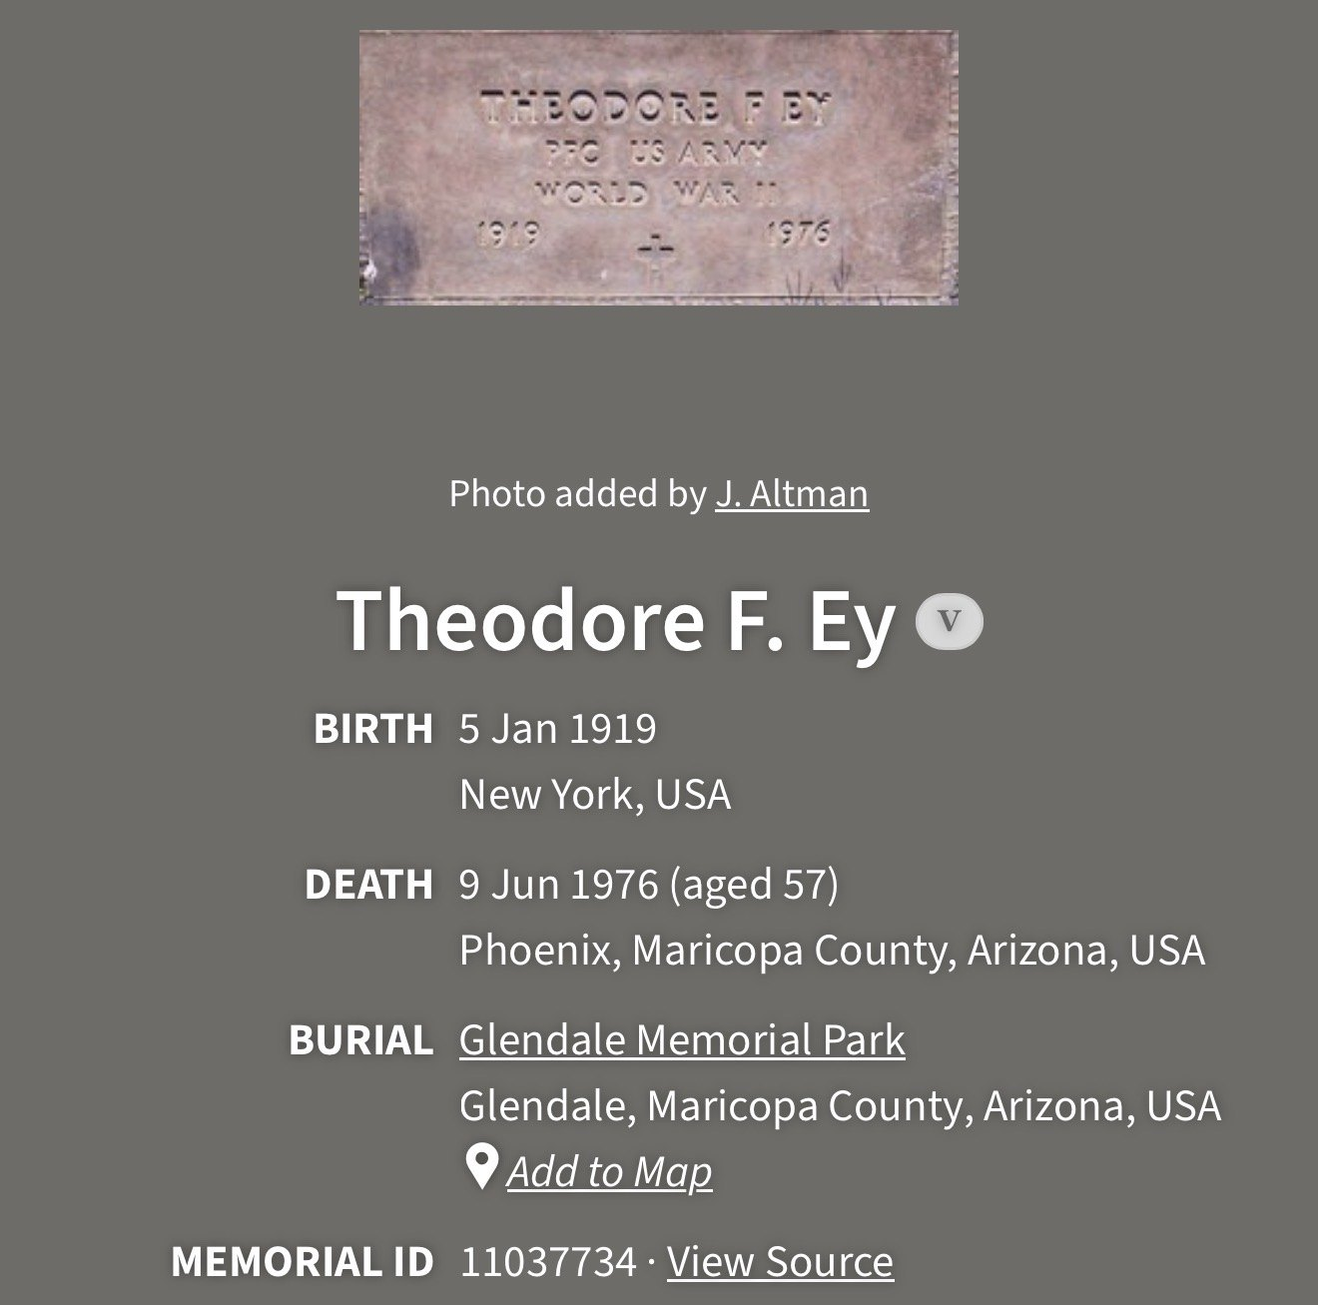
Glendale Memorial Park, Glendale, Arizona.
The obituary is worth reading slowly. It calls him a mechanical engineer. It gives him a wife, Evelyn. It lists three brothers and three sisters still living, and three grandchildren — Patricia’s Cindy and Stephen, and you, eleven months old in Texas. And it names his three daughters in order: Patricia Mayhew, Roxanne Gross and Martha Bannister.
None of that contradicts the family’s memory of a man who drank heavily and died in a bar; obituaries never say so, and a man can be a mechanical engineer and an alcoholic at once. But what the record shows is a working engineer, remarried, buried with military honours, mourned by six brothers and sisters and three grandchildren he had almost certainly never met. Whatever happened in June 1976, a life is longer than its worst chapter.
The death certificate is still the thing that will say how he died. Under Arizona’s fifty-year rule it became a public record on 9 June 2026.
Virginia married Theodore Voll — a second Theodore, thirty years after the first — somewhere between 1974 and 1976, probably at Plattsburgh, three hundred miles from where she was born. He died on 2 July 1986, so that marriage ran about ten or twelve years.
1986 took someone from each side of the family within five months. Virginia was widowed on the second of July. Margaret died on Christmas Day. Your father lost his mother and your mother lost her stepfather in the same year.
Leland Gross died the same year as Theodore Ey, in 1976, at seventy. The two men had almost certainly never met.

What Virginia did next
There is a résumé. Two typed pages from about 1969, headed Virginia R. Ey, 769 Liberty Street, Penfield, New York. Age forty-eight. Marital status: divorced. And then, on its own line, the sentence that tells you what the rest of it is for — daughter entering college in September, no support from Father.
The daughter was Marty, and that line dates her: entering college in September 1969 puts her birth around 1951. The father was in Arizona, and had seven years left to live.
What follows is a working life that this history had no idea about. Under education: East High School, Rochester; graduated from Miami Edison High School, Miami, Florida, in 1938; attended the University of Rochester for one year. Then the work.
- 1957 to 1963, the Y.W.C.A. — water safety instructor for girls’ and women’s classes, two days a week.
- 1957 to 1963, the C.Y.O. — water safety instructor for women’s classes three mornings a week, outdoor pools daily through the summers, and staff for the women’s swim classes at Monroe Community College.
- June 1963 to August 1965, the Association for Retarded Children — group leader in arts and crafts and daily living in the day training programme.
- From August 1965, the American Red Cross, as Youth Field Representative for Monroe County: interpreting the programme to principals, teachers and pupils; forming Red Cross clubs in schools; planning workshops, assemblies and special events; placing student volunteers with county agencies; arranging student entertainment at hospitals. A week every year on the staff of the Youth Leadership Development Center at the Manlius School. A two-hundred-slide presentation of the programme, made the year before. A yearly handbook for the teacher-sponsors, field reports on every visit, and the programme publicity.
- August 1968, Camp Stella Maris — waterfront director for the girls’ session, taken while on holiday from the Red Cross.
- October 1968 to March 1969, teaching an adult education Learn To Swim course at Penfield High School.
Her obituary in 2013 said she was active in the Red Cross. It was not a hobby. It was her profession, and the swimming that runs through every line of this page — the Y, the C.Y.O., the community college, the camp, the high school evening class — was the thing she could do and be paid for. A divorced woman of forty-eight, in a rented house in Penfield, getting a daughter to college on her own.
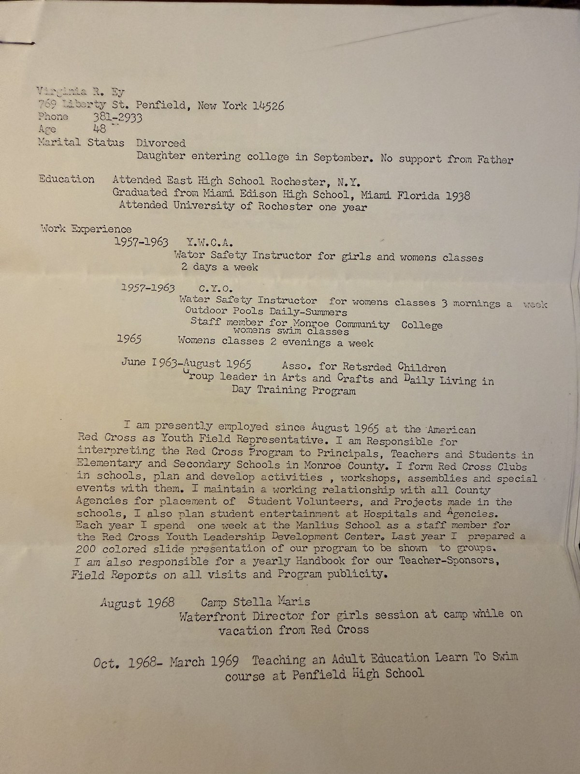
Virginia R. Ey, 769 Liberty Street, Penfield. Age 48. Marital status: divorced. Daughter entering college in September. No support from Father.

And a puzzle in it
One line does not fit anything else in this book: she graduated from Miami Edison High School in Miami in 1938. She had been a junior at East High in Rochester when the newspapers wrote about her father’s voyage, and the Sachem was to have sailed down the Atlantic coast. Whether the Rankins got as far as Florida before the schooner was lost, or whether they simply wintered south while the boat lay at New London, the family was in Miami and Virginia finished school there — in the same year the hurricane came.

Ginny
Virginia outlived all of them. She died at Rochester on 7 January 2013, aged ninety-two, after a long illness, with Marty and Roxanne at her side. Pat had gone before her, and so had both her husbands — Ted Voll and Theodore Ey — and a good friend, George Mennie. Her obituary is headed Voll, Virginia (Rankin Ey): she kept all three names to the end.
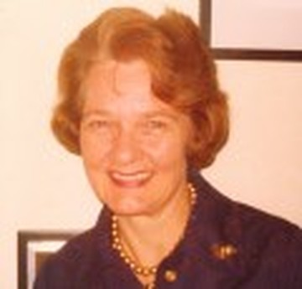
Virginia — Ginny — Rankin Ey Voll, 1920–2013.
It calls her a lifelong resident, and she was: born in the city in September 1920 and dead in it ninety-two years later, with a spell out at Penfield in between. She was active in Reformation Lutheran Church, the Red Cross, the Salvation Army, OASIS and the Stardust Ballroom. The obituary spells her name Ginnie; the family spelled it Ginny. Her family thanked the staff at the Highlands in Pittsford, and asked for contributions to whatever charity the reader liked best. Her warm smile and gentle hugs will be missed, it says, which is the sort of line that only gets written by somebody who meant it.
Two small things fall out of that notice. Her age settles a date the tree had wrong: ninety-two on 7 January 2013 means she was born in September 1920, not 1921. And the church appears for a third time — Roxanne was married there in 1968, Marty’s memorial service was held there in 2017, and Virginia was a member. Reformation Lutheran was her congregation, which means its registers may be a Rankin record rather than an Ey one — and the Rankins are the emptiest branch of this whole tree.
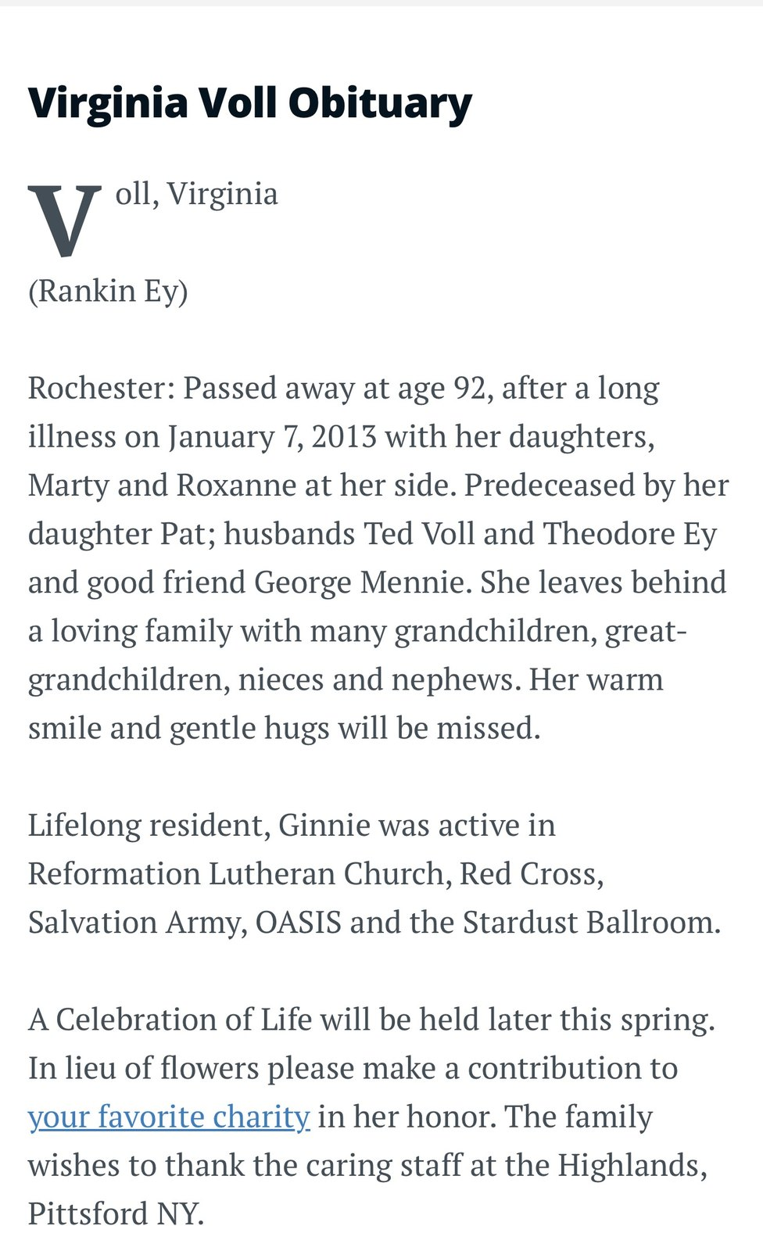
Voll, Virginia (Rankin Ey), Rochester, January 2013.

Three sisters
Photographs of the three Ey girls survive from either side of the divorce, and one of them is the rare thing in this history — captioned and dated by the family at the time. It is a studio portrait signed by Rogers in the corner of the print, with Patricia, Roxanne and Martha ranged left to right, and a caption in the album that reads Patty, Roxy, Marty 11/63, new braces = no smile. Marty is the one on the right, not smiling. She was twelve. Roxanne was sixteen and Patricia about twenty.
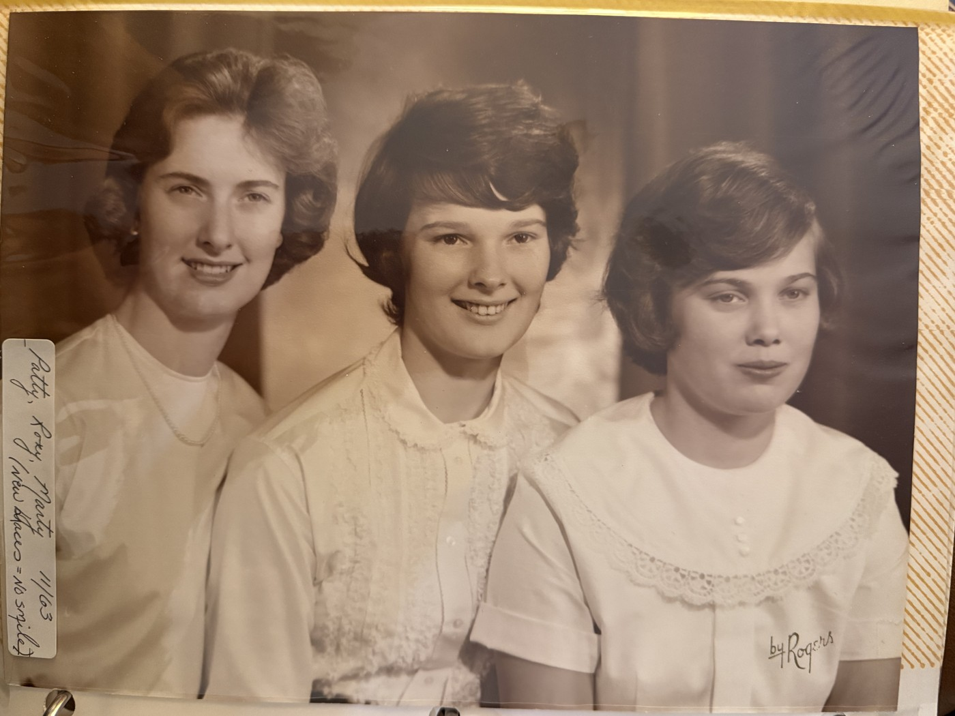
Patty, Roxy, Marty, November 1963, by Rogers — the album’s own caption, and the note that explains why the youngest will not smile.
Two earlier studio groups show the same three, both undated. In the first the sisters are in matching checked dresses with white collars and the youngest is an infant, propped on the seat beside them; in the second she is a toddler of about two, sitting between her sisters in white. The infant is Marty: Roxanne was born in 1947, and the eldest girl in the frame is plainly a schoolgirl. That places the first about 1951 or 1952 and the second a year or two later, with Patricia nine or ten and Roxanne four to six.
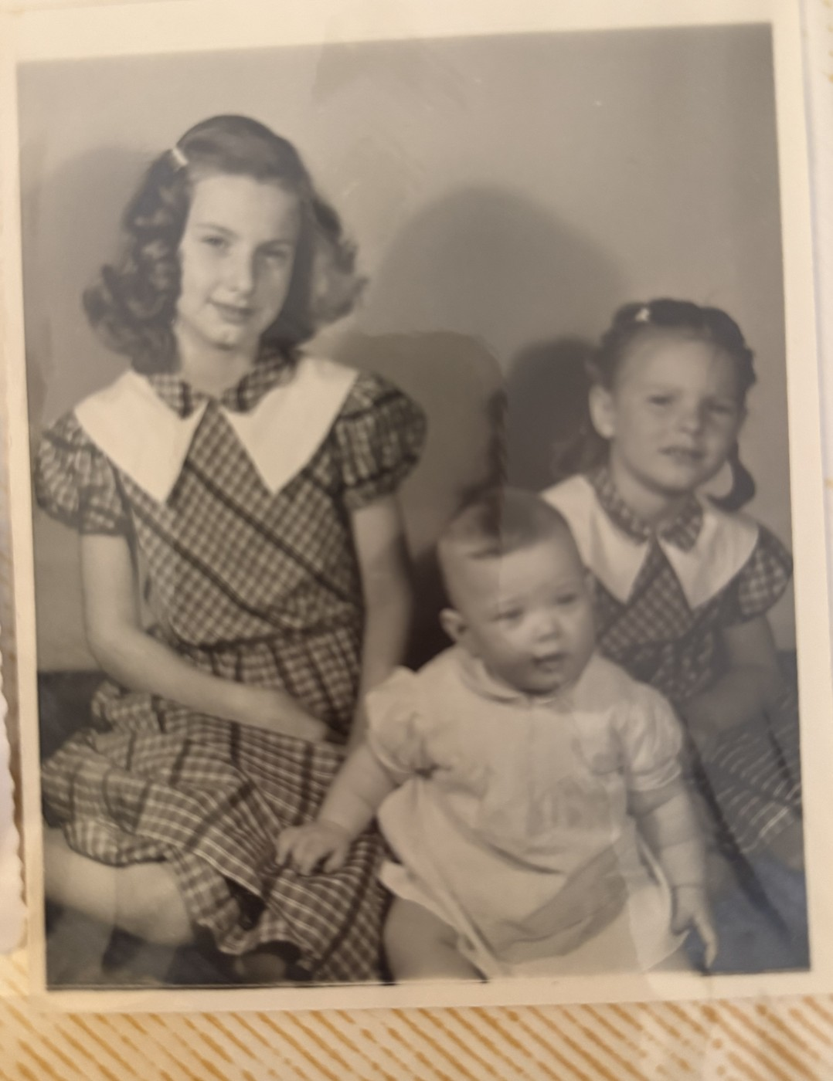
Patricia, Roxanne and Martha Ey, about 1951 or 1952. Undated; placed by the infant’s age.
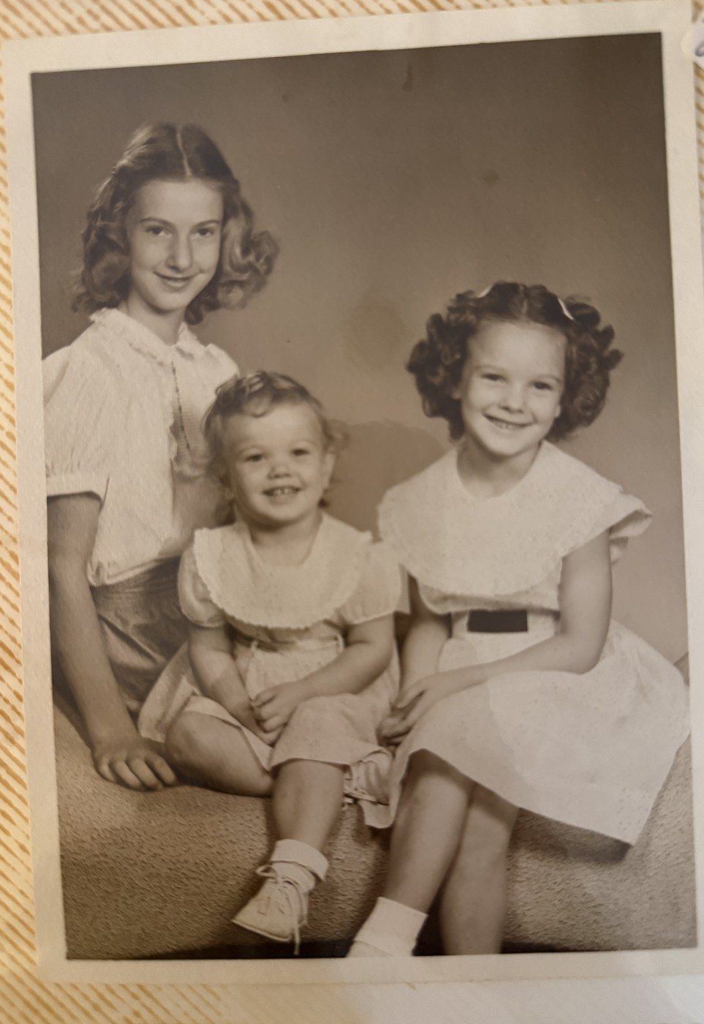
The same three a year or two later, the youngest now a toddler of about two.
Three colour prints record dancing. One shows a girl in a red and gold flounced Spanish costume, a flower in her hair, one arm raised, standing on a lawn beside a paved walk with a long institutional building behind the trees. Its border is stamped JUN 59. A second shows a girl in a pale tutu on grass beside a drive closed off with chained posts — the same grounds, by the trees and the posts, so probably the same place and the same dancing school. The third is a dirndl: dark bodice, white apron, pale blue skirt with a banded hem, in a garden beside a house with a picket fence and a white house behind. A processing stamp dates the print rather than the day, but rarely by more than a few weeks.
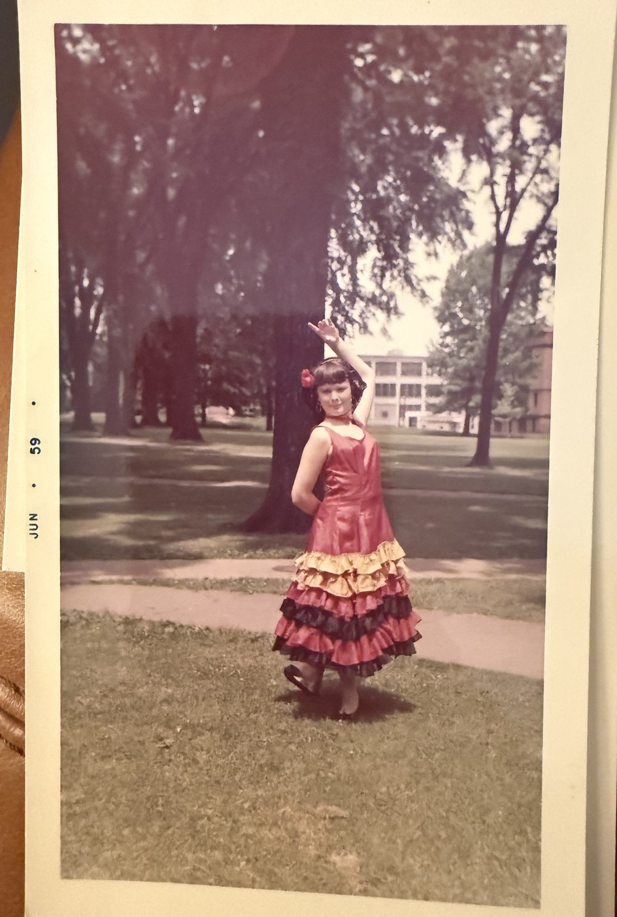
Roxanne in the Spanish costume, aged eleven. The border of this print is stamped JUN 59.
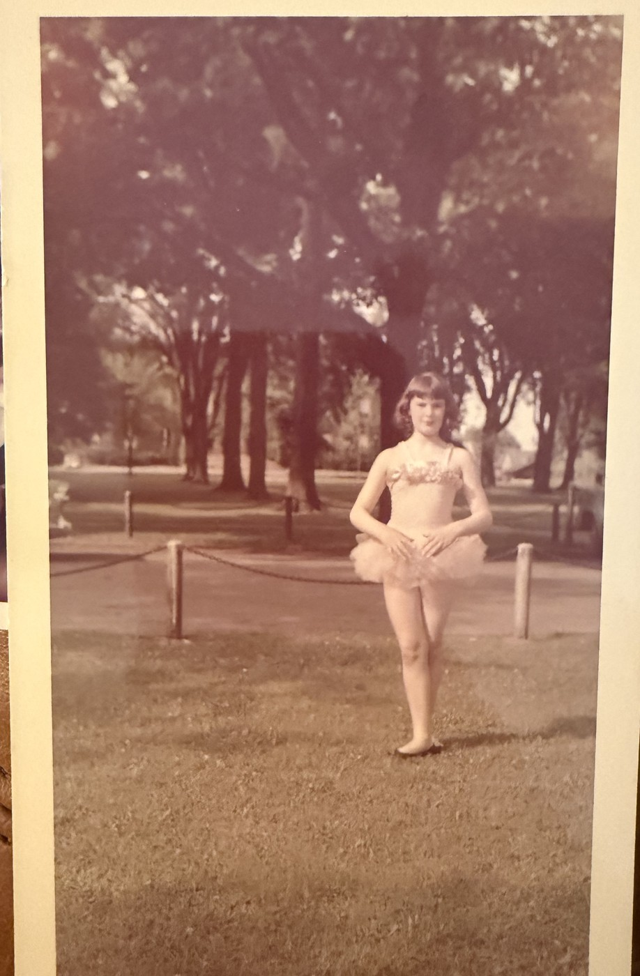
Roxanne in the tutu, on what look like the same grounds. This print carries no stamp of its own; the MAR 64 visible in the photograph belongs to the print lying underneath it.
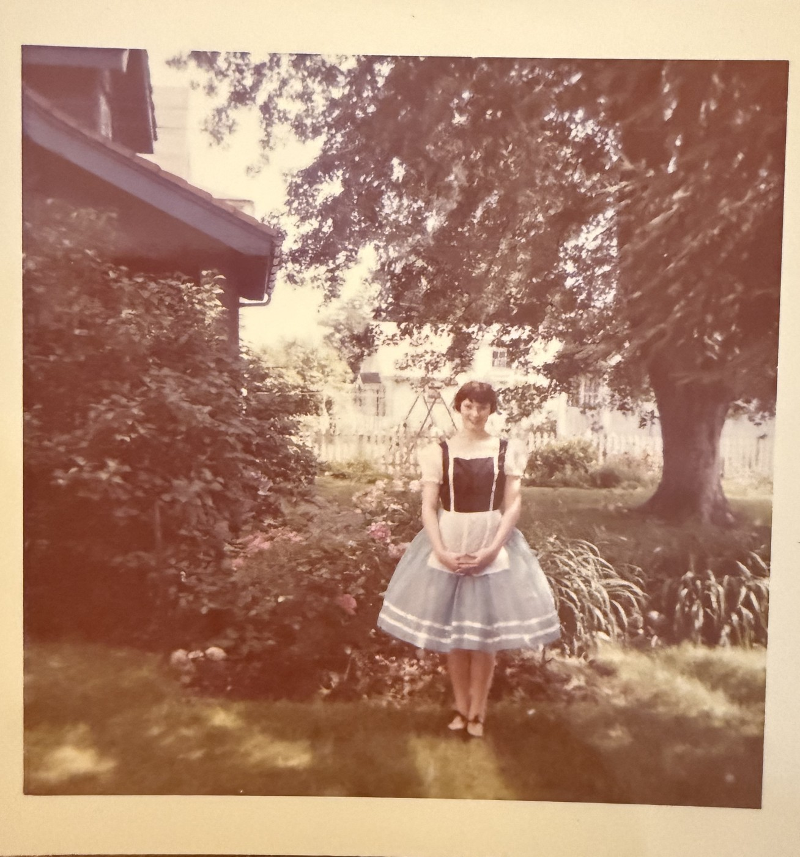
Roxanne in the dirndl, in a garden beside a picket fence. Undated, and the house is not yet identified.
All three are Roxanne, on her own identification. The dated print puts her at eleven in June 1959. The costumes are the sort a dancing school runs through in a single recital season — a Spanish number, a classical number, a folk number — which is why the Spanish and the ballet prints share a background. Which school, where the recitals were held, and whose garden the dirndl was photographed in are all still open.

10. The Two Valleys Meet
This book opened by saying that for a hundred and fifty years the two sides of the family had nothing to do with one another. It is now possible to say exactly where that ended. It ended at Alfred, in Allegany County — a state technical college about sixty-five miles south of Rochester and a hundred and thirty west of Greene, in a village where the students outnumber the residents.
Both of them went there. The wedding announcement says so in a single line: both the bride and her husband are graduates of the State Agricultural and Technical Institute at Alfred. A farmer’s son from the Chenango valley and a bookkeeper’s granddaughter from the Genesee, sent by their families to the same two-year college in the hills, and that is how the Chenango and the Genesee finally found each other.
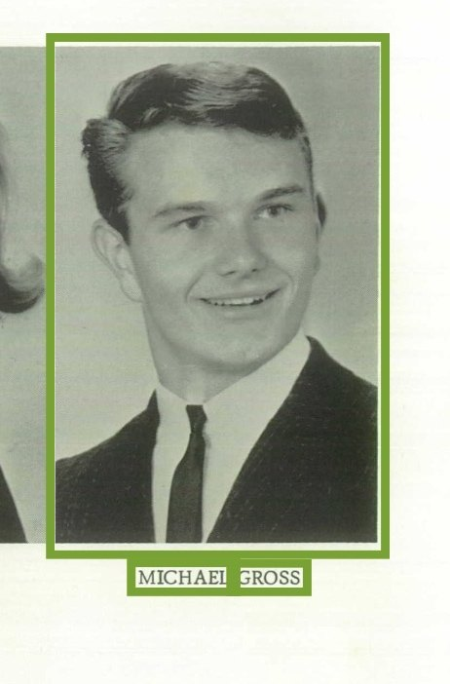
Michael Gross, senior portrait — the same year he and Roxanne were finishing at Alfred.

The wedding
Saturday 4 May 1968. He was twenty-one, she was twenty; the announcement ran in the Binghamton paper the next morning, which is why it says they were married yesterday. It was the spring between the killing of Martin Luther King in April and the killing of Robert Kennedy in June, though nothing in the notice suggests anybody was thinking about that.
They were married in the Lutheran Church of the Reformation, Rochester, at a candlelight ceremony performed by the Rev. Walter Freed. The bride was given in the newspaper as the daughter of Mrs. Virginia Rankin Ey of Penfield; the bridegroom as the son of Mr. and Mrs. Leland J. Gross of Greene. Theodore is not mentioned.
Lynn Bowdey was maid of honour and Wayne Wagner best man. Sarah Schofield and Martha Ey, the bride’s sister, were bridesmaids; Norman Campbell, Lawrence Gage, Albert Prudom and Raymond Stone were ushers. The bride wore a chapel-length satin gown with a lace border at the hem and elbow sleeves, a seed pearl crown holding a chapel-length silk illusion veil, and carried a cascade of white Amazon lilies.
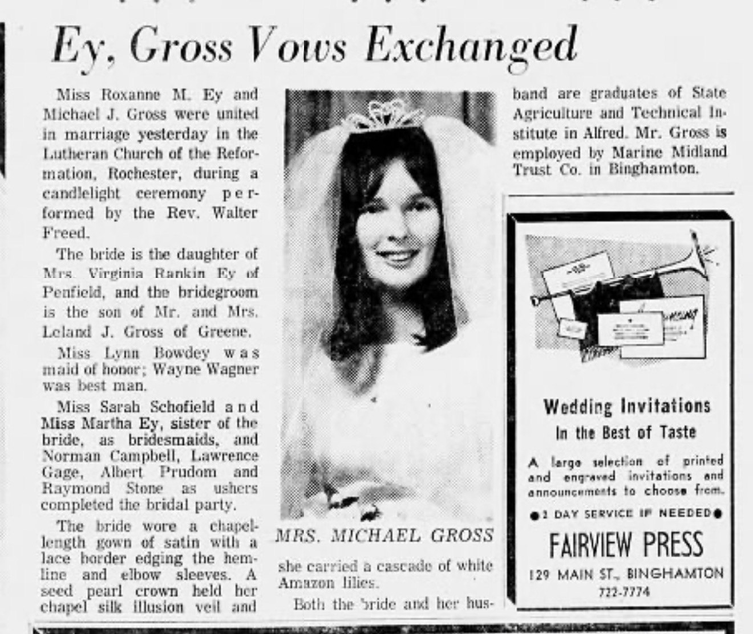
The announcement in the Binghamton paper the following morning. Roxanne wore a chapel-length satin gown and carried white Amazon lilies; her sister Martha was a bridesmaid.
Three of the four parents were alive that Saturday. Leland Gross had eight years to live and Margaret eighteen. Theodore Ey was in Arizona, unmentioned in his daughter’s wedding announcement, and had eight years left himself.
Two details in that announcement reach backwards and forwards through this book. The church is the Lutheran Church of the Reformation — the same congregation that held Marty’s memorial service half a century later, in 2017. That is no longer a single data point: it is the family’s church across at least fifty years, which makes its registers a serious lead rather than a speculative one. And the announcement records that Michael was employed by the Marine Midland Trust Company in Binghamton — the same bank at which his mother Margaret was a mortgage officer.

The generation now
Michael Jay Gross and Roxanne Marcia Ey had two children: Adrienne, born 11 July 1975, and Benjamin, born 23 February 1979. Michael was the third of four and the only son, so the Gross surname in this line runs through him alone.
A small thing, but the kind of thing a family history exists to notice. Leland was born on 22 February, Ben on the 23rd — a day apart and seventy-three years, and Leland died three years before his grandson arrived. Michael was born on 7 February. All three men of the Gross line, in three consecutive generations, were born in the same month.
Of Michael’s three sisters, Leslie and Dorothy are living; Patricia, who married Thomas Aylward, died in 2015. Their children are your first cousins on that side: Kristen Aylward and Abraham Ceesay, both named among Margaret’s four grandchildren in 1986. It is Leslie who kept the album that most of Chapters 3 and 4 come from — the photographs with the captions in a careful hand, dating the wedding suit and naming the one-room school and remembering that Donald died at six. Almost nothing in those chapters could have been recovered from records alone.
Of Roxanne’s two sisters, both have died. Patricia married Ron Mayhew, a large-animal veterinarian, and had two children, Cindy and Stephen. Marty went to Penfield High School, then Brockport, then the University of Connecticut, married David Banister — a classmate from her Penfield biology class — and worked at a recreation centre. She died on 16 September 2017 and her memorial service was held at Reformation Lutheran Church in Rochester. Her own minister signed her guest book. So did the teacher who remembered both her and David from the same classroom, and a friend who wrote about her hats and her glitter-filled birthday cards.
And Marty kept her own name. She married David Banister and stayed Marty Ey, and died as Marty Ey. With her sisters gone, she was the last person in this line to carry it.

The bylines, 1996 to 1997
Fifteen issues of the Mustang Daily, Cal Poly’s student newspaper, have been added to this record. Fourteen of them carry work by Adrienne Gross — seventeen bylined pieces between May 1996 and May 1997, and one further appearance in July 1997 in which she is not the writer but the person being quoted. She was twenty and twenty-one.
This matters to a family history for a reason that has nothing to do with journalism. Every other person in this book is known through documents made about them by somebody else — a census taker, a registrar, an enumerator, an obituary writer. Fitch Gross exists because a clerk wrote him down. Here, for the first and only time in eight generations, an ancestor is the one holding the pen.
The first piece, and the thread it started.
On 21 May 1996 she shares a byline with Ryder M. Beery and Derek Daggett on a front-page story headed Alcohol policy favored by students; not in community. The tag reads Special to the Daily — she was not yet on staff. It is not a write-up of a meeting: the three of them surveyed 480 Cal Poly students and San Luis Obispo residents over twenty-one about proposals to liberalise the campus alcohol policy, and the story is built on their own numbers.
Eight months later she was Daily Staff Writer, and on 13 January 1997 she carried the same story forward alone: the San Luis Obispo Drug and Alcohol Advisory Board had declined to support the university Foundation’s application for a licence to sell alcohol at the new Performing Arts Center. She got six people on the record — the county Drug and Alcohol Services director, two representatives of the state Alcoholic Beverage Control, the PAC’s managing director, an ASI representative, and the Fifth District Supervisor, Mike Ryan, who told her on a Friday that he thought having alcohol on a limited basis was not all that bad. A twenty-one-year-old got an elected county supervisor to say something quotable about a live application.
The interview that turned out to matter.
On 4 February 1997 she wrote up a guest lecture under the head Class welcomes Walter Capps for visit. Capps had been sworn into the United States House of Representatives four weeks earlier, on 3 January, as the member for California’s 22nd district, and he came to a global communications class at Cal Poly. She quoted him directly. He wanted the students to know who he was and to tell him what was on their minds. He said he was so much more an educator than a Democrat, so much more an educator than a politician; he had taught religious studies at UC Santa Barbara for thirty-two years before the campaign. He told them cynicism would hurt them more than anything they were cynical about.
Walter Capps died of a heart attack at Dulles Airport on 28 October 1997, aged sixty-three, on his way back to Washington to vote. He had been in office nine months and three weeks. He was the first Democrat elected from that district since the Second World War, and his widow Lois won the seat in a special election the following March and held it for nearly twenty years. So a Cal Poly junior sat in a classroom in February and took down the words of a man who had eight months to live, and the interview is one of a small number he gave as a congressman. It is now in this family’s papers.
The news beat.
The rest of her news writing that spring circles three subjects. On 24 April she profiled the Multicultural Center, opening with the flat line that most would not describe Cal Poly as an ethnically diverse community and then letting the centre’s director and four students answer it. On 21 May she covered the Clothesline Project in the University Union Plaza, where survivors of sexual violence hung their stories on T-shirts on an ordinary washing line ahead of the Take Back the Night rally. On 29 May she covered an open forum on sexual assault run by the S.A.F.E.R. programme, with the campus outreach coordinator of the Rape Treatment Center in Santa Monica as guest speaker. Twenty-one years old, and the subjects she chose or was given were race on campus and sexual violence.
Arts Weekly.
The rest of the file is arts reporting, and there is a lot of it: STOMP at the Performing Arts Center twice, once as a preview interview with the troupe and once as a review; the Monologue Festival, built around a memorial fund for a Cal Poly theatre student who had died in 1995, which she handled with care; Pacific Repertory Opera’s La Bohème, the first opera ever staged in the new PAC; the Steve Miller Band bringing four eighteen-wheelers and thirty-four people to the Rec Center; the California Festival of Beers at Avila Beach, whose profits went to county hospice; Spike and Mike’s Sick and Twisted Festival of Animation; and Polypalooza, the Sigma Nu benefit for the San Luis Obispo County AIDS Support Network, which she covered twice.
Two of those pieces are worth singling out. On 23 January she reviewed David Crosby’s 1997 tour at Cuesta College and came away with him on the record about his own life — the son he had given up for adoption and was now playing keyboards beside him, the liver transplant, the house lost in the Northridge earthquake, the audit. He asked the audience to keep the Central Coast a secret and to tell everyone it always rains.
And on 13 March she wrote up Victor Borge, then eighty-eight. That piece reaches further back than anything else in her file: Borge trained at the Royal Danish Academy of Music, fled Denmark as a Jew during the German occupation, reached America in 1940 and made his first United States appearance on Bing Crosby’s radio show in 1941. She also noticed, and wrote down, that his audiences were thinning — a house manager at one show inviting the back rows to move down into the empty expensive seats.
The turn, July 1997.
The last appearance is the one that explains the degree. On 17 July 1997 the paper ran a preview of the 27th San Luis Obispo Mozart Festival, and quoted Adrienne Gross, a Cal Poly journalism senior interning for the festival, on the fact that student rush tickets were being offered for the first time — gallery seats at five dollars instead of ten, thirty minutes before curtain. It was, she said, a great way to get more students to come.
That is the whole arc of a degree in one line. In January she was reporting on whether the Performing Arts Center could be licensed to sell a glass of wine; by July she was on the other side of the notebook, doing publicity for a festival in that same building and being quoted by her own newspaper. The journalism was the training; the public relations concentration was the destination. Nearly thirty years of executive communications followed.

11. Threads
Some patterns run right through this family, and they are worth naming because they are the closest thing a genealogy has to a character.

Names carried as inheritances
Look at the men of the 1850s and 1860s: Fitch B. Gross, Judson K. Lounsbury, Nelson C. Butts, John Jay Fenderson. Four given names that are also well-established American surnames, and Fitch, Judson and Nelson are New England names of exactly the kind these families would have married into. Herbert Spencer Ey in the next generation is the same pattern.
Three cases are now solved, and all three worked exactly as predicted. Jay entered the family as John Jay Fenderson, who was simply called Jay, and passed to his grandson Leland Jay Gross and then to his great-grandson Michael Jay Gross. The C in Nelson C. Butts stands for Crandall, his mother’s maiden name, which is how the Crandall line came to be visible at all. And the earliest instance by a century and a half: Hincks Gross, born 1708, was named for his mother Elizabeth Hincks.
Fitch now looks all but settled too. Fitch B. Gross was the son of Micah Gross and Martha Foster — and the New York State census of Greene for 1875 records a boy called Fitch B. Foster living in the same town. Two Fitch B.s a few years apart, one a Gross and one a Foster, in a place where Fitch was already an old settler surname. The name almost certainly came into the family with Martha. Find her father, and the last of the four is closed.
Given names travel the same way. Virginia Gertrude Rankin was named for her mother Gertrude, and Clara Frances Ey for her mother Clara. And Jabez Gross, born on Cape Cod in 1743, was almost certainly named for the Crowells: his mother was Abagail Crowell, and a Jabez Crowell of Eastham had married a Lydia Gross a generation earlier. Whatever else this family did with names, it did not choose them for sound.
That is two out of the four surname cases tested, and it makes the remaining two worth pursuing rather than merely noting. Find each man’s mother’s maiden name and see whether it matches. There were Fitches at Greene from the 1790s, so Fitch was locally available to inherit — which is what the hypothesis needs. Judson K. Lounsbury is the other.

Two farms, and a marriage that closed the circle
John Gross and his brother William bought adjoining farms at the foot of Gross Hill in the 1840s, and John married Elizabeth Aldrich while her brother Nathan took land alongside. A hundred and forty years later Madolyn Gross — John’s descendant, Leland’s sister — married Joseph Gross, who descended from William. Families that stay in one valley for a century end up marrying their neighbours, and their neighbours turn out to be cousins.

Men who buried their wives
Four generations in a row on the Gross side married more than once. Thomas Gross, born 1678, had three wives — Elizabeth, Experience and Joan. His son Hincks had three: Abigail, Bathia and Dorothy. Micah, born 1780, had three: Ann, who was the mother of this line, then Sally, then Lucy. And Leland had two, Laura and Margaret.
Only the last of those was a divorce. The others are what the arithmetic of the period looked like from the inside: women died young, often in childbirth, and men remarried because a farm and a houseful of children could not be run alone. Nine wives across three generations, and the family history remembers the names of every one of them.

Men who left
Raymond Butts walked out in 1919 and came back decades later to a family that had mostly decided against him. Theodore Ey left Rochester for Arizona and died there. Leland Gross had a first marriage that ended in an Albany courtroom and is not otherwise remembered. Three men across two generations, and in each case what survives is the record of a departure rather than an account of it.

February
Leland Jay Gross was born on 22 February 1906, Michael Jay Gross on 7 February 1947, and Benjamin J. Gross on 23 February 1979 — three generations of the male line, three February birthdays, and grandfather and grandson a single day apart. Leland died in 1976, three years before Ben was born, so they never met.

Children who did not grow up
Donald Gross died at six. Kyle Sexton drowned at fourteen. Neither appears in any pedigree chart, because pedigree charts are built from people who had descendants. They belong here.

Women who held things together
Myrtie Fenderson Gross was widowed in 1941 and sold her farm to her son that same year, and lived until 1961. Cora Lounsbury Butts was left with two small daughters in 1919 and got them home from California; she died at forty-five. Her sister Angeline raised Marlea. Margaret Butts was orphaned in effect at a few months old and in fact at twenty-two, and was keeping herself as a bookkeeper in a strange city when she married. Clara Goldsmith Ey raised ten children and was still working in 1930. None of them left a document of their own; all of them are visible only in the margins of other people’s papers.

12. What the Story Still Lacks
Written honestly, a family history should say what it does not know. This one does not yet know:
- Which side of the German-Polish border Johanna Spritzke was born on. One family sheet says Poland, the ancestral-tree chart says Halberstadt.
- Whether Clara Nettie Goldsmith was born at Unadilla, in Otsego County, or at Clarendon, in Orleans County. Two family papers disagree.
- Which dancing school Roxanne attended, where the recitals were held, and whose garden the dirndl picture was taken in.
- What became of Clarence Rankin between September 1938 and his death in 1963 — whether he went back into business, and where he and Gertrude are buried.
- Why the Rankins were in Miami in 1938, and whether the Sachem ever left New London.
- When exactly Theodore and Virginia divorced. She was already divorced and receiving no support by 1969.
- Who Aunt Ethel and Ralph Corrigan were.
- Which province Armenias Fletcher Rankin and Phoebe Maria Reed came from, and when they crossed into New York. Huntingdon is probably Quebec and Murray probably Ontario, but the chart writes P.O. for both.
- Whether the second marriage implied by the 1930 census is real — whether Herman or Clara had married before 1908.
- Where Winifred Eleanor Ey is buried, and what she died of at fifteen in January 1929.
- Which high school Margaret attended, and who she was living with. If it was Schenectady, she came east as a child and the family’s return from California is decades earlier than assumed.
- Whether Leland lies with Margaret at Sylvan Lawn.
- Where and when the two loose snapshots of Edward and Myrtie were taken, and who kept them.
- When Marlea Black was born and when she died, and whether she and Ralph had children — more cousins on that side.
- When Raymond came back, and whether Margaret knew he was still alive when she called him dead in 1941.
- Whether Raymond served in the Philippines, and when. It would explain how the family came to be in California at all.
- How Cora and the girls got home to New York after he left.
- Who Laura was, and what became of her after 1941.
- How Leland and Margaret actually met.
- When Theodore left Rochester, why Arizona, and what happened in that bar.
- What happened at Phoenix on 9 June 1976, and whether the family account of it is right.
- Who Evelyn was, when Theodore married her, and whether she outlived him long.
- Isaac Gross’s English parish — Kelsale in Suffolk, King’s Lynn in Norfolk, or Cornwall — and whether his wife was Mary Howard or Ann Lobley.
- Martha Foster’s father, which should close the Fitch question for good.
- Whether Betsey M. Crandall really was Nelson’s mother, and whether the Crandall descent behind her holds. It is the deepest line in the tree and the least tested.

PART TWO
The People

13. Households
Household by household, oldest first, paternal line then maternal. Names in capitals are direct ancestors. Where a fact is family recollection rather than record, it is marked as such.

13.1 MICAH GROSS and ANN
Where | Town of Preston, Chenango County, New York; later the neighbourhood of North Norwich.
What is known | Micah Gross was among the early settlers of Preston, on the road from Preston to Norwich. Preston was formed in 1806 and its first settler arrived about 1787, so the family was in the county from the 1790s or the first years of the 1800s. Ann is named only as the mother of their son John.
Children | JOHN GROSS, born Preston 1806. Others unknown.
Note on the name | There are two Micah Grosses a generation apart: this one at Preston before 1806, and his grandson Micah, born about 1831, who farmed at Greene.
Note | Recorded as "Micar" in the 1880 directory entry for John. New England given names and an Aldrich marriage in the next generation make an English rather than a German origin more likely for this line than was long assumed.

13.2 JOHN GROSS and ELIZABETH ALDRICH
John | Born at Preston, Chenango County, 1806; died at Greene 1881. Farmer. Son of Micah and Ann Gross.
Elizabeth | Elizabeth Aldrich, 1809–1893, daughter of Nathan Aldrich.
The farm | In the 1840s they bought 160 acres at the foot of Gross Hill in the town of Greene. The farm to the south was bought at the same time by John’s brother William and Elizabeth’s brother Nathan. By 1880 John farmed 450 acres on lot 30, post office Greene.
Children | Fourteen. One of them was MICAH GROSS, born in Chenango County about 1831.
Afterwards | The farm stayed in the family for roughly a century and was sold by their great-great-grandson Leland in 1947.

13.2A MICAH GROSS and MARTHA
Micah | Recorded as Michael in 1865 and Micah in 1870. Born in Chenango County about 1831; died at Greene in 1902. Farmer. Pathmaster for district 93 of the town of Greene in 1893.
Martha | Martha FOSTER, born 1836, died 1910. Widowed by 1910, when she was keeping her own house at about seventy-four, next door to her grandson Edward N. Gross. Her family name is almost certainly where Fitch came from — see Chapter 11.
Children | FITCH B. GROSS, born May 1854. At least one other, on the evidence of the 1865 state census.
Sources | The 1865 New York State census and the 1870 federal census of the town of Greene.

13.3 FITCH B. GROSS and MARIA A. WILLCOX
Fitch | 1854–1911. Leland’s paternal grandfather. A photograph survives of him in later life, in shirtsleeves on a porch.
Maria | Born November 1855, died 1926. Daughter of Charles Willcox, farmer of the town of Oxford, Chenango County, and his wife Levina; at home there aged fourteen in 1870 with a sister Sophia and a brother Inman. The family pronounced her name Ma-RYE-ah. Photographed seated in a studio chair in a white dress, probably in the 1910s.
Children | EDWARD N. GROSS, born March 1880. Mattie L., born about 1885. Claud C., born about 1891. Three children, all living in 1900.
Note | Fitch is a surname used as a given name — see Section 11. There were Fitches in the town of Greene from the first settlement in the 1790s.

13.4 JOHN JAY FENDERSON and ALICE E. CROTSKY
Jay | 1863–1936. Known to the family simply as Jay. Leland’s maternal grandfather. A studio portrait survives of him as a young man.
Alice | 1860–1951. Photographed in old age, outdoors beside a shrub. The spelling of her surname is doubtful — see Section 17.
Children | MYRTIE (MYRTLE) G. FENDERSON, born about 1884 in what is now Endicott, Broome County. Others unrecorded here.
Note | His given name is the origin of the middle name carried by Leland Jay Gross and Michael Jay Gross.

13.5 EDWARD N. GROSS and MYRTIE FENDERSON
Edward | 1880–1941. Born at Greene. Farmer on the Gross farm. Photographed with Myrtie in a formal portrait, bow tie, hair combed flat. A second photograph, a loose undated snapshot, shows him seated on a bench out of doors, white-haired, in an open cardigan.
Myrtie | 1884–1961. Born in what is now Endicott — then the town of Union, Broome County. Widowed 1941; sold the farm to her son Leland the same year. Living at Greene and described as a housewife on his marriage application that November. A loose undated snapshot also survives of her outdoors in a bib apron, laughing, a car and an outbuilding behind her.
Children | Edna. Ralph. LELAND JAY GROSS, 1906–1976. Madolyn, who married Joseph Gross — a descendant of William Gross, whose farm adjoined — and lived until about 2003. Donald, who died at six.
Where they lived | The Gross farm at Genegantslet, town of Greene. Leland was born in a house on the edge of the farm; other houses had been built over the years as the family grew.

13.6 NELSON C. BUTTS and MARY F. McCRAY
Nelson | Nelson CRANDALL Butts, 1857–1929 — his middle name is his mother’s maiden name. Son of Agrippa Butts (b. c. 1798) and Betsey M. Crandall (1812–1887) of New Berlin, Chenango County; aged thirteen in the 1870 census there, with siblings Mary, Jane and Herbert, and his Connecticut-born grandmother Betsey Crandall, eighty-two, in the house. A headstone photograph is attached to the family tree.
Mary | 1862–1935. A photograph survives of the two of them together.
Children | RAYMOND M. BUTTS, 1887. Mary, who married a Rubidge. Serena, who married Francis Cahoon. Esther. Leslie, whose widow was Ruth. May. Florence, who married a Sexton; her son Kyle drowned at fourteen.
The estrangement | When Raymond returned years after leaving his family, Serena was the only one of his brothers and sisters willing to meet him. Esther and Leslie had died; May and Florence refused. Serena and her husband Francis Cohoon were still living at Greene in December 1986 and are named as aunt and uncle in Margaret’s obituary.

13.6A The CRANDALLS behind Nelson Butts
This line is drawn from the Ancestry tree; the join at Betsey has not yet been proved from a record. It is the deepest line in the pedigree.
Betsey M. Crandall | 1812–1887. Mother of Nelson Crandall Butts, whose middle name is hers.
The line behind her | Lodowick Crandall, 1775–1847; Ezekiel Crandall, 1746–1838; James W. Crandall, 1719–1778; John Crandall, 1682–1767; Rev. Samuel Crandall, 1661–1737; and Elder John Crandall, baptised at Westerleigh, Gloucestershire, 15 February 1616/17, died Newport, Rhode Island, 29 November 1676.
Elder John | Son of James Crandall, a yeoman of Kendleshire, and his first wife Eleanor. In New England by 1643. Arrested at Lynn in July 1651 for holding a Baptist service, imprisoned at Boston, fined and publicly whipped. Founding settler of Westerly, Rhode Island, and its first elder and preacher; freeman 1655; conservator of the peace 1670; deputy to the general assembly 1670–71; seized by Connecticut in the boundary dispute in May 1671. Died at Newport during King Philip’s War. First wife’s name unknown; second wife Hannah Gaylord. Nine children.
Not in this family | Elizabeth Maud Drake, given in some trees as Elder John’s mother, with a cousinhood to Oliver Wolcott descending from her. Elder John’s parents were James and Eleanor Crandall.

13.7 JUDSON K. LOUNSBURY and SARAH A. INGRAHAM
Judson | Born February 1863. Found at seventeen in the 1880 census of the town of Greene, at school, in the household of Robert and Angeline Lounsbury with a brother Eugene and a sister Gertrude; and in 1900 at Chenango Town, Broome County, a farm labourer. Died 1930.
Sarah | Born June 1868; died 1907, at about thirty-nine, twenty-three years before her husband.
Children | CORA M. LOUNSBURY, 1884–1929. Angeline — Angie in the 1900 census — who raised her niece Marlea after Raymond Butts left. A son, and possibly others. Note that Angeline was also the name of Judson’s own mother: a given name carried down two generations, like Jay and Crandall.
The surname | Spelled Lounsberry on the 1941 marriage application and Lounsbury in the family tree. The evidence now favours Lounsbury for this branch — a Judson Lounsbury of Chenango Forks died in 2020 aged eighty-six, carrying the family name forward three generations, and Ingrahams were still there too.

13.8 RAYMOND M. BUTTS and CORA M. LOUNSBURY
Raymond | Born Chenango Forks 1888; died 1954. Left his family in 1919, shortly after Margaret was born. Returned years later for a reunion with both daughters. Margaret recorded him as dead on her 1941 marriage application; he was alive, and lived another thirteen years.
Cora | Born Chenango Forks 1884; died 1929, when Margaret was ten.
Children | Marlea, the elder, raised after 1919 by Cora’s sister Angeline; later Marlea Black, wife of Ralph Black of Binghamton, and dead before December 1986. MARGARET ELIZABETH BUTTS, born Oakland, California, 1 June 1919; died 25 December 1986.
Burial | Raymond and Cora are buried together in the Chenango Forks cemetery, twenty-five years apart.

13.9 LELAND JAY GROSS and MARGARET E. BUTTS
Leland | Born Genegantslet, town of Greene, 22 February 1906; died 1976. Greyhound bus driver, then farmer, and later a gas station owner; bought his mother’s farm in 1941 and sold it in 1947. Drafted in the Second World War and exempted for a heart condition. Married twice. His first wife was Laura; that marriage ended in a divorce granted in Albany County on 29 June 1941, by reason of adultery, no co-respondent named.
Margaret | Margaret Elizabeth Butts, born Oakland, California, 1 June 1919; died Christmas Day 1986 at Wilson Memorial Hospital, Johnson City, after a long illness, aged sixty-seven. Bookkeeper at Schenectady when they married; later a mortgage officer at the Marine Midland Bank, Binghamton, from which she retired. A member of the United Church of Christ of Greene. Buried at Sylvan Lawn Cemetery, Greene.
Marriage | Licence applied for at Montrose, Susquehanna County, Pennsylvania, on 29 November 1941; married 20 December 1941. They crossed the state line because a New York decree of that period barred the party found at fault from remarrying in New York.
Children | Leslie, b. 1942 — married to Hans Grysko in 1986 and of Binghamton; the family tree gives her married name as Tuffy, so there were probably two marriages. Patricia G., 1944–2015, married Thomas Aylward of Endwell; daughter Kristen. MICHAEL JAY GROSS, b. 7 February 1947. Dorothy J., b. 1950, married name Ceesay, of Binghamton; son Abraham.
Homes | The Gross farm until 1947; then 16 Willard Street, Greene. Margaret was a resident of Greene until 1974 and afterwards lived at 559 Chenango Street, Binghamton.

13.10 The EY immigrants
Who | August Ey and Johanna Spritzke.
Where | August Ey came from Halberstadt, in the Harz foothills of Saxony-Anhalt. Johanna Spritzke is given as Poland on one family sheet and as Halberstadt on another. They settled at Erie, Pennsylvania, not New York, where the 1880 census finds him a machinist.
How we know | The 1930 census gives Herman born in Pennsylvania of German parents; the 1880 census of the first ward of Erie finds the household; and two sheets of family handwriting supply the names and Halberstadt. Children listed: Johanna, Rose, Herman, Anna, Edward.

13.11 HERMAN A. EY and CLARA NETTIE GOLDSMITH
Herman | Herman August Ey, born Erie, Pennsylvania, 21 September 1877; died 5 October 1937, aged sixty. Came north to Rochester. Salesman in 1930. The 1976 medical chart gives him diabetes and puts his death about 1930 in his late forties, which the family page and his own age both contradict.
Clara | Clara Nettie Goldsmith, born 24 July 1880; died July 1948. Birthplace given as Unadilla, Otsego County, on the family page and as Clarendon, Orleans County, on the ancestral-tree chart. Daughter of Calvin Dwight Goldsmith and Sarah Elizabeth Alsop. In work in 1930. Known in the family as Nettie.
Marriage | 21 October 1908, from the margin of the family page. He was thirty-one, she twenty-eight. The ages at first marriage of twenty and nineteen given to the 1930 enumerator, from which this history previously inferred about 1899, do not fit the birth of the eldest child in May 1910 and should be set aside.
Children | Nine, with dates from the family page. Eugene Harold, b. 24 May 1910. Mildred Louise (Brown), b. 3 June 1912. Winifred Eleanor, 4 October 1913 to 7 January 1929, died at fifteen. Herman August, b. 8 July 1915. Dwight Raymond, 26 July 1917 to 16 March 1974, and Clara Lorraine (Smith), 26 July 1917 to 27 April 1977 — twins. THEODORE FREDERICK EY, 5 January 1919 to 9 June 1976. Spencer Herbert, b. 26 March 1923. Mary Jeanette (Short), b. 17 May 1926. Eight were at home in April 1930, Winifred having died the year before, which is what confirms the page. Six were still living when Theodore died in 1976.
Home | The sixteenth ward of Rochester; a house they owned, valued at $11,000 in 1930, with a radio.

13.11A CALVIN DWIGHT GOLDSMITH and SARAH ELIZABETH ALSOP
Calvin | Calvin Dwight Goldsmith, born Owego, Tioga County, New York, 18 March 1842.
Sarah | Sarah Elizabeth Alsop, born Shropshire, England, 24 May 1843. The English mother the 1930 census recorded behind Clara Nettie.
Marriage | 31 January 1866.
Children | CLARA NETTIE GOLDSMITH, b. 24 July 1880, who married Herman August Ey. Others not yet known.
Worth noting | Owego is twenty miles from Endicott, where Myrtie Fenderson was born — the two sides of this family were within a morning’s drive of one another for a generation and never met. Shropshire is a new county for this history and the only English birthplace in it that is documented rather than argued.
Where to go next | Tioga County records for the Goldsmiths from 1842; the 1866 marriage, which should name both sets of parents; and English parish registers for Alsop about 1843, with the emigration between 1843 and 1866. Try Derbyshire and Staffordshire alongside Shropshire: Alsop is a Derbyshire name from Alsop en le Dale and thins out quickly with distance from that county.

13.12 CLARENCE RUFUS RANKIN and GERTRUDE EMMA NETH
Clarence | Clarence R. Rankin, funeral director, of 756 Main Street East, Rochester; in business there twenty years. Member of the Chamber of Commerce, the Monarch Club and Germania Lodge, Masons. Tall, with reddish hair. Owned a pipe organ. At forty he sold up to sail round the world in the schooner Sachem — see Chapter 7. Born at Rochester about 1899; died 1963, aged sixty-four, of a second heart attack. His full name, from the ancestral-tree chart, was Clarence Rufus Rankin.
Gertrude | Gertrude Emma Neth, born at Rochester about 1899. Died 28 August 1947 at Rochester, aged forty-eight, of uterine cancer; New York State death certificate 48114. Her daughter was named Virginia Gertrude for her. She was to have made the voyage too. She died three months before her granddaughter Roxanne was born.
Children | VIRGINIA GERTRUDE RANKIN, born Rochester 17 September 1920, certificate no. 77105. Others unknown.
Where to go next | The maiden name is now had, and Generation V nos. 28 to 31 are named. What is still wanted: the Rankin marriage record, Monroe County, about 1915 to 1920; the 1925 state census and the 1930 federal census of Monroe County; Rochester directories for the years between 1938 and 1963; and burials for both of them. Gertrude’s death certificate, 48114, will name her parents and confirm the Neth line.

13.12A BERNARD NETH and ANNA FREDERICA HARTMAN
Bernard | Bernard Neth, born in Germany. Died of cancer of the prostate about 1940, aged seventy-nine as the 1976 chart has it, which would put his birth about 1861.
Anna | Anna Frederica Hartman Neth, born at Rochester, New York. Died 1964 of old age, aged ninety-eight, which would put her birth about 1866. She outlived her daughter by seventeen years and lived to see her great-granddaughters.
Children | GERTRUDE EMMA NETH, b. about 1899, who married Clarence Rufus Rankin. Others not yet known.
How we know | The two ancestral-tree charts and the 1976 medical-history chart, both family documents written from memory. Nothing here is yet confirmed from a record.
Where to go next | Rochester city directories and the federal censuses of 1900 to 1940 for Neth, an uncommon spelling; Anna’s death in Monroe County in 1964; and Bernard’s German origin, which is the second documented immigrant line in this family after the Eys.

13.12B ARMENIAS FLETCHER RANKIN and PHOEBE MARIA REED
Armenias | Armenias Fletcher Rankin, of Murray P.O., Canada — Murray Township, Northumberland County, Ontario, on the north shore of Lake Ontario at the west end of the Bay of Quinte. Died of a heart attack at seventy.
Phoebe | Phoebe Maria Reed Rankin, of Huntington P.O., Canada — most probably Huntingdon Township, Hastings County, Ontario, thirty miles from Murray, rather than the better-known Huntingdon in Quebec. P.O. is a post-office address, the ordinary way of writing a rural Ontario address, not a slip for P.Q. Died of old age at eighty-three.
Children | CLARENCE RUFUS RANKIN, b. Rochester about 1899. Others not yet known — and the fact that Clarence was born at Rochester means the couple had already crossed by then.
Why it matters | This is the only Canadian line in the family. Every other branch comes out of New England, New York, Germany or England.
Where to go next | The Canadian censuses of 1851 to 1901 for Rankin in Murray Township, Northumberland County, and for Reed in Huntingdon Township, Hastings County — both Ontario, both Bay of Quinte. Then Ontario civil registration from 1869, the 1878 Belden historical atlas of Hastings and Prince Edward counties, which maps landowners by township, and the crossing into New York before about 1899. Search Armenias, Armenius and Arminius; Reed, Read and Reid.

13.13 THEODORE FREDRICK EY and VIRGINIA GERTRUDE RANKIN
Theodore | Known as Ted. Born Rochester 5 January 1919 — in his own hand on his draft card. Working for the Kee Lox Manufacturing Company, Rochester, in 1940; later at Eastman Kodak. A studio portrait of 19 July 1943 is labelled PFC Ey. Private first class, US Army, in India during the Second World War. Later a mechanical engineer. Died at Phoenix, Arizona, on Wednesday 9 June 1976, aged 57, at 6837 N. 25th Drive; buried with military rites at Glendale Memorial Park, Glendale, Maricopa County. The family says he drank heavily and was killed in a bar.
Virginia | Born Rochester 17 September 1920; died there 7 January 2013, aged ninety-two, after a long illness. Known as Ginny. Educated at East High School, Rochester, and Miami Edison High School, Miami, Florida, where she graduated in 1938; one year at the University of Rochester. Her first job was at the Eastman Kodak main office, 343 State Street, where her identification pass A17256 survives. Afterwards a water safety instructor for the Y.W.C.A., the C.Y.O. and Monroe Community College; group leader for the Association for Retarded Children, 1963–65; and from August 1965 Youth Field Representative for the American Red Cross in Monroe County. Living at 769 Liberty Street, Penfield, in 1969. Keeping house in 1950; living at Penfield in 1968. Married second, between 1974 and 1976 and probably at Plattsburgh, Theodore — Ted — Voll, who died on 2 July 1986. A lifelong Rochester resident, active in Reformation Lutheran Church, the Red Cross, the Salvation Army, OASIS and the Stardust Ballroom. Her later companion, George Mennie, predeceased her.
Evelyn | Theodore’s wife at his death in 1976. Nothing else is yet known of her — not her maiden name, nor when they married.
Marriage | 28 May 1941, at Rochester. The marriage ended in divorce at some point after 1950.
Children | Patricia, b. about 1943; married Ron Mayhew, a large-animal veterinarian; children Cindy and Stephen. Both Patricia and Ron are deceased — Patricia before January 2013, when her mother’s obituary records her as predeceased. ROXANNE MARCIA EY, b. 2 November 1947. Martha "Marty" Ey, b. about 1951 — she entered college in September 1969 — d. 16 September 2017; married David Banister, who survived her, and kept her own surname.
Homes | 262 Champlain Street and later 303 Arnett Boulevard, Rochester, in 1940; house 29A, Enumeration District 69-244, Rochester, in 1950; later the family was in Penfield, where Marty went to high school. Theodore’s last address was 6837 N. 25th Drive, Phoenix.

13.14 MICHAEL JAY GROSS and ROXANNE MARCIA EY
Michael | Born 7 February 1947 near Greene, Chenango County. Third of four children and the only son, so the Gross surname in this line runs through him. Graduate of the State Agricultural and Technical Institute at Alfred; employed at the time of his marriage by the Marine Midland Trust Company, Binghamton — the bank where his mother was a mortgage officer.
Roxanne | Born 2 November 1947 at Rochester, Monroe County. The middle of three sisters. Danced as a girl: photographs survive of her in a Spanish costume in June 1959, aged eleven, and in a ballet tutu and a dirndl. Also a graduate of Alfred, which is where they met.
Marriage | Saturday 4 May 1968, at the Lutheran Church of the Reformation, Rochester, in a candlelight ceremony performed by the Rev. Walter Freed. Lynn Bowdey maid of honour, Wayne Wagner best man; bridesmaids Sarah Schofield and the bride’s sister Martha Ey; ushers Norman Campbell, Lawrence Gage, Albert Prudom and Raymond Stone. The bride was given as the daughter of Mrs. Virginia Rankin Ey of Penfield. Announced in the Binghamton paper the following morning.
Children | ADRIENNE LEIGH GROSS, b. 11 July 1975 at Johnson City, Broome County. Benjamin J. Gross, b. 23 February 1979 — a day after his grandfather Leland’s birthday, and three years after Leland’s death.
Coincidence worth noting | They were born within nine months of each other in 1947, a hundred and thirty miles apart, into families that had never heard of one another.
Where | Fort Lauderdale, Florida, then Gaithersburg, Maryland, then Hollis, New Hampshire, where they were living in December 1986 and remained until June 1992; then Moorpark, Ventura County, California.

13.15 ADRIENNE LEIGH GROSS and ROBERT SCOTT BABCOCK
Adrienne | Born 11 July 1975 at Johnson City — in the town Endicott-Johnson built, and a generation after her great-grandmother Myrtie Fenderson was born a few miles away in what became Endicott.
Robert | Born 1973.
Children | Robert S. Babcock, b. 1999. Dylan Alan Babcock, b. 2001. Danielle L. Babcock, b. 2007.
Where | Johnson City, New York; Fort Lauderdale, Florida; Gaithersburg, Maryland; Hollis, New Hampshire, from third grade to June 1992; Moorpark, California, 1992–2002, with San Luis Obispo for college from August 1993 to December 1997; Fresno, California, 2002–2007; Moorpark again, 2007–2018; Frisco, Texas, from June 2018.
In print | Seventeen bylined pieces in the Mustang Daily as Adrienne Gross, May 1996 to May 1997, as Special to the Daily, then Daily Staff Writer, then Arts Weekly Staff Writer. Quoted in the same paper in July 1997 as a journalism senior interning for the San Luis Obispo Mozart Festival. See Chapter 10.

PART THREE
The Places

14. Four Localities
Ancestors are not names on a chart; they are people who took particular jobs in particular towns for particular reasons.

14.1 Greene and Genegantslet, Chenango County
Greene sits on the Chenango River about twenty-two miles south-west of Norwich. The land east of the river was part of a purchase made by the State from the Oneida and Tuscarora in 1785 and sold on to patentees. Stephen Ketchum settled within the bounds of the present village in 1792; the French colony came the following year and broke up. Permanent settlement came from New England and the Hudson Valley: Nathaniel Kellogg, Zopher Betts, Benajah Loomis, Cornelius Hill and Daniel Tremaine at East Greene in 1793; Conrad Sharp, a Dutchman from the east of the state; and along the Chenango Road between 1792 and 1795 the Bennetts, Roots, Skinners, Elliotts, Fitches and Clemmonses.
The town was organised in 1798, in the same month Chenango County was created; the first town meeting was held at Conrad Sharp’s house that April. The Chenango Canal came through in the 1830s and the village was incorporated on 12 April 1842. By the 1860s it had four churches — Baptist, Congregational, Episcopal and Methodist — a union school, two banks, two hotels, a grist mill, a foundry and about 850 people. Later industry meant the Page Seed Company, founded 1896, and the Lyon and St. John Iron Works, whose successor the Raymond Corporation became one of the county’s largest employers.
Genegantslet, where Leland was born, is one of the hamlets of the town, on the creek of the same name — an Indian word glossed by one nineteenth-century authority as the Three Deer-Lick river and by others as Pleasant Stream. The creek runs some twenty-two miles down from the high country to join the Chenango south of Greene. The Second Baptist Church Society of Greene was organised on the Genegantslet in 1807 by Elder Jeduthan Gray, who was its pastor for twenty-five years.

14.2 Chenango Forks and Johnson City, Broome County
Chenango Forks is a hamlet in Broome County, partly in the town of Chenango and partly in Barker, about nine miles north of Binghamton where the Chenango meets the Tioughnioga, and a few miles from the Chenango County line. Raymond Butts and Cora Lounsbury were both born there, and both are buried there. It is fifteen to twenty miles from Greene.
Downriver is Johnson City, where you were born, and it is not an ordinary village. The Lester Brothers Boot and Shoe Company moved west from Binghamton in 1890 and the settlement around the factory was incorporated as Lestershire in 1892. Financial trouble brought in a creditor and fellow shoemaker, Henry B. Endicott; his foreman and then partner George F. Johnson bought half the business, and in 1916 the village renamed itself for him.
What Endicott-Johnson did next shaped the whole Triple Cities. Johnson called it the Square Deal: an eight-hour day decades before it was standard, company medical care, profit sharing, thousands of houses sold to workers at cost, a library, parks, and six carousels the county still rides free. The workforce peaked around twenty thousand in the 1920s and ran higher in the mid-1940s, when military contracts pushed output to some fifty-two million pairs of shoes a year. The company advertised for labour in European newspapers, which is why the Triple Cities absorbed large Slovak, Italian, Polish, Russian, Ukrainian and Lithuanian populations. The last plant closed in 1993.
Myrtie Fenderson was born in what became Endicott, a few miles away, about 1884 — so the family was in that corner of Broome County a generation before you were born there.

14.3 Rochester and Penfield, Monroe County
Monroe County was created in 1821 from Genesee and Ontario Counties, in land opened by the Phelps and Gorham Purchase of 1788. The Genesee falls made Rochester a milling centre and the Erie Canal made it a city — the Flour City, then the Flower City as the nurseries took over. Industry diversified through the nineteenth century into clothing, furniture, caskets, dental chairs, optics at Bausch & Lomb from 1874 and photography at Eastman Kodak, and that industry pulled in Irish and Germans first, then Italians, Poles and other Eastern Europeans. It was also a centre of reform: Frederick Douglass published The North Star there and Susan B. Anthony made it the headquarters of the suffrage movement.
The Eys lived in the sixteenth ward in 1930 and at house 29A in Enumeration District 69-244 in 1950. By the time Marty reached high school the family had moved east to Penfield, and Fairport adjoins it — which is where she was living when she died.

14.4 Oakland, Alameda County, California
Oakland in 1919 was one of the three fastest-growing cities in the United States, climbing from about 67,000 people in 1900 to 284,000 by 1930. Two things drove it. The 1906 San Francisco earthquake and fire sent perhaps a hundred and fifty thousand refugees across the bay, effectively doubling Alameda County’s population while San Francisco rebuilt. And the shipping channel dredged from 1902 turned Oakland into a working seaport: by the First World War the estuary carried a dozen shipbuilders employing some forty thousand men. Automobile assembly followed from Detroit — Chevrolet in 1916, then Durant, Star and Willys-Overland, with Coast Tire and Rubber opening in 1919, the year Margaret was born. The 1920 census counted 216,261 people in the city.
It was a place people moved to, which is what the Butts family did, and a place people left again, which is what Cora and her daughters did after Raymond went.

PART FOUR
The Evidence

14.5 The moves
The four localities above are places families stayed. This one is a list of departures, and it belongs here because it is the first generation in this book that did not stay anywhere.
Born at Johnson City in July 1975, in the valley where the Grosses and Fendersons had been for a century and a half. Then Fort Lauderdale, Florida. Then Gaithersburg, Maryland. Then Hollis, New Hampshire, from third grade until June 1992 — the longest stretch, and the one that covers school from eight or nine years old to the end of eleventh grade. Then Moorpark, in Ventura County, California, in 1992, which meant a senior year of high school begun in a state she had not lived in.
Moorpark held from 1992 to 2002, with San Luis Obispo overlaid on it from August 1993 to December 1997 for Cal Poly. Then Fresno, in the San Joaquin Valley, from 2002 to 2007. Then Moorpark again from 2007 to 2018 — the only place in the list she returned to. Then Frisco, Texas, from June 2018.
Set against the rest of the book the shape is plain. The Grosses held one farm at Genegantslet for three generations. The Fendersons stayed in Broome County. The Eys stayed in Rochester from the eighteen-nineties to the nineteen-seventies. The Butts line is the one precedent for movement, and it moved once — Nelson and Cora out to Oakland, and their daughter Margaret back east again to marry. Nine moves across four time zones in forty-three years is a different kind of life from any of them, and it is the reason this history had to be assembled out of albums and certificates in the first place: nobody stayed in the county where the records are kept.

15. The Pedigree
Ahnentafel numbering: you are 1, your father 2, your mother 3; each person’s father is double their number and their mother double plus one.
No. | Name | Born | Birthplace
1 | Adrienne Leigh Gross | 11 July 1975 | Johnson City, Broome Co., NY
2 | Michael Jay Gross | 7 February 1947 | Near Greene, Chenango Co., NY
3 | Roxanne Marcia Ey | 2 November 1947 | Rochester, Monroe Co., NY
4 | Leland Jay Gross | 22 Feb 1906 – 1976 | Genegantslet, Greene, Chenango Co.
5 | Margaret Elizabeth Butts | 1 June 1919 – 25 Dec 1986 | Oakland, CA; died Johnson City, buried Greene
6 | Theodore Frederick Ey | 5 Jan 1919 – 9 June 1976 | Rochester; died Phoenix, buried Glendale, AZ
7 | Virginia Gertrude Rankin | 17 Sep 1920 – 7 Jan 2013 | Rochester, Monroe Co., NY
8 | Edward N. Gross | 1880–1941 | Greene, Chenango Co., NY
9 | Myrtie (Myrtle) G. Fenderson | 1884–1961 | Town of Union (now Endicott), Broome Co.
10 | Raymond M. Butts | 1888–1954 | Chenango Forks, Broome Co., NY
11 | Cora M. Lounsbury | 1884–1929 | Chenango Forks, Broome Co., NY
12 | Herman A. Ey | 1877–1937 | Erie, Erie Co., Pennsylvania
13 | Clara Nettie Goldsmith | 1880–1948 | Unadilla or Clarendon, N.Y. — the two family papers disagree
14 | Clarence Rufus Rankin | c. 1899 – 1963 | Rochester; d. 1963, aged 64
15 | Gertrude Emma Neth | c. 1899 – 28 Aug 1947 | Rochester; d. aged 48, cert. 48114
16 | Fitch B. Gross | May 1854 – 1911 | Greene, Chenango Co.; m. Maria c. 1876
17 | Maria A. Willcox | Nov 1855 – 1926 | Dau. of Charles Willcox and Levina, of Oxford, Chenango Co.
18 | John Jay Fenderson | 1863–1936 | —
19 | Alice E. Crotsky | 1860–1951 | Spelling doubtful
20 | Nelson Crandall Butts | 1857–1929 | Son of Agrippa Butts and Betsey M. Crandall, of New Berlin
21 | Mary F. McCray | 1862–1935 | —
22 | Judson K. Lounsbury | Feb 1863 – 1930 | Son of Robert and Angeline Lounsbury, town of Greene
23 | Sarah A. Ingraham | June 1868 – 1907 | —
24, 25 | August Ey and Johanna Spritzke | Both b. Germany | He of Halberstadt; she given as Poland on one sheet and Halberstadt on the other. A machinist and his wife, at Erie, Pennsylvania, in 1880. Children: Johanna, Rose, Herman, Anna, Edward.
26, 27 | Calvin Dwight Goldsmith and Sarah Elizabeth Alsop | 1842–; 1843– | b. Owego, Tioga Co., N.Y., 18 Mar 1842; b. Shropshire, England, 24 May 1843. Married 31 Jan 1866.
28–31 | Bernard Neth and Anna Frederica Hartman; Armenias Fletcher Rankin and Phoebe Maria Reed | Neth d. c. 1940; Hartman d. 1964; Rankin and Reed dates unknown | —
All eight of your great-grandparents are named, and so, as of this edition, are all sixteen of the generation behind them. The last eight blanks — the Ey immigrants, the Goldsmith grandparents and the four Rankin great-great-grandparents — were filled from family papers in September 2026. Six of the eight have nothing behind them but a name and a country, and four of those are undocumented outside the family charts. Beyond Generation V, one line runs further still: John Gross and Elizabeth Aldrich in Generation VI, and Micah and Ann Gross in Generation VII.

10.4a The Gross line, generation by generation
From the immigrant to your father. The colonial generations come from a family chart compiled in 2000 and are corroborated for Isaac by the Great Migration literature; the New York generations are documented in this file from censuses and the 1880 county history.
Generation | Name | Dates and places
Immigrant | Isaac Gross | b. c. 1585–91; came to Massachusetts Bay c. 1635; admitted to the First Church of Boston 17 April 1636; d. Boston, between 29 May and 5 June 1649. Husbandman and brewer. English home disputed — Kelsale (Suffolk), King’s Lynn (Norfolk) or Cornwall. Wife given as Mary Howard or as Ann Lobley.
2 | Clement Gross | b. 18 Feb 1616, Bodmin, Cornwall; d. after 1691, Boston. Innholder. m. Mary (1626–1666) in 1649.
3 | Simon Gross | b. 1652, Boston; d. 26 Apr 1696, Boston. m. Mary Bond of Haverhill, 23 October 1675.
4 | Thomas Gross | b. 4 Nov 1678, Hingham, Mass.; d. 14 Mar 1728. Three wives: Elizabeth Hincks, Experience, Joan.
5 | Hincks Gross | b. 1708; d. 1786. In business. Named for his mother’s family. Three wives: Abigail Crowell, Bathia, Dorothy.
6 | Jabez Gross | b. 1743 at Billingsgate (Eastham), Massachusetts; d. 26 Mar 1819 at Garrattsville, New Lisbon, Otsego Co., N.Y. Farmer; remembered as a minuteman in the Revolution. m. Dorothy Ellis at Truro, Mass., 24 October 1763; she d. 1821 and is buried in the Gross Hill cemetery at Garrattsville.
7 | Micah Gross | b. 1780; d. 1858 at South Plymouth, Norwich, Chenango Co., N.Y. Cooper. Early settler of the town of Preston. Three wives: Ann, the mother of this line, then Sally, then Lucy.
8 | John Gross | b. Preston 1806; d. Greene 1881. m. Elizabeth Aldrich, 1809–1893, daughter of Nathan Aldrich. Bought 160 acres at the foot of Gross Hill in the 1840s; 450 acres by 1880. Fourteen children.
9 | Micah Gross | b. 1831; d. Greene 1902. m. Martha Foster, 1836–1910. Pathmaster for the town of Greene, 1893.
10 | Fitch B. Gross | b. May 1854; d. Greene 1911. m. Maria A. Willcox, Nov 1855–1926, about 1876.
11 | Edward N. Gross | b. Greene 1880; d. Greene 1941. m. Myrtie Fenderson, 1884–1961, about 1902.
12 | Leland Jay Gross | b. Genegantslet 22 Feb 1906; d. 1976. Bus driver, farmer and gas station owner. Two wives: Laura, and Margaret Butts.
13 | Michael Jay Gross | b. 7 Feb 1947.
Behind Isaac the same chart runs back through Kelsale in Suffolk to a William LeGross of 1282. That earlier stretch is not supportable and is discussed in Chapter 2.

10.4b Generations VI and VII on the Gross line
One discrepancy to resolve. The family account calls Madolyn — Leland’s sister — John’s great-great-granddaughter, which would make John the grandfather of Fitch B. Gross and imply a missing generation. The arithmetic points the other way: a man born in 1806 who bought a farm in the 1840s and had fourteen children fits comfortably as the father of a son born in 1854. Treat John as Fitch’s father provisionally.

16. The Sources
Everything in this history rests on one of these.

16.1 Marriage licence application, Susquehanna County, Pennsylvania, 29 November 1941
Application No. 394, sworn before Ruth Lamb, Deputy Clerk of the Orphans’ Court. Establishes Generation IV nos. 8 to 11 by name; both applicants’ ages, occupations, birthplaces and residences; that both of Margaret’s parents were dead; and Leland’s divorce — Albany County, 29 June 1941, adultery, no co-respondent named. It also settles the spelling of Fenderson.
Note that the spellings on the form are the clerk’s rendering of spoken names, and that "Endicott" is anachronistic for an 1884 birth — Myrtie was born in the town of Union, which became Endicott in 1906.

16.2 Fifteenth Census of the United States, 1930
Rochester, Ward 16, Enumeration District 28-151, sheet 11B, enumerated 11 April 1930 by Martha Moore. Establishes Generation IV nos. 12 and 13; Herman born in Pennsylvania with both parents born in Germany; Clara born in New York with an English-born mother; ages at first marriage of 20 and 19; eight children by name.
Herman and Clara gave their ages at first marriage as twenty and nineteen, which places the marriage about 1899.

16.3 1950 Census of Population and Housing
Rochester, Enumeration District 69-244, sheet 72, lines 9 to 12, house 29A, enumerated by Mary C. Curley. Establishes Theodore alive on 1 April 1950 — the first documented floor under his death — Patricia’s existence and approximate birth year, and Virginia’s age of twenty-nine, exactly consistent with a birth on 17 September 1920.

16.4 Obituary of Marty Ey, 19 September 2017
Richard H. Keenan Funeral Home, Fairport, New York, with guest book. The first record this research located rather than received. Establishes her death on 16 September 2017; Penfield High School, SUNY Brockport, the University of Connecticut; the memorial service at Reformation Lutheran Church; that David survived her; and, in a guest book entry describing her as special to her niece and nephew Cindy and Steve, the confirmation that this is the right family.

16.5 The Gross family album, compiled by Leslie Gross Tuffy
Photographs with manuscript captions. The captions are recollection written down long after; the photographs are contemporary. Between them they supply most of Chapters 3 and 4: the farm at the foot of Gross Hill, started in the 1840s by John and Elizabeth Aldrich Gross, 160 acres, fourteen children, sold by Leland in 1947; William Gross and Nathan Aldrich on the farm to the south; Leland born at Genegantslet; his purchase of the farm from his mother in 1941 and his years driving for Greyhound; the draft and the heart-condition exemption; the wedding on 20 December 1941; 16 Willard Street; his siblings Edna, Ralph, Madolyn and Donald; Maria pronounced Ma-rye-ah; Jay Fenderson known as Jay. And on the Butts side: Raymond’s departure in 1919, Marlea raised by Angeline, the later reunion at which only Serena would see him, and the shared grave at Chenango Forks.
One caption needs reading against the record. The family account is that they married quickly after Pearl Harbor because Leland expected to be drafted; the licence application was sworn on 29 November, eight days before Pearl Harbor, and the wedding followed on 20 December, thirteen days after it.

16.6 Theodore Ey’s draft registration card, 16 October 1940
Serial number 285, order number 1185, completed and signed by him. Settles the birth date beyond argument: Theodore Frederick Ey, born 5 January 1919 at Monroe County, New York, aged twenty-one. Gives his address as 262 Champlain Street, Rochester, amended to 303 Arnett Boulevard; his telephone as Genesee 1766; his employer as the Kee Lox Manufacturing Company, 10 Keelox Place; and, as the person who would always know his address, Mrs Clara Nettie Ey, mother.
It also settles the spelling: he wrote Frederick, with the second e, though the 1930 census and the family both give Fredrick.

16.7 His obituary, June 1976
Establishes his occupation as mechanical engineer; his age at death as 57; his address as 6837 N. 25th Drive; his wife Evelyn; his three daughters as Patricia Mayhew, Roxanne Gross and Martha Bannister; three surviving brothers and three sisters; three grandchildren; graveside military rites at Glendale Memorial Park; and viewing at Sunset Chapel, 301 W. Camelback.

16.8 Find a Grave memorial 11037734, with headstone photograph
Theodore F. Ey, born 5 January 1919 in New York, died 9 June 1976 at Phoenix aged 57, buried at Glendale Memorial Park, Glendale, Maricopa County. The government marker reads THEODORE F EY, PFC, US ARMY, WORLD WAR II, 1919–1976.

16.9 The Ancestry tree
Not an original record, and treated as family report pending verification. It is the source for Generation V, for the Crandall descent behind Betsey M. Crandall, and for several dates. Corrections to make in it: amend Fernderson to Fenderson; record Virginia’s birth as 1920 rather than 1921, since the 1950 census age of twenty-nine fits September 1920 and is a year out for 1921; mark Patricia Ey deceased and record her married name Mayhew; add Martha "Marty" Ey with her 2017 death; correct Theodore’s dates to 5 January 1919 and 9 June 1976, with burial at Glendale rather than Chandler; and record Margaret Elizabeth Butts as 1 June 1919 to 1986.
And one line should be removed rather than corrected: Elizabeth Maud Drake as the mother of Elder John Crandall, and the Oliver Wolcott connection that hangs from her. See Chapter 4.

16.10 Two loose photographic prints of Edward and Myrtie
Supplied in September 2026, outside the album at 16.5. Two small snapshot prints with deckled white borders, neither dated nor captioned, showing a white-haired man seated on a bench beside a rail fence and a woman in a bib apron standing out of doors. Identified by the family as Leland’s parents; Myrtie is corroborated by the studio portrait in the album. Provenance, date and anything written on the reverse are still to be established.

16.11 Ey family photographs
Supplied in September 2026. Six prints: two undated studio groups of the three sisters, an album page carrying a studio portrait signed by Rogers with the manuscript caption Patty, Roxy, Marty 11/63, new braces = no smile, and three colour prints of dance costumes, one of them stamped JUN 59 in its border. The 1963 caption is contemporary and is the only date in the group that is written rather than inferred. Roxanne has identified all three dance prints as herself; the recitals, the dancing school and the garden in the dirndl print are not yet established.

16.12 The Ey family papers
Three sheets of ruled loose-leaf in a family hand, supplied September 2026. The first, headed Ey Genealogy, establishes Herman August Ey’s birth at Erie on 21 September 1877 and death on 5 October 1937; Clara Nettie Goldsmith’s birth on 24 July 1880 and death in July 1948; their marriage on 21 October 1908; and their nine children with dates, including the twins Dwight Raymond and Clara Lorraine and the death of Winifred Eleanor at fifteen. The second names August Ey of Halberstadt and Johanna Spritzke and their five children, and gives Calvin Dwight Goldsmith of Owego, Sarah Elizabeth Alsop of Shropshire, and their marriage on 31 January 1866. The third lists three deaths and the households of Theodore’s brothers and sisters.
The pages are undated and unsigned. They correct the 1930 census on five of the eight children’s names and on the date of the marriage, and the census checks them in return.

16.13 The 1976 medical-history chart
One sheet, drawn as two four-generation charts headed Mother, age 55 and Father, age 57, with causes of death against each name. It supplies Gertrude Neth’s maiden name, her death in August 1947 at forty-eight of uterine cancer, Clarence Rankin’s death in 1963 at sixty-four, Bernard Neth and Anna Hartman with their deaths, and Armenius Rankin and Phoebe Reed with theirs. It is memory written down, not record, and it errs where it can be checked: it puts Herman Ey’s death about 1930 in his late forties against a documented 5 October 1937 at sixty. Treat the causes of death as family report. The ages given for Virginia and Theodore confirm births in September 1920 and January 1919.

16.14 The two ancestral-tree charts
A pair of school-project pages, My Ancestral Tree, mother’s side and father’s side, drawn in ink with printed decoration. Between them they give the full names Gertrude Emma Neth, Clarence Rufus Rankin, Anna Frederica Hartman Neth, Bernard Neth, Phoebe Maria Reed Rankin and Armenias Fletcher Rankin, with birthplaces; and on the father’s side Clarendon for Clara Nettie Goldsmith and Halberstadt for both August Ey and Johanna Spritzke. Where they disagree with 16.12 — Clarendon against Unadilla, Halberstadt against Poland — neither has priority and both should be tested.

16.15 The birth records of 1947
Four documents. The New York State certification of birth for Roxanne Marcia Ey, registration district 2701, registered number 10016, born 2 November 1947 at Rochester, Monroe County, filed 4 November 1947, issued 15 September 1965 over the signature of an assistant registrar. Her baby book, which adds St Mary’s Hospital, Sunday the 2nd of November, 3:07 P.M., and Dr Joseph Cooney. The Albany certificate of birth registration for Michael Jay Gross, born 7 February 1947 at Greene, son of Leland Jay Gross and Margaret Elizabeth Butts, filed 12 February 1947 by the local registrar Willard F. Knickerbocker. And the family-tree page of his baby book, giving Leland Jay born Greene 22 February 1906, Margaret born Oakland, California, 1 June 1919, and the grandparents Edward, Myrtie, Raymond and Cora.

16.16 New York State death index
Consulted online for Rankin. Gives Gertrude Rankin, died 28 August 1947 at Rochester, aged forty-eight, certificate number 48114. The only entry in this history confirmed from a public index rather than a family paper.

16.17 Surname authorities for the maternal names
For the names added in this edition: the Dictionary of American Family Names, 2nd edition (Oxford, 2022) on Neth, Alsop and Hartman; the Concise Oxford Dictionary of Family Names in Britain on Alsop; US census surname counts for Neth; the Alsop and Allsopp one-name studies on Alsop en le Dale; and, for Spritzke, an argument from the morphology of German surnames of Slavic derivation rather than an entry in any dictionary — it is not in them.

16.18 Reclaim The Records: New York State Death Index
Free public-domain scans of the New York State Death Index, 1880 to 1956, hosted on the Internet Archive. The source behind the Gertrude Rankin entry at 16.16, and the cheapest route to six more deaths in this history. See 19.3.

16.19 Ontario geography for the Rankin line
Wikipedia and WeRelate on Murray Township, Northumberland County — a Loyalist township on the north shore of Lake Ontario at the west end of the Bay of Quinte, amalgamated into Quinte West in 1998 — and on Huntingdon Township, Hastings County, amalgamated with Madoc in the same year to form Centre Hastings; the 1878 Belden Historical Atlas of Hastings and Prince Edward Counties, which maps a village of Huntingdon in that township. Together they place both of the chart’s Canadian post offices in Ontario, thirty miles apart, rather than in two provinces.

16.20 The Mustang Daily, 1996 to 1997
Fifteen issues of the Cal Poly student newspaper, supplied September 2026 as page scans with a text layer. Fourteen carry work by Adrienne Gross. The full run of the paper, under its various mastheads from 1916 to 2011, is digitised and free on the university’s DigitalCommons, so the remainder of her file — and any issues between December 1997 and her graduation — can be recovered there. This is the only source in the whole document written by one of its subjects.

17. The Surnames

17.1 Your father’s line
Gross | Long assumed German, from groß, large or tall — but that was a guess from the word alone and the evidence now points elsewhere. Micah Gross was at Preston before 1806; his son married an Aldrich, a Rhode Island and Massachusetts name; and the settlers listed alongside Micah include men who removed to what the county history calls the Rhode Island settlement. Micah, Nathan and Elizabeth are New England names. Gross and Grose are also good English surnames, from Old French gros. Test it in the censuses of 1800 to 1830 for Chenango County. Never search this name nationally — search it by place.
Fenderson | English in form and strikingly concentrated in Maine; about 1,800 bearers in the 2020 census. Grouped by researchers with Feddersen and Fedderson, North Frisian and Danish patronymics meaning son of Fedder. Documented Fendersons were at Owego, Tioga County, by 1841 — twenty miles from where Myrtie was born.
Willcox | From the personal name Will with a diminutive; the same name as Wilcox and Willcocks. Common, so always attach a county.
Crotsky | The one Generation V spelling that still looks wrong. It reads Central or Eastern European, which is unusual for a woman born in rural New York in 1860. Consider Crotty, Crosby, Crocker or Kratzky. Her marriage to John Jay Fenderson, about 1880 to 1883, would give it correctly and name her parents.
Butts | English topographic, from Middle English butt(e) — the archery butts, a short ridge of ploughland, or ground jutting out. Documented from Richard de la Butte in the Hundred Rolls of 1273.
Lounsbury | One family name with two attested spellings. The 1941 application says Lounsberry; the family at Chenango Forks appears as Lounsbury, and the -berry form attaches to the hamlet of Lounsberry in Tioga County thirty miles west. Record Lounsbury as primary, keep Lounsberry as a variant, and search both. Nearly all American bearers are held to descend from Richard Lounsberry of Hackness, Yorkshire, and Elizabeth Pennoyer, married at Rye in 1670.
McCray | Scottish and Ulster-Scots, an anglicisation of Mac Raith.
Ingraham | A variant of Ingram, from a Germanic personal name carried into England; strongly associated with New England, and still at Chenango Forks in the twentieth century.

17.2 Your mother’s line
Ey | German, most probably from Middle High German ei / âue, modern Aue — a river meadow. Related forms von der Ey, zur Ey, Eyberg. About 400 bearers in the entire United States. A two-letter surname is savaged by enumerators and by optical character recognition: search Ay, Aye, Eye, Ei, Eay and Oey as well.
Goldsmith | English and occupational, and also the standard anglicisation of German Goldschmidt. Clara’s mother was English-born, which supports the English reading.
Rankin | Scottish and northern English, from the medieval personal name Rankin, a diminutive of Rand or Ronald; first recorded in the charters of Ayr in 1429 and carried into Ireland by the Plantation of Ulster. Around 418th in the United States. Variants Rankine, Ranken, Rankins. The line is now known to come down from Canada, and there was a Rankin settlement in Huntingdon County, Quebec: a Rankin Cemetery is recorded at Dundee, and Rankins of Scottish birth were at Cazaville and St Anicet in the same county in the nineteenth century. That is the right country and possibly the right county, though the family chart puts Armenias at Murray and only Phoebe Reed at Huntington.
Voll | Virginia’s second married surname, carrying no blood relationship, but the name under which her later records are filed. Search her three times — Rankin, Ey, Voll.
Spritzke | Not attested in the standard dictionaries, but the form is diagnostic. German surnames in -ke and -tzke of Slavic derivation — Latzke, Nemitz, Witke — belong to the German-Slavic contact zone: Pomerania, Brandenburg, Silesia, Posen, East and West Prussia. Halberstadt, in Saxony-Anhalt, lies well west of that zone. The name therefore leans towards the Poland written on the family sheet rather than the Halberstadt on the chart. Search Spritzki, Spritzky, Spritke, Sprietzke and Spryczke.
Goldsmith | English and occupational, and also the standard anglicisation of German Goldschmidt. Now settled as English: Calvin Dwight Goldsmith was born at Owego in 1842 and his wife came from Shropshire.
Alsop | English habitational, from Alsop en le Dale in Derbyshire — the genitive of the Old English personal name Ælle plus hop, an enclosed valley. Domesday records it as Elleshope. The name thins out fast with distance from Derbyshire, which is a problem: the family papers put Sarah Elizabeth Alsop in Shropshire. Derbyshire and Shropshire are easily confused at second hand, and Derbyshire and Staffordshire registers should be searched alongside Shropshire. Variants Allsop, Allsopp, Alsup, Alsip.
Neth | German, and rare — about 1,266 bearers in the 2010 United States census. Probably habitational, from Nethen in Oldenburg, from the river Nethe near Höxter in Westphalia, or from the Nethen in the Low Countries; possibly instead from Agnethe, a form of Agnes. Rarity is an advantage here. Search it nationally, unlike Gross.
Hartman | German and Dutch, from the personal name Hartmann — hart, strong or hardy, plus man. Anna Frederica Hartman was born at Rochester, so the immigration is a generation or more earlier. Search Hartmann and Hardman as well.
Reed | English and Scottish, usually from Old English read, red — a nickname for red hair or complexion. Very common, so never search it without a place. Phoebe Maria Reed came from Huntington P.O., Canada, and Read, Reid and Reade all need trying.

PART FIVE
What Remains

18. Questions for the Family
The best archive available to you is living, and unlike the archives in Albany and Sacramento it can be asked a question over dinner.

18.1 For Leslie and Dorothy
- When did your mother die, and where is she buried? Margaret is the only one of the four grandparents without a date.
- What did Margaret say about California, or about her father? Did she ever talk about the reunion with Raymond — and when was it?
- What became of Marlea, her sister?
- How did your parents meet? Was a bus route ever mentioned?
- Did you know your father had been married before?
- What do you remember of Edward and Myrtie? Myrtie lived until 1961.
- Are there more photographs, papers, a family Bible, anything with writing on the back?
- Do you recognise the two loose snapshots — Edward on a bench by a fence, Myrtie in an apron by a barn? Where were they taken, and roughly when? Is there writing on the reverse?

18.2 For your mother
- Her grandparents’ names on the Rankin side — now had: Gertrude Emma Neth, daughter of Bernard Neth and Anna Frederica Hartman. Does she recognise them?
- Who Aunt Millie was. The 1976 chart says to ask her about the generation behind Herman and Nettie Ey — almost certainly Mildred Louise Ey Brown, born 1912. Did anyone ever ask her, and is there a note of what she said?
- What her mother said about the Rankins being Canadian, and whether Huntingdon and Murray meant anything to her.
- Where Gertrude Neth Rankin and Clarence Rankin are buried, and whether she remembers her grandmother at all. Gertrude died in August 1947, three months before Roxanne was born.
- When and where did her parents divorce — Rochester, or Arizona?
- When did her father leave Rochester, and why Arizona? Was he in her life afterwards? Who told the family he had died, and was there a funeral?
- When and where Virginia and Ted Voll married.
- Which county did Patricia and Ron Mayhew live in, and how can Cindy and Stephen be reached?
- Where did Marty and David live, and what was Marty’s exact birth date? She entered college in September 1969.
- Who was Evelyn, and when did her father marry her? Did the family in New York know about her?
- Which dancing school did she go to, and where were the recitals held? The Spanish costume print is dated June 1959; are the tutu and the dirndl from the same years? Whose garden is the dirndl picture taken in?
- Did Theodore work as an engineer in Rochester before he went to Arizona, or did the career come later?
- How far back does Reformation Lutheran go in this family? It was Virginia’s church, so its registers may reach the Rankins rather than the Eys. And when did the family move out to Penfield?
- What years your parents were at Alfred, and whether they met there or knew each other earlier.

19. Where to Look

19.1 Free, and immediate
# | Action | Expected yield
1 | New York death index 1880–1956, imaged free at the Internet Archive: Herman A. Ey, d. 1937; Clara Nettie Ey, d. 1948. Then order both certificates. | Each names the deceased’s parents with the mother’s maiden name — Generation V nos. 24 to 27 from two documents.
2 | ORDER VIRGINIA’S BIRTH CERTIFICATE. New York State Department of Health, Genealogy Unit, PO Box 2602, Albany NY 12220-2602. Quote: Rankin, Virginia G., born Rochester 17 September 1920, certificate no. 77105. | Her father and mother, with the mother’s maiden name. This is the single most valuable order left to place.
2b | 1925 New York State census and the 1930 federal census, Monroe County: the household of Clarence Rankin, with a daughter Virginia aged four and then nine. Then the Rochester directories. | The household around her, her brothers and sisters, and Clarence’s occupation.
2c | New York marriage index, Monroe County, groom Rankin, about 1915–1920. | Gertrude’s maiden name, and both sets of Virginia’s grandparents — Generation V nos. 28 to 31, still blank.
2d | Rochester city directories, free from the Rochester Public Library: look up Rankin, Clarence, year by year from about 1915. | His address and occupation, how long he was in the city, and how many Rankin households there were — which tells you whether the census search will be simple or crowded. Costs nothing and needs no subscription.
3 | 1900 census of Pennsylvania, surname sweep for Ey. Herman aged about ten in his parents’ household. | The German immigrants by name, with immigration year and naturalisation status.
4 | Arizona Republic, 10 to 14 June 1976 — news coverage as well as the death notice. | If the family account of how he died is right, a death in a bar would have been reported. Silence is also evidence.
5 | Arizona death certificate at genealogy.az.gov — the fifty-year window opened 9 June 2026. | Cause and MANNER of Theodore’s death — the one remaining question about it. If not yet loaded, your mother can request it as his adult daughter.
6 | California Birth Index 1905–1995, free: Margaret Butts, 1 June 1919, Alameda County. | Confirms Cora as her mother, from an index that uniquely carries maiden names.
7 | Rochester City Directories 1827–1946 and House Directories 1892–1919, free from Rochester Public Library. | The Ey household year by year, and the street name behind house 29A.
8 | Censuses of Chenango County, 1800–1830, for Micah Gross; and Owego, Tioga County, 1850–1870, for the Fendersons. | Where Micah was born — which settles the German question on that line — and whether the Owego Fendersons are yours.
8a | NYS Historic Newspapers, free: the Press-Republican (Plattsburgh), which runs 1966–1998. Theodore Voll’s obituary, first days of July 1986; and the Voll marriage announcement, 1974–76. | The obituary will name Virginia as his widow and give their town; a marriage announcement would name her parents, which is the Rankin gap.
9 | WWI draft registration card, 5 June 1917, for Raymond M. Butts, born 1888. Free and indexed on FamilySearch. | Question eleven asks what previous military service he had — rank, branch, years. And the card gives his address that June, which says whether the family was already in California.
10 | U.S. Army Register of Enlistments, 1798–1914 (NARA M233), surname Butts, birthplace New York. | Date and place of enlistment, regiment and company, and discharge. If he enlisted before 1914, this is the record.
11 | 1910 census — Raymond aged about twenty-two. Soldiers were enumerated at their posts, including overseas. | Whether he was in uniform, and where.
11b | New York State census of 1915, town of Chenango or Barker, Broome County — Raymond, Cora and Marlea. | If they are in New York in June 1915, the move west happened between then and 1919. A cheap test of the California timing.
12 | Find a Grave, Chenango Forks cemetery — is Raymond’s marker a government headstone? | A military marker settles service at a glance, and the headstone application files name the unit.
9 | Find a Grave: Raymond and Cora Butts at Chenango Forks; Judson K. Lounsbury and Sarah Ingraham; Ey in Monroe County and in Maricopa County, Arizona. | Dates from headstones, plot groupings, and the Lounsbury spelling settled.

19.2 Requests and visits
# | Action | Expected yield
10 | Patricia G. (Gross) Aylward’s 2015 obituary — ask your aunts for the county, then search legacy.com and Find a Grave directly. | Names Leland and Margaret, all four siblings, and probably whether Margaret was still living.
11 | Albany County Clerk, index to matrimonial actions, 29 June 1941, Gross. | Leland’s first wife’s name. The file is sealed until 2041; the index is open.
12 | Susquehanna County Clerk of the Orphans’ Court, Montrose — the marriage return accompanying application No. 394. | The ceremony of 20 December 1941, the officiant, and the witnesses.
13 | Central Library of Rochester, onsite: the index to 170,000 marriages 1876–1943. | The Ey–Goldsmith marriage of about 1899 and the Ey–Rankin marriage of about 1940.
14 | Death certificates or obituaries for any of Theodore’s eight siblings. | Each names Herman and Clara with Clara’s maiden name. Eight chances at one fact.
15 | Monroe County Clerk: a WWII discharge recorded for Theodore F. Ey, c. 1945–46; and the WWII Army Enlistment Records, free at aad.archives.gov. | Unit, dates and places of service — the workaround for the 1973 St Louis fire, which destroyed about 80 per cent of Army files for men discharged 1912–1960.
16 | Chenango County Historical Society, Norwich — the Flanagan Research Center; and the Broome County Local History Center, Binghamton, which will search its obituary files by mail. | The Gross farm, Gross Hill, the Preston Grosses, and the Butts and Lounsbury families at Chenango Forks.

19.3 The next eight records, in order
Open-web searching in September 2026 reached exactly one of the new names: the New York State death index entry for Gertrude Rankin. Everything else about these people sits in subscription and login-walled indexes. What follows is therefore a list of specific records to pull rather than a report of findings, ordered by what each one settles.
- The 1880 federal census, Goldsmith household. The census was taken as of 1 June 1880 and Clara Nettie was born on 24 July, so she will not be in it — but the household will, and wherever it is enumerated is where she was born seven weeks later. This settles Unadilla against Clarendon in a single lookup. Try Otsego County and Orleans County both.
- Gertrude Rankin’s death certificate, Monroe County 1947, number 48114. Death certificates name the deceased’s parents, so this confirms Bernard Neth and Anna Hartman from a record rather than a memory chart. It is the single highest-value order on this list.
- The Rankin’s marriage, Monroe County, about 1915 to 1920. Names both sets of parents at once and should give Armenias and Phoebe their birthplaces in a clerk’s hand.
- The 1850 and 1860 censuses of Owego, Tioga County, for Goldsmith and for Alsop. The first tests the Fenderson coincidence; the second should find Sarah Elizabeth Alsop as a girl and date the family’s arrival from Shropshire between 1843 and 1866.
- The Goldsmith–Alsop marriage, 31 January 1866. County unknown; try Tioga first.
- Erie and Monroe County marriages, 1896 to 1900, for Ey. The 1930 census says one of the couple first married at about twenty, which cannot be the 1908 wedding. If there was an earlier marriage it falls in these years.
- Winifred Eleanor Ey, died 7 January 1929 at fifteen. Monroe County death certificate, and the Rochester papers for that week.
- The Canadian censuses of 1871, 1881 and 1891 for Rankin in Northumberland County, Ontario, and for Reed in Huntingdon County, Quebec. There was a Rankin settlement in Huntingdon County — a Rankin Cemetery at Dundee is recorded there, and Robert Sellar’s 1888 history of the county covers its settler families and is digitised. Search Armenias, Armenius and Arminius; Reed and Read.
Since that list was drafted, one piece of the problem has dissolved. Reclaim The Records, a non-profit that sues public agencies for public data, obtained the New York State Death Index and put it on the Internet Archive as free, public-domain, full-text-searchable scans covering 1880 to 1956. It is the same index the online mirror was drawing on when it produced Gertrude Rankin’s certificate number. That brings six of the deaths in this history within reach at no cost and without a subscription:
- Winifred Eleanor Ey, 7 January 1929, aged fifteen — the 1929 volume.
- Herman August Ey, 5 October 1937 — the 1937 volume, which will also test the family page against the 1976 chart’s about 1930.
- Bernard Neth, about 1940 — try 1938 to 1942, since the chart is working from memory.
- Gertrude Emma Neth Rankin, 28 August 1947, certificate 48114 — already found.
- Clara Nettie Goldsmith Ey, July 1948 — the 1948 volume.
- Margaret’s mother Cora M. Lounsbury, 1929, and any other pre-1956 death in the book that is still carrying an approximate date.
Each index entry gives a certificate number, and the certificate is what names the parents. Clarence Rankin in 1963 and Anna Hartman Neth in 1964 fall outside the free range and will have to be ordered. New York releases deaths fifty years old and older to anyone, so both are now open.
The last of these has since been narrowed. Both Canadian places are most likely Ontario and thirty miles apart: Murray Township in Northumberland County and Huntingdon Township in Hastings County, either side of the Bay of Quinte. Search those two townships first, and keep Huntingdon, Quebec as the fallback rather than the starting point.

19.4 Newspapers, and how to search them
The newspaper record is where the stories are, and it is the part of this research that cannot be done remotely by machine. New York State Historic Newspapers is free and covers Chenango, Broome, Monroe, Tioga and Orleans among others, but it refuses automated access and its page text is not reachable through ordinary web search. Old Fulton New York Post Cards holds seventeen million images of upstate papers and is free, and equally has to be worked by hand. Both need a person at a keyboard.
The papers that matter, and where they are:
- The Chenango American, published at Greene. The New York State Library union list shows it on microfilm at the Moore Memorial Library in Greene covering 1855 to 1960 — which spans Fitch Gross, Edward Gross and Leland Gross entire. This is the single richest untouched source for your father’s side. Look for the 1941 farm purchase, Edward’s death that same year, Fitch’s death in 1911, and the ordinary run of farm sales, church suppers and school prize-givings that local weeklies printed by the column.
- The Greene Weekly News, 1881 to 1883, and the Oxford Review-Times, for the Chenango County years either side.
- Whitney’s Point Reporter and the Broome County Herald for Chenango Forks — the Butts and Lounsbury side.
- The Rochester papers for the Eys and Rankins: Winifred Eleanor’s death in January 1929, Herman’s in October 1937, Nettie’s in July 1948, Gertrude’s in August 1947, and Clarence’s in 1963. The 1938 Sachem story came out of a Rochester paper, so the clipping already in the family proves the coverage exists.
- The Huntingdon Gleaner, for the Quebec fallback only. Robert Sellar’s 1888 History of the County of Huntingdon is free in full text on the Internet Archive if that line is ever needed.
One thing to hunt that is not an obituary. The Sachem was a hundred and thirty-two feet of Lunenburg schooner, and a vessel that size leaves a wake in print — registry entries, brokerage notices, and the New London wreck lists after the hurricane of 21 September 1938. Searching the name on the open web is useless, because a famous steam yacht called Sachem swamps it. Search instead by the specifics: a hundred and sixty-eight tons, built 1920, converted to a yacht, at New London in September 1938. The Merchant Vessels of the United States registers for 1937 to 1940 would show her owner, her official number, and whether she was still listed after the storm.

19.5 New Hampshire, and a hole in the record
The Hollis years — third grade to June 1992 — should be the best-documented stretch in this whole book. Small-town weeklies print honour rolls, class lists, science fairs, concerts, town-team scores and every child who ever held a ribbon. Two children were living in Hollis through the whole of it. There ought to be a shelf of mentions.
There is almost certainly a shelf of them. None of it is online. Checked against five independent listings, the digitised New Hampshire newspaper record for the towns that cover Hollis reads as follows:
- The Hollis Times, the old town weekly: digitised 1886 to 1921. Ends sixty years too early.
- The Nashua Telegraph, the daily that covered Hollis and Brookline: Newspapers.com holds 1946 to 1977; the Nashua Public Library’s own archive runs 1901 to 1952; the NewsBank text file begins in July 1998. The Library of Congress lists the title through 1986.
- The Hollis Brookline Journal, the free Cabinet Press weekly: digitised 2005 to 2008 on Google News Archive, and about nine hundred scans from 2005 on OldNews.
- The Milford Cabinet, published since 1802 and the parent of the Journal: partial, and not covering these years.
The gap is exact and it is unlucky. The Telegraph is digitised to 1977 and again from 1998. The Journal starts in 2005. Every year the family lived in Hollis — roughly September 1983 to June 1992 — falls into the twenty-year hole between the two, and nothing in it can be searched by name from a keyboard anywhere.
So this has to be done on film and in person, and the targets are narrow enough to be worth a day:
- Nashua Public Library, which holds the Telegraph on microfilm for the years the digital collections skip. Go straight to June of each year for school-year honour rolls, prize nights and graduation lists, and to the autumn and spring sports pages.
- The Hollis Social Library and the Hollis Historical Society, for town reports, which name residents, committees and school enrolments year by year and are usually shelved complete.
- Hollis Brookline High School yearbooks for about 1989 through 1992, and the middle-school ones before that. A yearbook is a better record of those years than any newspaper and nobody has to search it.
- The Telegraph’s own morgue at 110 Main Street, Nashua. Papers that have changed hands three times — Independent Publications, then Ogden in 2013 — do not always keep clip files, but it costs a phone call to ask.
One note for whoever does it. Search Gross, not the given names. In a small-town weekly a family surfaces as a household — a fire-department pancake breakfast, a scout troop, a church list, a house sale — and the surname catches all four of them at once where a first name catches one.

19.6 California, 1992 to 2018
California is the opposite of New Hampshire. Where the Hollis years fall into a hole, every one of the twenty-six California years is covered by at least one searchable archive, and three of them are free. Four addresses, four sets of papers.
Moorpark and Ventura County, 1992 to 2002.
- The Ventura County Star is free online at the California Digital Newspaper Collection, cdnc.ucr.edu, for 1965 to 2001 — which covers this whole stretch bar the last few months. Free, full text, no card needed.
- The same paper is on Newspapers.com for 1994 to 2026, about 1.9 million pages, and on ProQuest from 2001 through a Ventura County Library card, which is also free.
- The Moorpark News-Mirror, the town weekly, was bought by Scripps in 1992 and is the local paper for the early part of this period.
San Luis Obispo, August 1993 to December 1997.
- This is the best single target in the file. Cal Poly’s student newspaper is digitised complete from 1916 to 2011 and is free on the university’s DigitalCommons: The Polygram, El Mustang, then the Mustang Daily, which is what it was called across these four and a half years. It is produced by the Journalism Department, and a journalism student is more likely than most to appear in it — bylines, staff mastheads, photographs, or simply as a name in somebody else’s story.
- Cal Poly Special Collections has also digitised yearbooks and photographs in the CSU Digital Archives. The El Rodeo yearbooks for 1994 to 1998 are the obvious place for a picture.
Fresno, 2002 to 2007.
- The Fresno Bee is on Newspapers.com from 1903 to 2026, about 2.5 million pages.
- Better and cheaper: Fresno County Public Library gives NewsBank access to the Bee from 1986 to the present, free with a library card and searchable from home.
Moorpark again, 2007 to 2018.
- The Moorpark Acorn, which carries its own online archive at mpacorn.com. Acorn Newspapers have covered Moorpark for decades and are the kind of weekly that prints school events, youth sport and community photographs by the page.
- The Ventura County Star through ProQuest, 2001 to the present, again free with the county library card.
For photographs specifically.
Two leads worth more than a newspaper search. The Museum of Ventura County holds a collection of press negatives corresponding to local-interest stories in the Star’s local editions for 1994 and 1995, and the cities covered include Moorpark — original negatives, not microfilm reproductions. And the Cal Poly yearbooks are photographs by definition. Between them they cover the two periods of this family’s life least likely to be photographed by anybody at home.
A note on why this list is a list and not a set of findings. None of these archives can be searched from here. The California Digital Newspaper Collection and Cal Poly’s DigitalCommons both refuse automated access, and the text inside their scanned pages is not indexed by ordinary web search, so a name search from outside returns nothing whether or not the name is on the page. Unlike New Hampshire, though, that is a limit on this method and not on the record. Every one of these can be searched by hand, most of them from a chair, and three of them cost nothing.

19.7 A warning about people-search sites
Searching a living family member’s name on the open web does not return newspaper articles. It returns people-search aggregators — Spokeo, OfficialUSA, ZoomInfo and their kind — which scrape credit headers, property records, voter files and marketing lists and sell the result as a profile. They are the first thing any search surfaces and they are worth nothing to this project.
They are worth less than nothing, in fact, because they are wrong in a specific and dangerous way: they merge people who share a name. A single aggregator page consulted in September 2026 presented, as though they were one person, at least four different women called Adrienne Babcock — one in Nashville, one in Clymer, New York, one in Rochester and one in Texas — with three different birth dates attached and addresses in eight cities. The entry that genuinely matched this family carried a birthday that was right and an age that was wrong by two years.
The lesson generalises backwards. This history has spent a hundred pages arguing that the 1930 enumerator mangled five of eight children’s names and that a memory chart drifted seven years on a death date. An aggregator does the same thing at industrial scale and presents the result with no source at all. Nothing from one of these sites should ever enter this document, and nothing in it should be checked against one. Use them for nothing.
The living generations are documented in the same places as the dead ones: newspapers, yearbooks, school and church records, and the family’s own papers and photographs. Those are listed at 19.4 through 19.6.

20. A Note on Access
New York is one of the harder states. Civil registration outside New York City began in 1881. Births open at seventy-five years and deaths at fifty, with marriages at fifty and both spouses deceased — but the time limits are waived for direct-line descendants. The State Archives holds the indexes rather than the certificates, which is useful: an index gives you the certificate number and turns an open-ended search into a cheap one. Divorce is different again — matrimonial files are sealed for a hundred years, but the county clerk’s index to matrimonial actions is public.
California and Arizona are more generous. California distinguishes an authorised certified copy, restricted to close family, from an informational copy that carries the same genealogical content and is available to anyone. Arizona publishes actual death certificate images once a death is fifty years old, which is why Theodore’s became public in June 2026; the certain route otherwise is a request by a spouse, parent, adult child, grandparent or sibling.
Pennsylvania has required marriage licences since 1885, held at county level by the Clerk of the Orphans’ Court. Note that the licence application and the marriage return are two different documents — the application is the sworn affidavit with the genealogical payload. Ask for the complete licence file by number.

21. Sources

21.1 Original records and family material
- Application for Marriage License No. 394, Commonwealth of Pennsylvania, County of Susquehanna, Leland J. Gross and Margaret E. Butts, sworn 29 November 1941.
- Fifteenth Census of the United States, 1930, New York, Monroe County, Rochester, Ward 16, Enumeration District 28-151, sheet 11B, household of Herman Ey.
- 1950 Census of Population and Housing, Form P1, New York, Monroe County, Rochester, Enumeration District 69-244, sheet 72, household of Theodore Ey.
- Obituary of Marty Ey, Richard H. Keenan Funeral Home, Fairport, New York, 19 September 2017, with guest book, via Legacy.com.
- Selective Service registration card of Theodore Frederick Ey, serial number 285, order number 1185, 16 October 1940, Rochester, Monroe County, New York.
- Obituary of Theodore F. Ey, Phoenix, Arizona, June 1976.
- Obituary of Margaret (Butts) Gross, Binghamton, New York, December 1986.
- Obituary of Virginia Voll (Rankin Ey), Rochester, New York, January 2013, with photograph.
- New York State birth index, 1920, entry for Rankin, Virginia G., Rochester, 17 September, certificate no. 77105.
- Résumé of Virginia R. Ey, 769 Liberty Street, Penfield, New York, typescript, about 1969.
- Photograph album compiled by Martha “Marty” Ey: portraits, snapshots and newspaper clippings of Virginia Rankin and Theodore Ey, with manuscript captions; supplied 6 September 2026. Includes "A Dream Come True! Man to Give Up Business at 40 to Girdle Globe by Yacht" and a companion illustrated article, Rochester newspapers, 1938; Virginia’s Eastman Kodak identification pass; and an Eastman Kodak company magazine clipping.
- Connecticut History (CT Humanities), "The Hurricane of 1938 Rocks Connecticut"; National Weather Service, "The Great New England Hurricane of 1938"; NOAA Climate.gov, "A Hurricane in New England?"; Wikipedia, "1938 New England hurricane."
- High school yearbook page for Margaret E. Butts, c. 1937 — school not yet identified.
- "Ey, Gross Vows Exchanged," marriage announcement of Roxanne M. Ey and Michael J. Gross, Binghamton newspaper, 5 May 1968.
- Federal censuses of 1860 (Broome Co.), 1870 (Greene, Oxford and New Berlin, Chenango Co.; Erie, Pennsylvania), 1880 (Greene, Chenango Co.; Erie, Pennsylvania), 1900 (Greene, Chenango Co.; Chenango Town, Broome Co.) and 1910 (Chenango Co.); New York State censuses of 1865 and 1875. Supplied 6 September 2026.
- "Pathmasters Appointed" for the town of Greene, Chenango County newspaper, 2 March 1893.
- Cascading pedigree charts and person sheets for the Gross line, created 11–13 December 2000 with EasyTree for Windows 95; supplied 6 September 2026. Compiler not named on the sheets.
- Newcomb ahnentafel at RootsWeb WorldConnect, for Jabez Gross of Billingsgate and Dorothy Ellis of Truro, their Cape Cod marriages and the Gross Hill cemetery at Garrattsville; Wikipedia, "Garrattsville, New York" and "New Lisbon, New York."
- WikiTree and Find a Grave profiles for Isaac Gross of Boston (memorial 37148428), drawing on Robert Charles Anderson’s Great Migration series and on Meredith B. Colket, Founders of Early American Families (1975); Grosse Genealogy (rootsweb); coadb.com, "Gross Coat of Arms."
- Find a Grave memorial 11037734, Theodore F. Ey, Glendale Memorial Park, Glendale, Maricopa County, Arizona, with headstone photograph by J. Altman.
- Wikipedia, "John Crandall"; CrandallGenealogy.com and the Crandall Family Association; Paul Gifford, on the origins and ancestry of Elder John Crandall, RI Roots (journal of the Rhode Island Genealogical Society), December 2006; Geni and WikiTree profiles for Elder John Crandall.
- The Gross family album compiled by Leslie Gross Tuffy: photographs with manuscript captions, supplied 6 September 2026.
- Ancestry.com family tree compiled by Adrienne Leigh Babcock, screenshots supplied 5 September 2026; and family information supplied by her throughout.

21.2 Local history
- History of Chenango and Madison Counties (1880), transcribed at Chenango NYGenWeb and Genealogy Trails — for the town of Greene, the town of Preston, the French colony, the early settlers, and the 1880 directory entry for John Gross.
- Chenango County Historical Society, town profile of Greene; Smithville History, "Mills Along the Genegantslet Creek"; Local History Notes (smdlocalhistoryblog), "French Settlement in Greene, NY."
- Village of Johnson City, "Johnson City, NY History"; "Endicott Johnson Corporation," Wikipedia; Spectrum News and WBNG local reporting.
- Blake McKelvey, ed., Rochester History, vol. XX (1958), on the German community; New York Genealogical & Biographical Society research guides for Monroe and Broome Counties.
- FoundSF, "Oakland Rising"; Wikipedia, "History of Oakland, California."

21.3 Records access and repositories
- New York State Department of Health, "Genealogy Records & Resources"; New York State Archives, "Birth, Marriage, and Death Records" and "Census Records"; New York State Library, "Vital Records."
- NYG&B, "New York Divorce Records for Genealogy Research" and "Divorce in New York" — on the hundred-year seal, the open county indexes, and adultery as the sole ground before 1966.
- Pennsylvania Historical & Museum Commission and State Library of Pennsylvania; York County Archives on the content of licence applications.
- California Department of Public Health on authorised versus informational copies; FamilySearch on the California Birth Index, 1905–1995.
- Arizona Department of Health Services, genealogy.az.gov; Arizona State Library, "Vital Records" and its free obituary lookup service.
- Rochester Public Library Digital Collections — city, house and suburban directories; New York Heritage / Rochester Genealogical Society, "Rochester Area Church Records," ContentDM collection p16694coll54.
- National Archives, "World War II Army Enlistment Records" and its FAQs on the 1973 St Louis fire; NARA Guide to Federal Records, Record Group 493, China-Burma-India Theaters.

21.4 Surnames and deep ancestry
- Dictionary of American Family Names, 2nd ed. (2022), and the Oxford Dictionary of Family Names in Britain and Ireland (2016); US Census Bureau surname files, 2000, 2010 and 2020; forebears.io and namecensus.com.
- Jim Jurista’s Lounsbery one-name-study FAQ, The Lounsbury Tree, and lockwood.one-name.net — a researchers’ consensus, not an established fact; John Freund, Some Descendants of Richard Lounsberry of Rye, N.Y.
- Find a Grave, FamilySearch and Wikipedia on Rev. James Fitch (1622–1702); John T. Fitch, Descendants of the Rev. James Fitch; Robert Charles Anderson, The Great Migration Begins.
- WikiTree Fenderson and Lounsbury surname pages; FamilySearch Research Wiki, "Maine Compiled Genealogies."
- CBI-Theater.com; HyperWar, "The U.S. Army Campaigns of World War II: India-Burma"; Library of Congress Veterans History Project on the China-Burma-India theatre.

Third edition, revised 7 September 2026. Thirty sources of record; all thirty-two names in Generations IV and V now filled, and the Gross line two generations deeper. What is left is not blanks but thin entries: six people in Generation V with a name and a country and nothing else, four of them known only from family charts.

